Unit 7 Lesson 14: Position, Speed, Direction

1 Distance, Rate, Time (Warm up)

Student Task Statement
- An airplane moves at a constant speed of 120 miles per hour for 3 hours. How far does it go?
- A train moves at constant speed and travels 6 miles in 4 minutes. What is its speed in miles per minute?
- A car moves at a constant speed of 50 miles per hour. How long does it take the car to go 200 miles?

2 Velocity

Images for Launch

Student Task Statement
A traffic safety engineer was studying travel patterns along a highway. She set up a camera and recorded the speed and direction of cars and trucks that passed by the camera. Positions to the east of the camera are positive, and to the west are negative.
Vehicles that are traveling towards the east have a positive velocity, and vehicles that are traveling towards the west have a negative velocity.
- Complete the table with the position of each vehicle if the vehicle is traveling at a constant speed for the indicated time period. Then write an equation.
- velocity  (meters per  second) | - time after passing  the camera  (seconds) | - ending  position  (meters) | - equation  describing  the position
- +25 | - +10 | - +250 | - $25⋅10=250$
- -20 | - +30
- +32 | - +40
- -35 | - +20
- +28 | - 0
- If a car is traveling east when it passes the camera, will its position be positive or negative 60 seconds after it passes the camera? If we multiply two positive numbers, is the result positive or negative?
- If a car is traveling west when it passes the camera, will its position be positive or negative 60 seconds after it passes the camera? If we multiply a negative and a positive number, is the result positive or negative?

3 Before and After (Warm up)

Student Task Statement
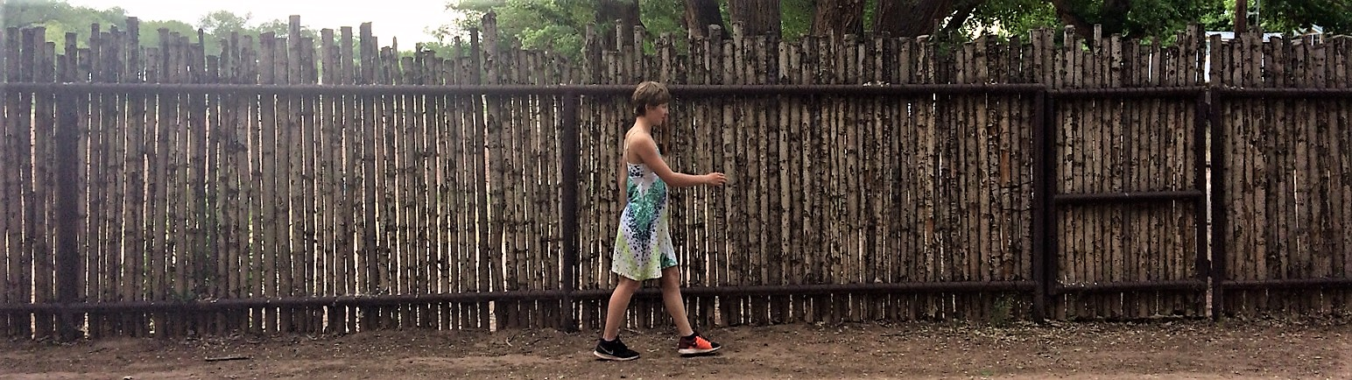
Where was the girl:
- 5 seconds after this picture was taken? Mark her approximate location on the picture.
- 5 seconds before this picture was taken? Mark her approximate location on the picture.

4 Backwards in Time

Student Task Statement
A traffic safety engineer was studying travel patterns along a highway. She set up a camera and recorded the speed and direction of cars and trucks that passed by the camera. Positions to the east of the camera are positive, and to the west are negative.
- Here are some positions and times for one car:
- position (feet) | - -180 | - -120 | - -60 | - 0 | - 60 | - 120
- time (seconds) | - -3 | - -2 | - -1 | - 0 | - 1 | - 2
  - In what direction is this car traveling?
  - What is its velocity?

  - What does it mean when the time is zero?
  - What could it mean to have a negative time?
- Here are the positions and times for a different car whose velocity is -50 feet per second:
- position (feet) |  |  |  | - 0 | - -50 | - -100
- time (seconds) | - -3 | - -2 | - -1 | - 0 | - 1 | - 2
  - Complete the table with the rest of the positions.
  - In what direction is this car traveling? Explain how you know.
- Complete the table for several different cars passing the camera.
 | - velocity  (meters per  second) | - time after passing  the camera  (seconds) | - ending  position  (meters) | - equation
- car C | - +25 | - +10 | - +250 | - $25⋅10=250$
- car D | - -20 | - +30
- car E | - +32 | - -40
- car F | - -35 | - -20
- car G | - -15 | - -8

  - If a car is traveling east when it passes the camera, will its position be positive or negative 60 seconds before it passes the camera?
  - If we multiply a positive number and a negative number, is the result positive or negative?

  - If a car is traveling west when it passes the camera, will its position be positive or negative 60 seconds before it passes the camera?
  - If we multiply two negative numbers, is the result positive or negative?
© CC BY Open Up Resources. Adaptations CC BY IM.

