Unit 3 Lesson 20: Dividing Decimals by Decimals

1 Number Talk: Dividing by 4 (Warm up)

Student Task Statement
Find each quotient mentally.
$80÷4$
$12÷4$
$1.2÷4$
$81.2÷4$

2 Dividends and Divisors

Images for Launch
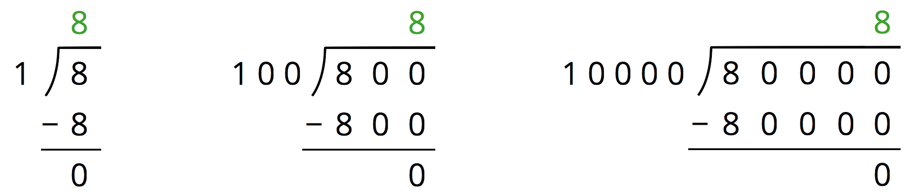

Student Task Statement
Analyze the dividends, divisors, and quotients in the calculations, and then answer the questions.
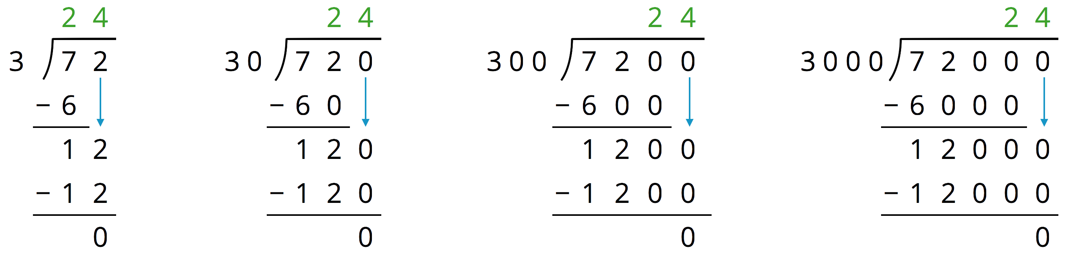
- Complete each sentence. In the calculations shown:
  - Each dividend is ______ times the dividend to the left of it.
  - Each divisor is ______ times the divisor to the left of it.
  - Each quotient is _____________________ the quotient to the left of it.
- Suppose we are writing a calculation to the right of $72,​000÷3,​000$. Which expression has a quotient of 24? Be prepared to explain your reasoning.
  - $72,​000÷30,​000$
  - $720,​000÷300,​000$
  - $720,​000÷30,​000$
  - $720,​000÷3,​000$
- Suppose we are writing a calculation to the left of $72÷3$. Write an expression that would also give a quotient of 24. Be prepared to explain your reasoning.
- Decide which of the following expressions would have the same value as $250÷10$. Be prepared to share your reasoning.
  - $250÷0.1$
  - $25÷1$
  - $2.5÷1$
  - $2.5÷0.1$
  - $2,500÷100$
  - $0.25÷0.01$

3 Placing Decimal Points in Quotients

Student Task Statement
- Think of one or more ways to find $3÷0.12$. Show your reasoning.
- Find $1.8÷0.004$. Show your reasoning. If you get stuck, think about what equivalent division expression you could write.
- Diego said, “To divide decimals, we can start by moving the decimal point in both the dividend and divisor by the same number of places and in the same direction. Then we find the quotient of the resulting numbers.”
- Do you agree with Diego? Use the division expression $7.5÷1.25$ to support your answer.

4 Practicing Division with Decimals

Student Task Statement
Find each quotient. Discuss your quotients with your group and agree on the correct answers. Consult your teacher if the group can't agree.
- $106.5÷3$
- $58.8÷0.7$
- $257.4÷1.1$
- Mai is making friendship bracelets. Each bracelet is made from 24.3 cm of string. If she has 170.1 cm of string, how many bracelets can she make? Explain or show your reasoning.
© CC BY Open Up Resources. Adaptations CC BY IM.

