Lesson 3 Practice Problems
- Here is an equation that represents a function: $72x+12y=60$.
- Select all the different equations that describe the same function:
  - $120y+720x=600$
  - $y=5−6x$
  - $2y+12x=10$
  - $y=5+6x$
  - $x=\frac{5}{6}−\frac{y}{6}$
  - $7x+2y=6$
  - $x=\frac{5}{6}+\frac{y}{6}$

  - Graph a system of linear equations with no solutions.
  - Write an equation for each line you graph.
- 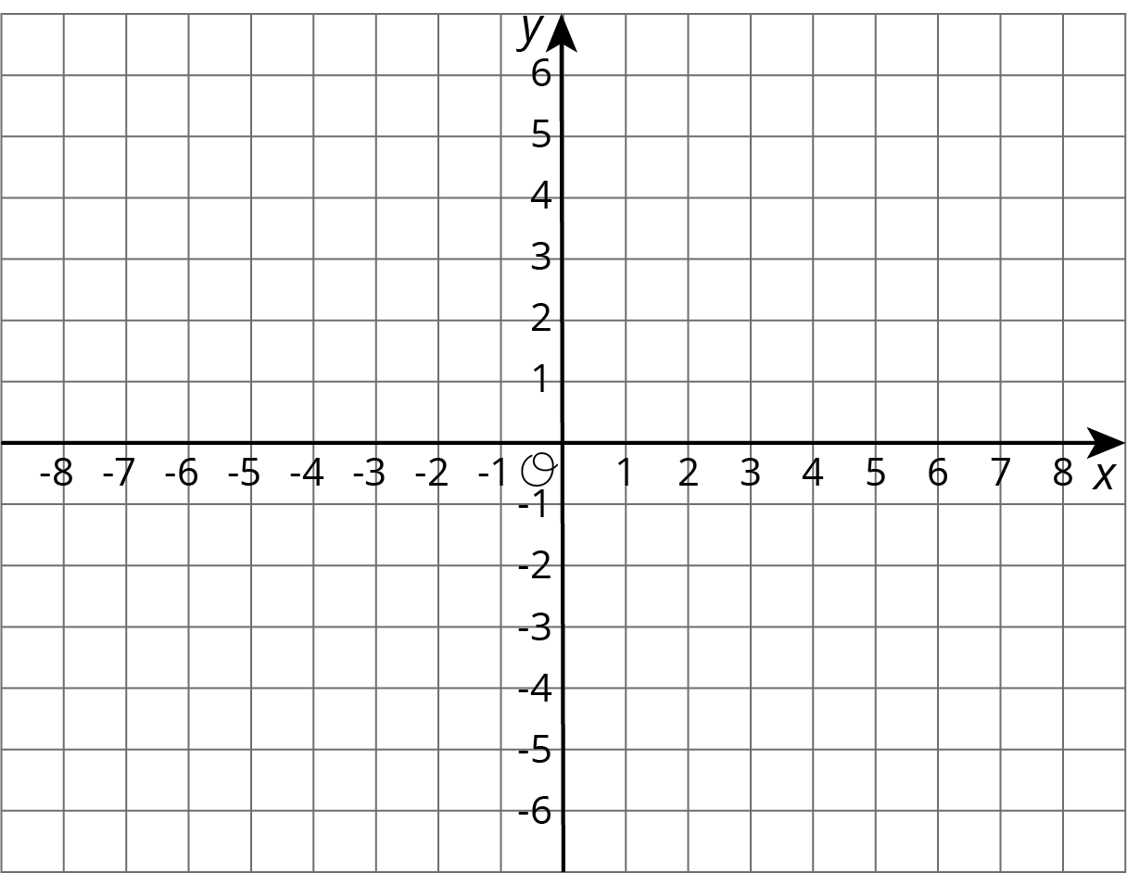
- (From Unit 4, Lesson 13.)
- Brown rice costs $2 per pound, and beans cost $1.60 per pound. Lin has $10 to spend on these items to make a large meal of beans and rice for a potluck dinner. Let $b$ be the number of pounds of beans Lin buys and $r$ be the number of pounds of rice she buys when she spends all her money on this meal.
  - Write an equation relating the two variables.
  - Rearrange the equation so $b$ is the independent variable.
  - Rearrange the equation so $r$ is the independent variable.
- Solve each equation and check your answer.
- $2x+4\left(3−2x\right)=\frac{3\left(2x+2\right)}{6}+4$
- $4z+5=\text{-}3z−8$
- $\frac{1}{2}−\frac{1}{8}q=\frac{q−1}{4}$
- (From Unit 4, Lesson 6.)
© CC BY Open Up Resources. Adaptations CC BY IM.

