Lesson 9: Speedy Delivery
- Let’s use perpendicular bisectors.

9.1: Notice and Wonder: Dots in a Square
What do you notice? What do you wonder?
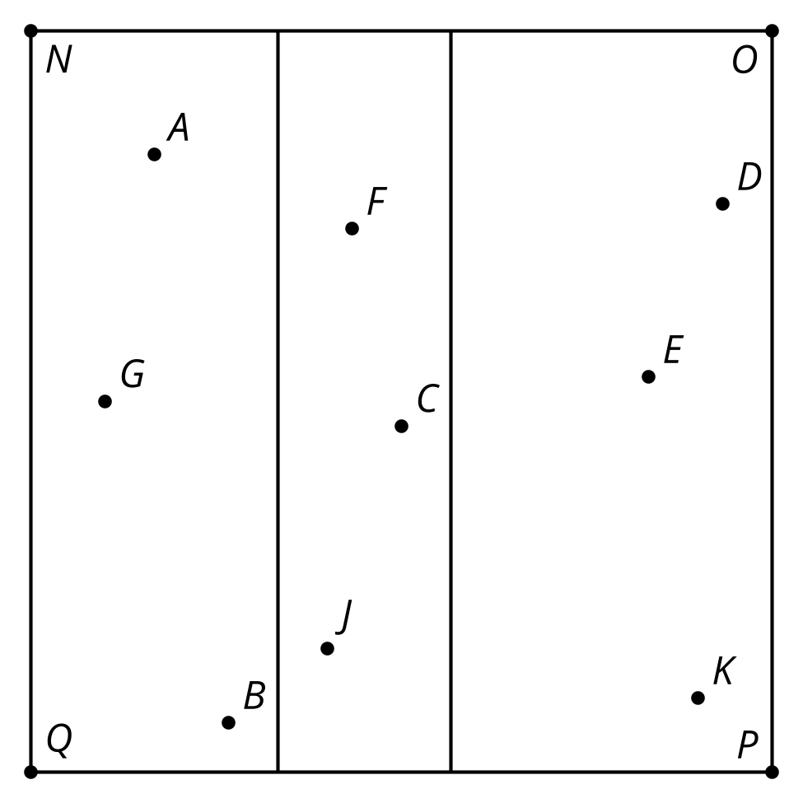

9.2: Who Is Closest?
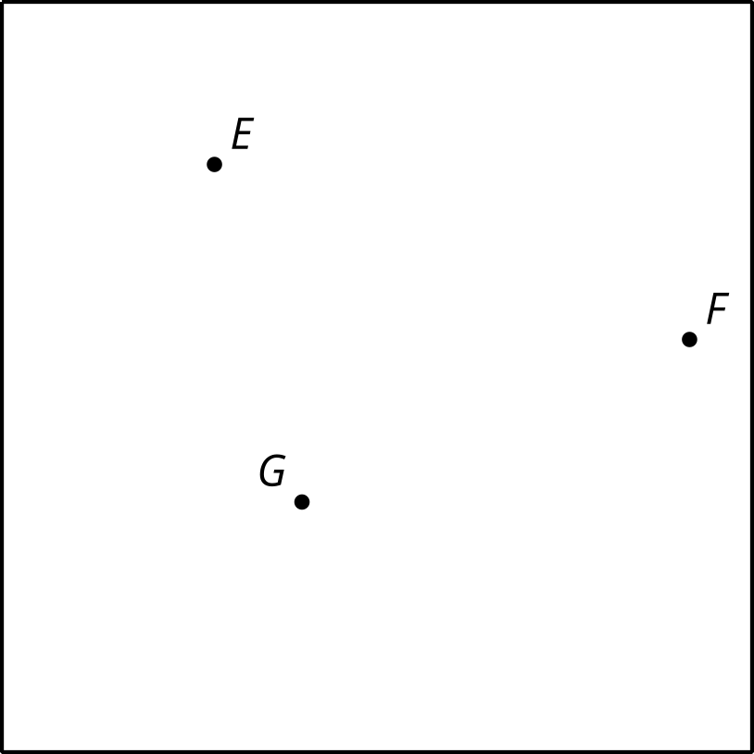
Here is a square city with 3 locations of the same store.
- The company wants to break the city down into regions so that whenever someone orders from an address, their order is sent to the store closest to their home. They have hired you to decide how to partition the city between the 3 stores. Explain or show your reasoning.
- If there are 100 employees, how should they be distributed among the 3 locations?
- Is there anywhere in the city that has the same distance to all 3 stores?
- Now a fourth store opens. Partition the city again.
- 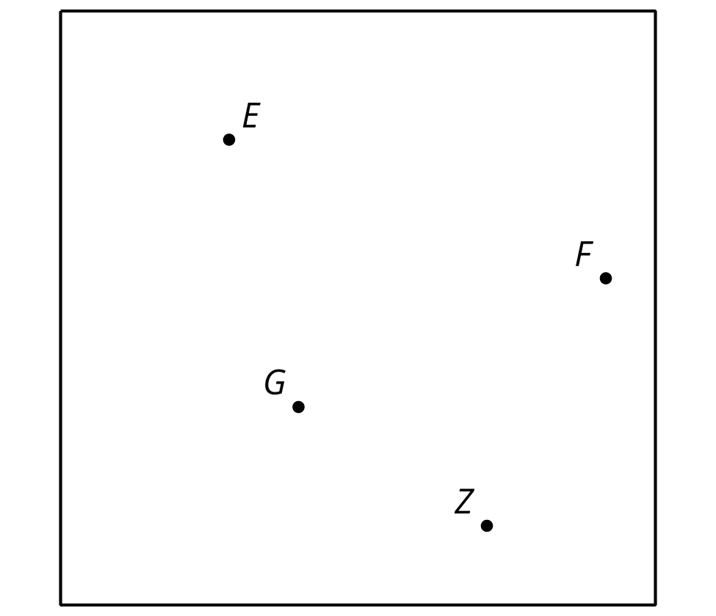

Are you ready for more?
In 1854, there was an outbreak of cholera in London. A physician named John Snow thought the water supply might be responsible. He made a map showing the location of all the water pumps in the city and the locations of all the deaths due to cholera in the city. How could he have used the ideas in this activity to help isolate the cause of the outbreak?
The diagrams you made in the activity and that Snow made are called Voronoi diagrams, and are still actively studied by mathematicians.

9.3: Now Who is Closest?
Use technology to explore the same type of problem from the earlier activity, “Who Is Closest?”, with a larger number of points, such as all major airports in the U.S.

9.4: Another Layer
Your teacher will give you a tessellation.
- Mark the intersection points on the tessellation.
- Imagine that each point is a store from the “Who Is Closest?” activity. Repeat the process you used there to define the regions that are closest to each of the points.
- Use color or shading to enhance your design.

Lesson 9 Summary
A tessellation is an arrangement of figures that covers the entire plane without gaps or overlaps. A simple example is a square grid. So that means graph paper is a tessellation. Here is another tessellation made of quadrilaterals. Can you see how repeating this pattern could cover the entire plane?
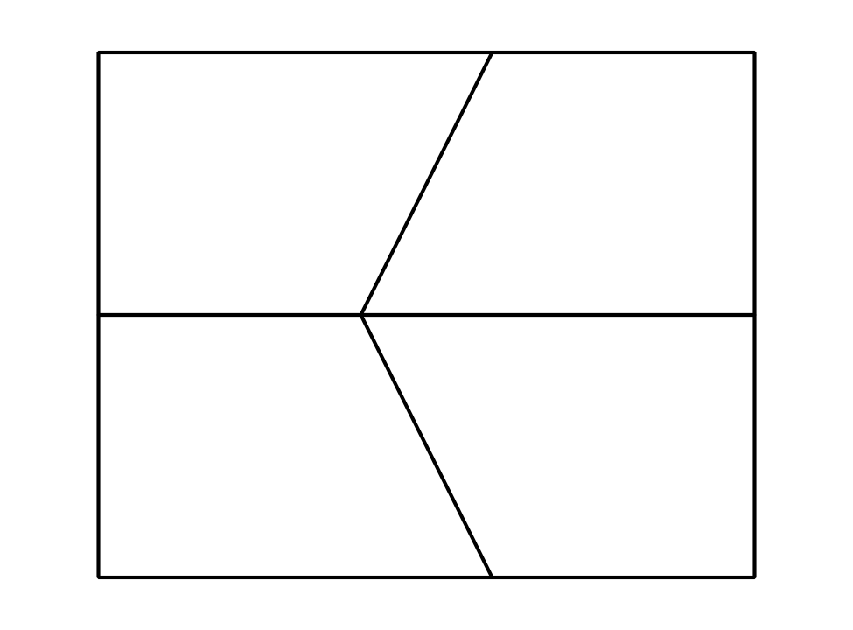
One way to draw a new tessellation is to decompose the plane into regions that are closest to each vertex. This method uses perpendicular bisectors and is called a Voronoi diagram. It is also a tessellation. What would this pattern look like when it is extended to cover the entire plane?
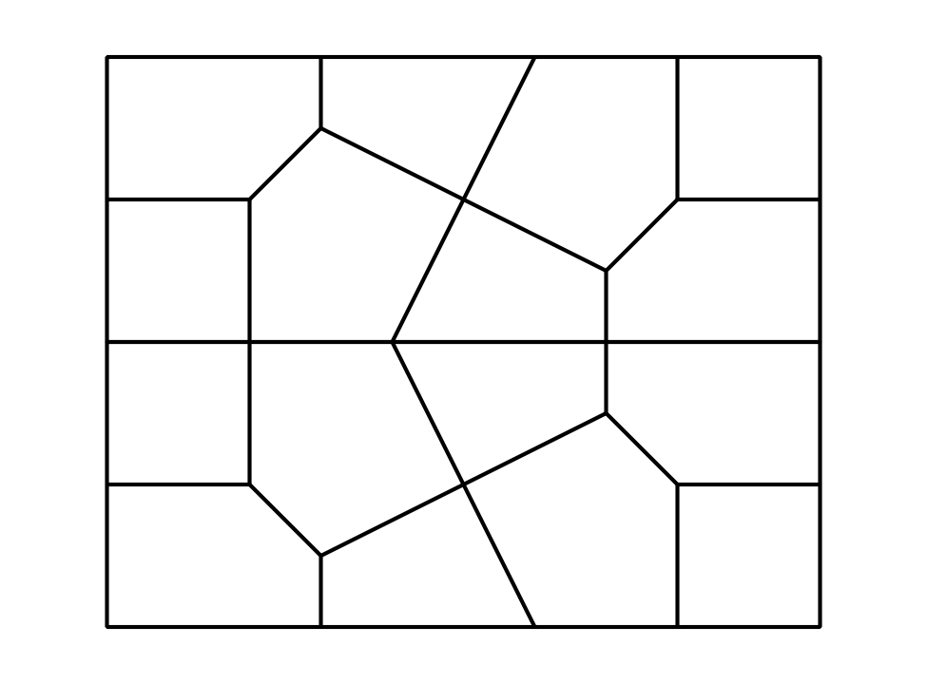
© CC BY 2019 by Illustrative Mathematics®

