Unit 3 Lesson 7: Inequivalent Equations

1 2 and -2 (Warm up)

Student Task Statement
What do you notice? What do you wonder?
- $x^{2}=4$
- $x^{2}=\text{-}4$
- $\left(x−2\right)\left(x+2\right)=0$
- $x=\sqrt{4}$

2 Careful When You Take the Square Root

Student Task Statement
Tyler was solving this equation:
$x^{2}−1=3$
He said, “I can add 1 to each side of the equation and it doesn’t change the equation. I get $x^{2}=4$.”
- Priya said, “It does change the equation. It just doesn’t change the solutions!” Then she showed these two graphs.

- Figure A
- 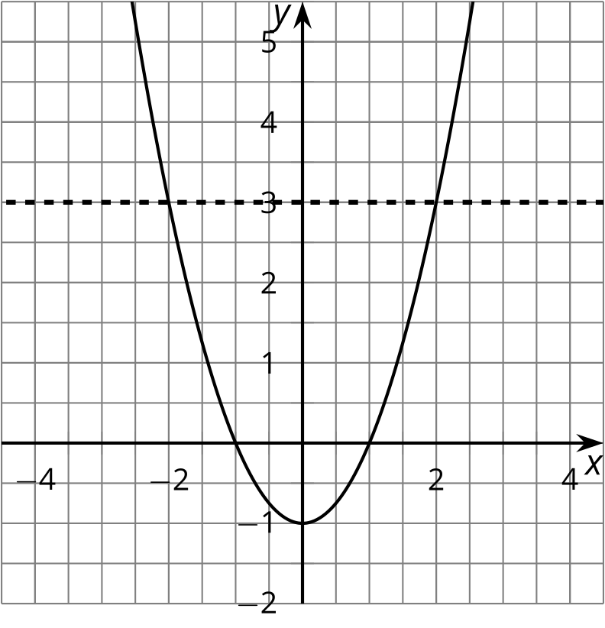

- Figure B
- 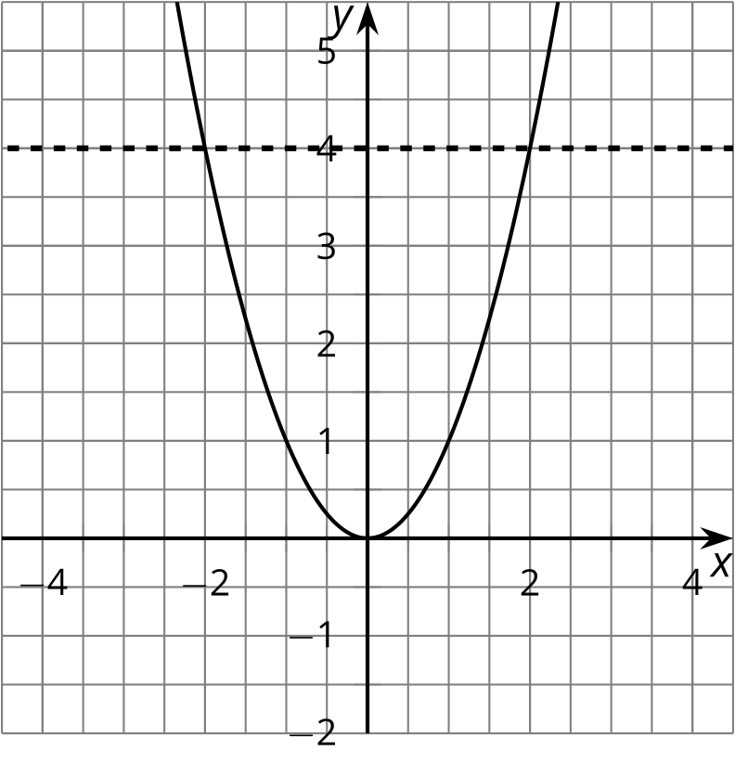
  - How can you see the solution to the equation $x^{2}−1=3$ in Figure A?
  - How can you see the solution to the equation $x^{2}=4$ in Figure B?
  - Use the graphs to explain why the equations have the same solutions.
- Tyler said, “Now I can take the square root of each side to get the solution to $x^{2}=4$. The square root of $x^{2}$ is $x$. The square root of 4 is 2.” He wrote:
- $\begin{matrix}x^{2} & =4 \\ \sqrt{x^{2}} & =\sqrt{4} \\ x & =2\end{matrix}$
- Priya said, “But the graphs show that there are two solutions!” What went wrong?

3 Another Way to Solve

Student Task Statement
Han was solving this equation: $\frac{x+3}{2}=4$
He said, "I know that half of $x+3$ is 4. So $x+3$ must be 8, since half of 8 is 4. This means that $x$ is 5."
- Use Han's reasoning to solve this equation: ${\left(x+3\right)}^{2}=4$.
- What advice would you give to someone who was going to solve an equation like ${\left(x+3\right)}^{2}=4$?

Activity Synthesis
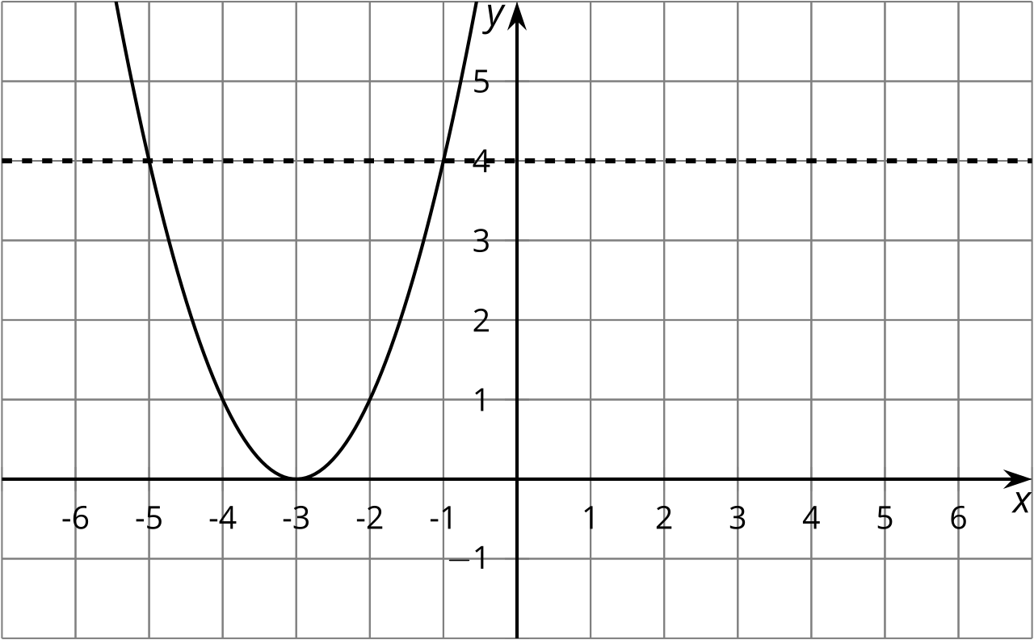

4 What Happens When You Square Each Side?

Student Task Statement
Mai was solving this equation: $\sqrt{x−1}=3$
She said, “I can square each side of the equation to get another equation with the same solutions.” Then she wrote:
$\begin{matrix}\sqrt{x−1} & =3 \\ {\left(\sqrt{x−1}\right)}^{2} & =3^{2} \\ x−1 & =9 \\ x & =10\end{matrix}$
- Check to see if her solution makes the original equation true.
- Andre said, “I tried your technique to solve $\sqrt{x−1}=\text{-}3$but it didn’t work.” Why doesn’t it work? Explain or show your reasoning.

5 Solve These Equations With Square Roots in Them (Optional)

Student Task Statement
Find the solution(s) to each of these equations, or explain why there is no solution.
- $\sqrt{t+4}=3$
- $\text{-}10=\text{-}\sqrt{a}$
- $\sqrt{3−w}−4=0$
- $\sqrt{z}+9=0$
© CC BY 2019 by Illustrative Mathematics®

