Unit 7 Lesson 13: Distances and Shapes on the Coordinate Plane

1 Coordinate Patterns (Warm up)

Student Task Statement
Plot points in your assigned quadrant and label them with their coordinates.
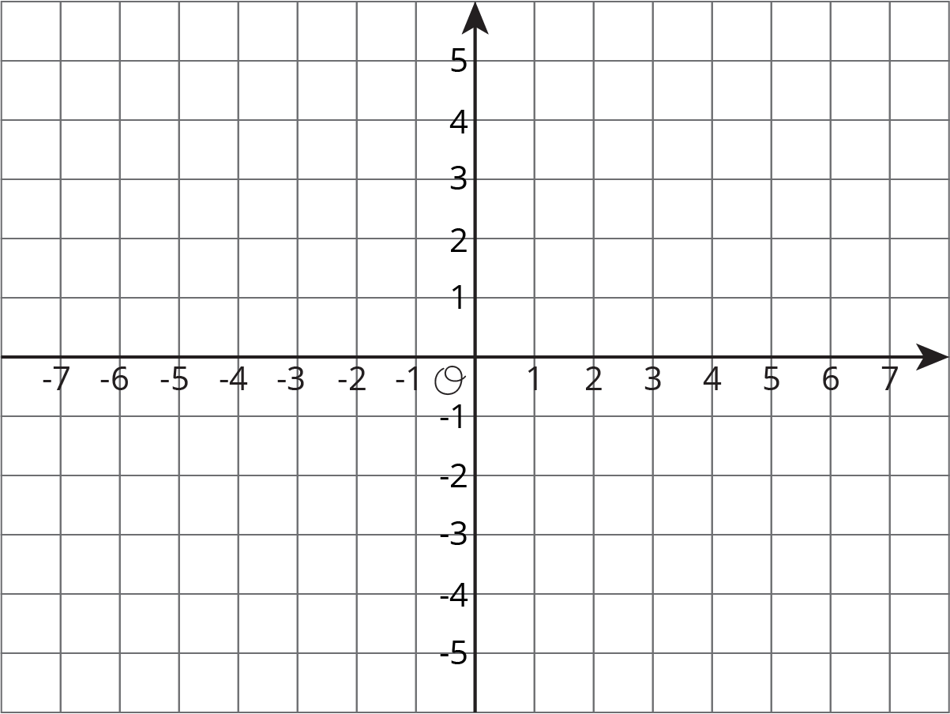

2 Signs of Numbers in Coordinates

Student Task Statement
- Write the coordinates of each point.
- 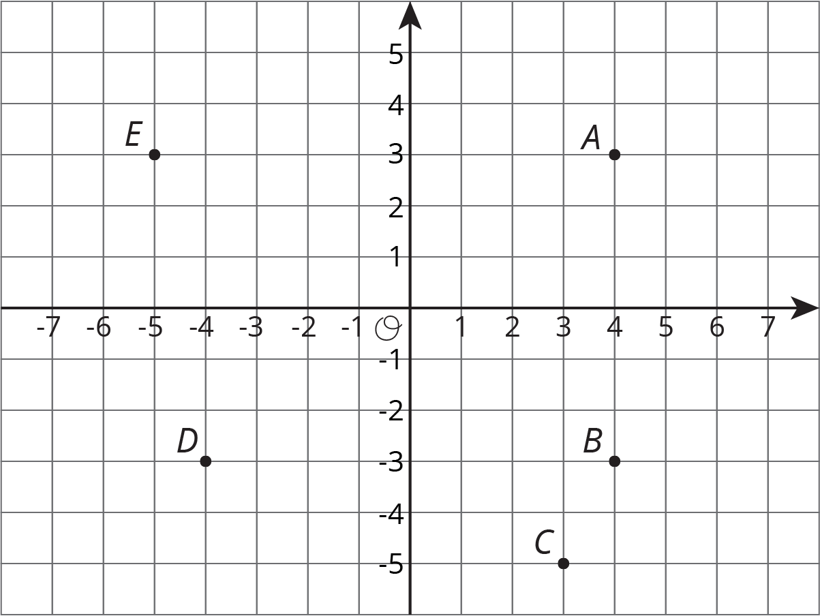

- $A=$
- $B=$
- $C=$
- $D=$
- $E=$
- Answer these questions for each pair of points.
  - How are the coordinates the same? How are they different?
  - How far away are they from the y-axis? To the left or to the right of it?
  - How far away are they from the x-axis? Above or below it?
  - $A$ and $B$
  - $B$ and $D$
  - $A$ and $D$
- Pause here for a class discussion.
- Point $F$ has the same coordinates as point $C$, except its $y$-coordinate has the opposite sign.
  - Plot point $F$ on the coordinate plane and label it with its coordinates.
  - How far away are $F$ and $C$ from the $x$-axis?
  - What is the distance between $F$ and $C$?
- Point $G$ has the same coordinates as point $E$, except its $x$-coordinate has the opposite sign.
  - Plot point $G$ on the coordinate plane and label it with its coordinates.
  - How far away are $G$ and $E$ from the $y$-axis?
  - What is the distance between $G$ and $E$?
- Point $H$ has the same coordinates as point $B$, except its both coordinates have the opposite sign. In which quadrant is point $H$?

3 Finding Distances on a Coordinate Plane

Student Task Statement
- Label each point with its coordinates.
- 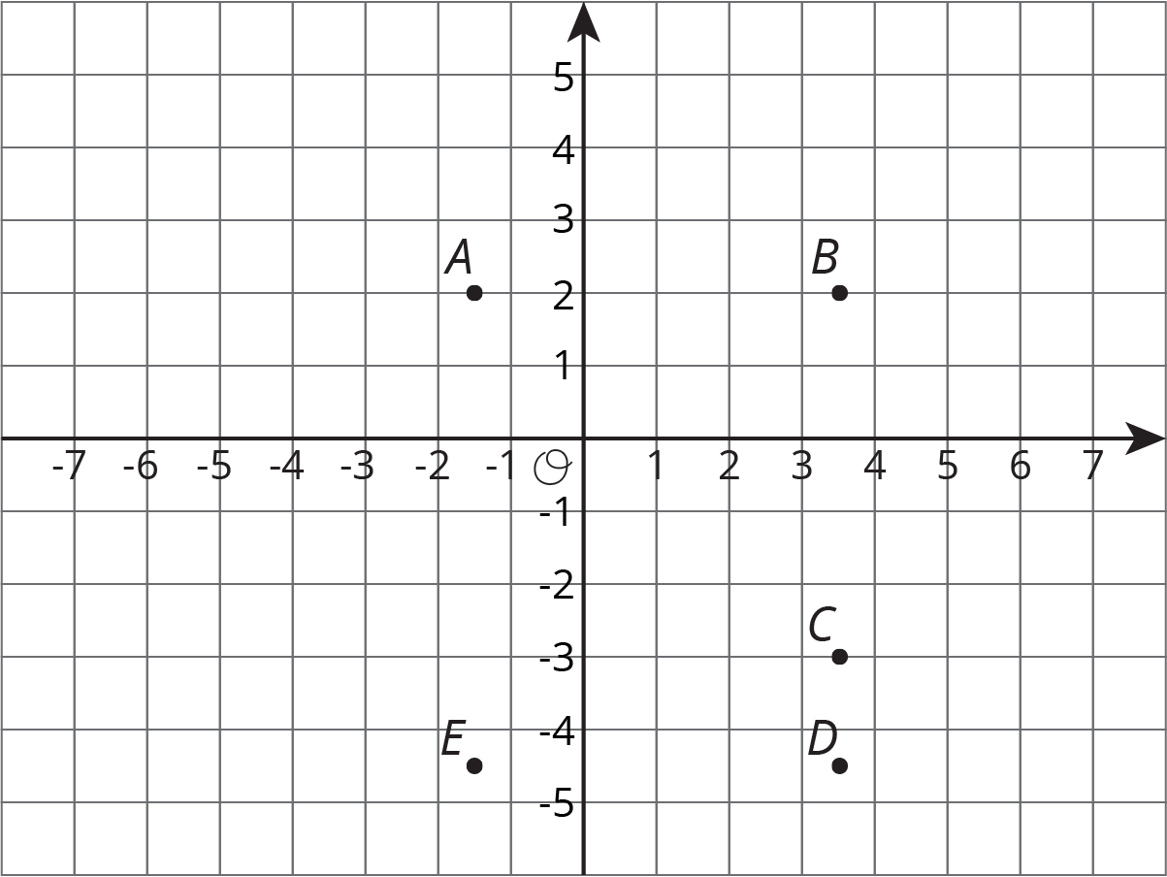
- Find the distance between each of the following pairs of points.
  - Point $B$ and $C$
  - Point $D$ and $B$
  - Point $D$ and $E$
- Which of the points are 5 units from $\left(\text{-}1.5,\text{-}3\right)$?
- Which of the points are 2 units from $\left(\text{0}.5,\text{-}4.5\right)$?
- Plot a point that is both 2.5 units from $A$ and 9 units from $E$. Label that point $M$ and write down its coordinates.

4 Plotting Polygons

Student Task Statement
Here are the coordinates for four polygons. Plot them on the coordinate plane, connect the points in the order that they are listed, and label each polygon with its letter name.
- Polygon A: $\left(\text{-}7,4\right),\left(\text{-}8,5\right),\left(\text{-}8,6\right),\left(\text{-}7,7\right),\left(\text{-}5,7\right),\left(\text{-}5,5\right),\left(\text{-}7,4\right)$
- Polygon B: $\left(4,3\right),\left(3,3\right),\left(2,2\right),\left(2,1\right),\left(3,0\right),\left(4,0\right),\left(5,1\right),\left(5,2\right),\left(4,3\right)$
- Polygon C: $\left(\text{-}8,\text{-}5\right),\left(\text{-}8,\text{-}8\right),\left(\text{-}5,\text{-}8\right),\left(\text{-}5,\text{-}5\right),\left(\text{-}8,\text{-}5\right)$
- Polygon D: $\left(\text{-}5,1\right),\left(\text{-}3,\text{-}3\right),\left(\text{-}1,\text{-}2\right),\left(0,3\right),\left(\text{-}3,3\right),\left(\text{-}5,1\right)$
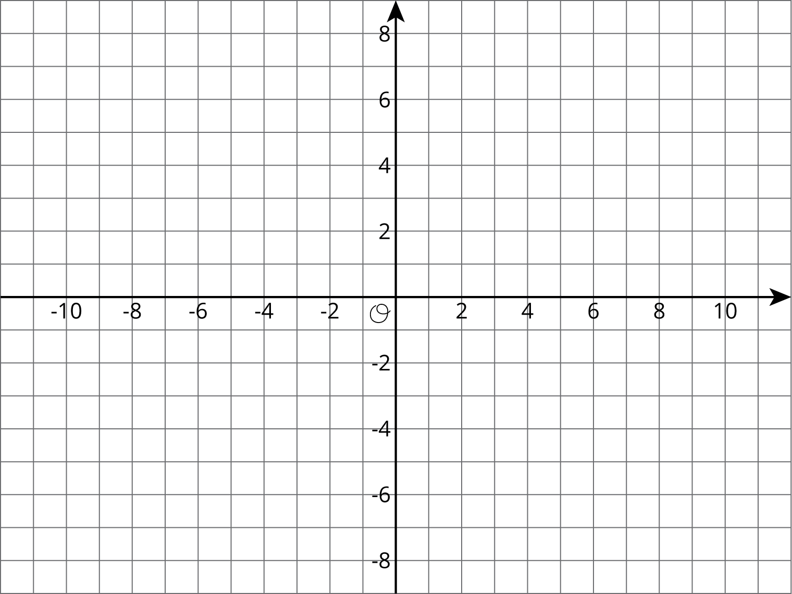

© CC BY Open Up Resources. Adaptations CC BY IM.

