Lesson 4 Practice Problems
- Match each situation with a diagram.
- 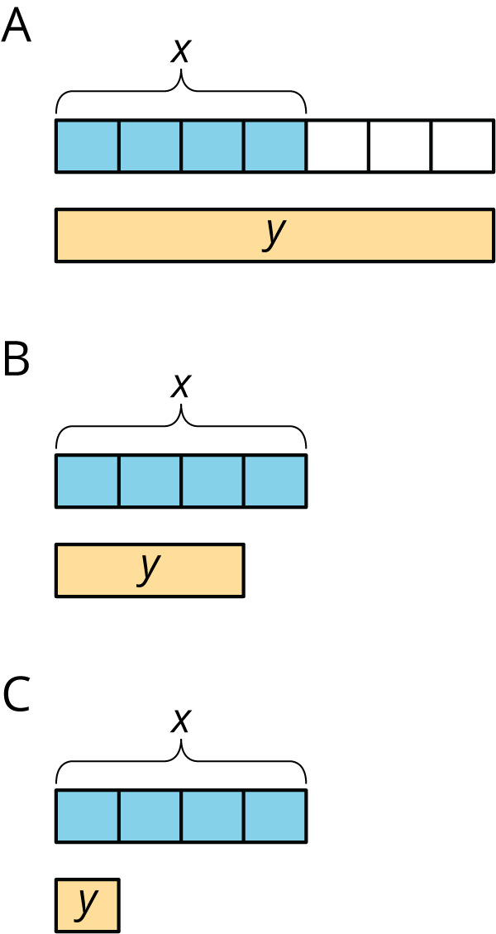
  - Diagram A
  - Diagram B
  - Diagram C
  - Diego drank $x$ ounces of juice. Lin drank $\frac{1}{4}$ less than that.
  - Lin ran $x$ miles. Diego ran $\frac{3}{4}$ more than that.
  - Diego bought $x$ pounds of almonds. Lin bought $\frac{1}{4}$ of that.
- Elena walked 12 miles. Then she walked $\frac{1}{4}$ that distance. How far did she walk all together? Select all that apply.
  - $12+\frac{1}{4}$
  - $12⋅\frac{1}{4}$
  - $12+\frac{1}{4}⋅12$
  - $12\left(1+\frac{1}{4}\right)$
  - $12⋅\frac{3}{4}$
  - $12⋅\frac{5}{4}$
- Write a story that can be represented by the equation $y=x+\frac{1}{4}x$.
- Select all ratios that are equivalent to $4:5$.
  - $2:2.5$
  - $2:3$
  - $3:3.75$
  - $7:8$
  - $8:10$
  - $14:27.5$
- (From Unit 4, Lesson 1.)
- Jada is making circular birthday invitations for her friends. The diameter of the circle is 12 cm. She bought 180 cm of ribbon to glue around the edge of each invitation. How many invitations can she make?
- (From Unit 3, Lesson 10.)
© CC BY Open Up Resources. Adaptations CC BY IM.

