Lesson 9 Practice Problems
- A kite is a quadrilateral which has 2 sides next to each other that are congruent and where the other 2 sides are also congruent. Given kite $WXYZ$, show that at least one of the diagonals of a kite decomposes the kite into 2 congruent triangles.
- 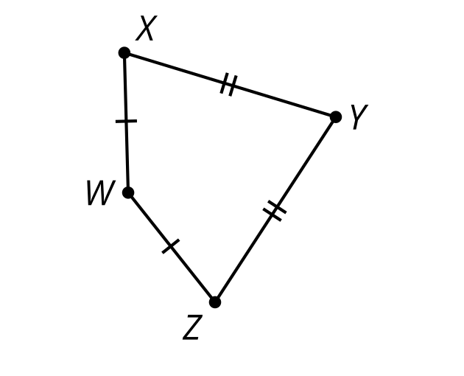
- Mai has proven that triangle $WYZ$ is congruent to triangle $WYX$ using the Side-Side-Side Triangle Congruence Theorem. Why can she now conclude that diagonal $WY$ bisects angles $ZWX$ and $ZYX$?
- 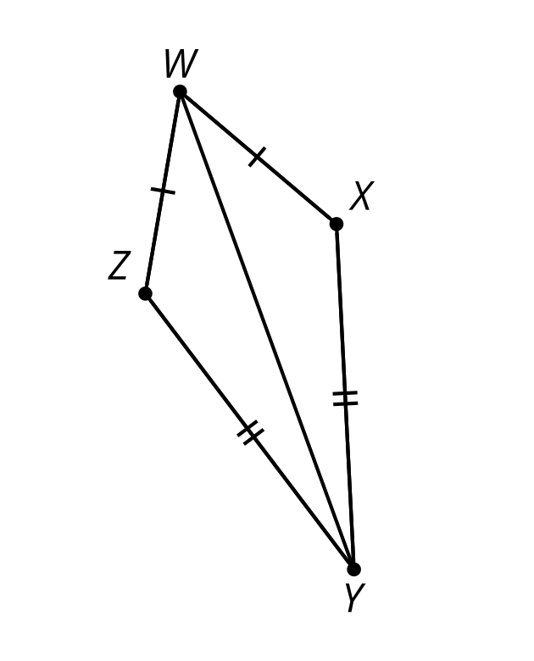
- $WXYZ$ is a kite. Angle $WXY$ has a measure of 133 degrees and angle $ZWX$ has a measure of 60 degrees. Find the measure of angle $ZYW$.
- 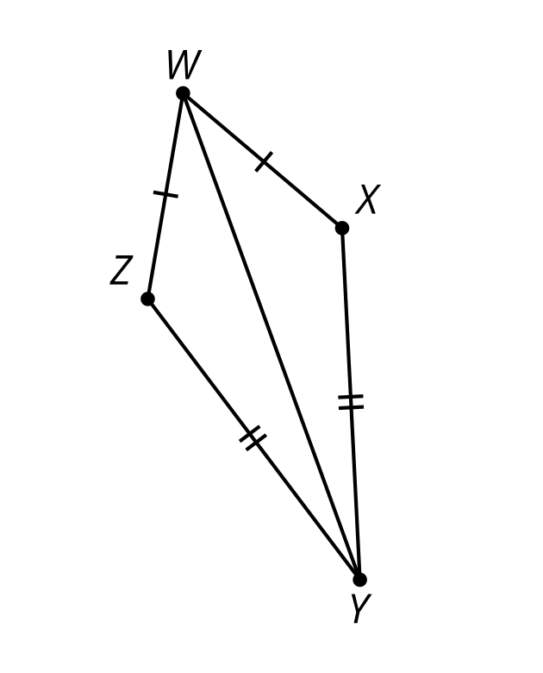

- Each statement is always true. Select all statements for which the converse is also always true.
  - Statement: If 2 angles form a straight angle, then they are supplementary. Converse: If 2 angles are supplementary, then they form a straight angle.
  - Statement: In an isosceles triangle, the base angles are congruent. Converse: If the base angles of a triangle are congruent, then the triangle is isosceles.
  - Statement: If a point is equidistant from the 2 endpoints of a segment, then it lies on the perpendicular bisector of the segment. Converse: If a point lies on the perpendicular bisector of a segment, then it is equidistant from the 2 endpoints of the segment.
  - Statement: If 2 angles are vertical, then they are congruent. Converse: If 2 angles are congruent, then they are vertical.
  - Statement: If 2 lines are perpendicular, then they intersect to form 4 right angles. Converse: If 2 lines intersect to form 4 right angles, then they are perpendicular.
- (From Unit 2, Lesson 8.)
- Prove triangle $ABD$ is congruent to triangle $CDB$.

- $DC∥AB$
- 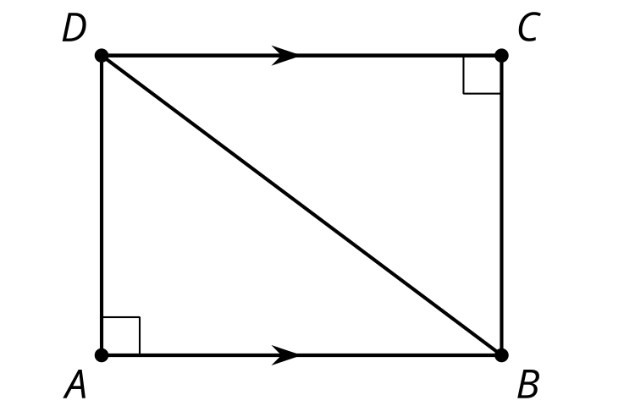
- (From Unit 2, Lesson 7.)
- Triangles $ACD$ and $BCD$ are isosceles. Angle $DBC$ has a measure of 84 degrees and angle $BDA$ has a measure of 24 degrees. Find the measure of angle $BAC$.

- $\overset{¯}{AD}≅\overset{¯}{AC}$ and $\overset{¯}{BD}≅\overset{¯}{BC}$
- 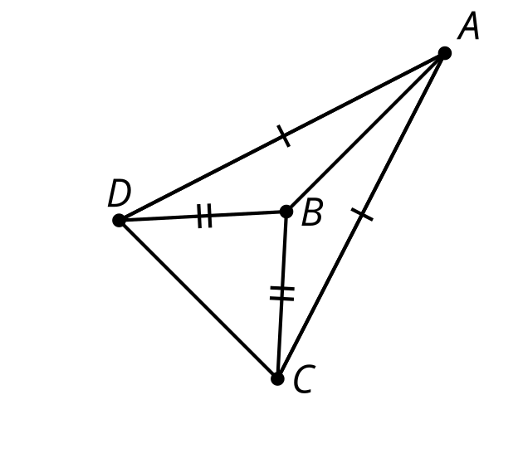
- (From Unit 2, Lesson 6.)
- Reflect right triangle $ABC$ across line $AB$. Classify triangle $CAC^{′}$ according to its side lengths. Explain how you know.
- 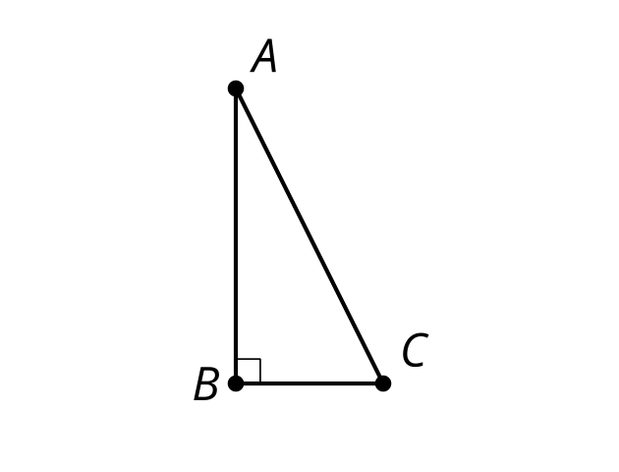

- (From Unit 2, Lesson 1.)
© CC BY 2019 by Illustrative Mathematics®

