Unit 3 Lesson 10: A New Kind of Number

1 Numbers Are Inventions (Warm up)

Student Task Statement
Jada was helping her cousin with his math homework. He was supposed to solve the equation $8+x=5$. He said, “If I subtract 8 from both sides, I get $x=5−8$. This doesn’t make sense. You can’t subtract a bigger number from a smaller number. If I have 5 grapes, I can’t eat 8 of them!”
What do you think Jada could say to her cousin to help him understand why $5−8$ actually does make sense?

Activity Synthesis

2 The Square Root of Negative One

Student Task Statement
Numbers on the number line are often called real numbers.
- The equation $x^{2}=9$ has 2 real solutions. How can you see this on the graph of $y=x^{2}$? Draw points on this real number line to represent these 2 solutions.
- How many real solutions does $x^{2}=0$ have? Explain how you can see this on the graph of $y=x^{2}$. Draw the solution(s) on a real number line.
- How many real solutions does $x^{2}=\text{-}1$ have? Explain how you can see this on the graph of $y=x^{2}$. Draw the solution(s) on a real number line.

Activity Synthesis
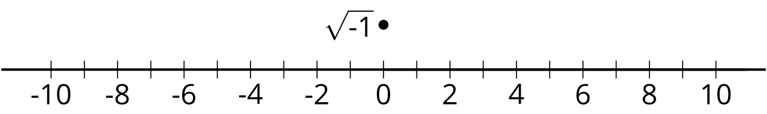

3 Imaginary Numbers

Images for Launch

Student Task Statement
- On the real number line:
  - Draw an arrow starting at 0 that represents 3.
  - Draw an arrow starting at 0 that represents -5.
- This diagram shows an arrow that represents $\sqrt{\text{-}1}$.
- 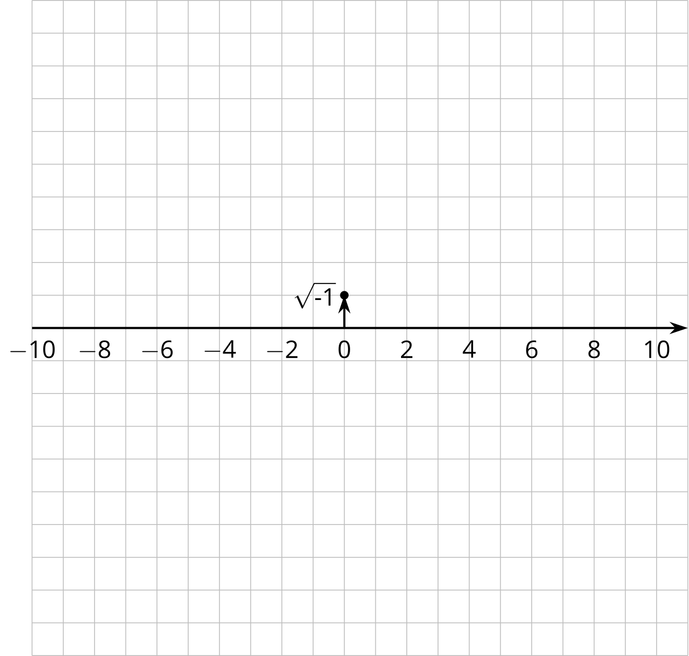
  - Draw an arrow starting at 0 that represents $3\sqrt{\text{-}1}$.
  - Draw an arrow starting at 0 that represents $\text{-}\sqrt{\text{-}1}$.
  - Draw an arrow starting at 0 that represents $\text{-}5\sqrt{\text{-}1}$.
© CC BY 2019 by Illustrative Mathematics®

