Unit 2 Lesson 22: Benchmark Percentages

1 What Percentage Is Shaded? (Warm up)

Student Task Statement
What percentage of each diagram is shaded?
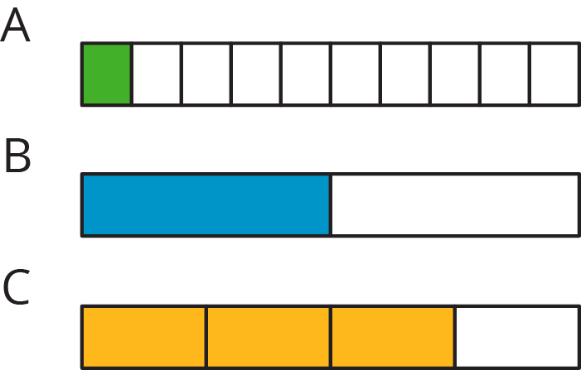

2 Liters, Meters, and Hours

Student Task Statement

  - How much is 50% of 10 liters of milk?
  - How far is 50% of a 2,000-kilometer trip?
  - How long is 50% of a 24-hour day?
  - How can you find 50% of any number?

  - How far is 10% of a 2,000-kilometer trip?
  - How much is 10% of 10 liters of milk?
  - How long is 10% of a 24-hour day?
  - How can you find 10% of any number?

  - How long is 75% of a 24-hour day?
  - How far is 75% of a 2,000-kilometer trip?
  - How much is 75% of 10 liters of milk?
  - How can you find 75% of any number?
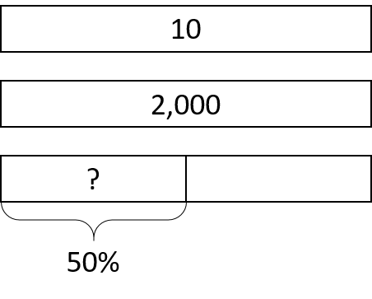

Activity Synthesis
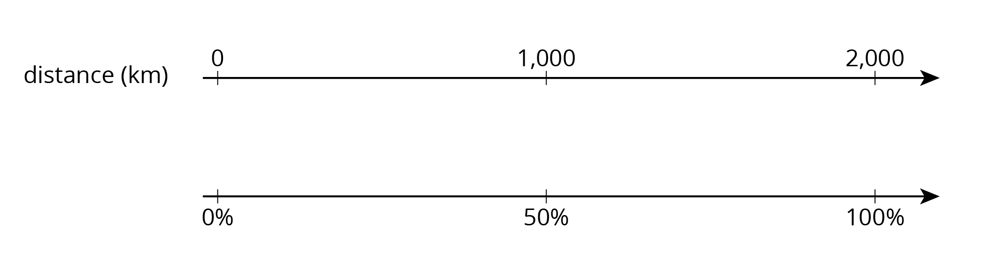
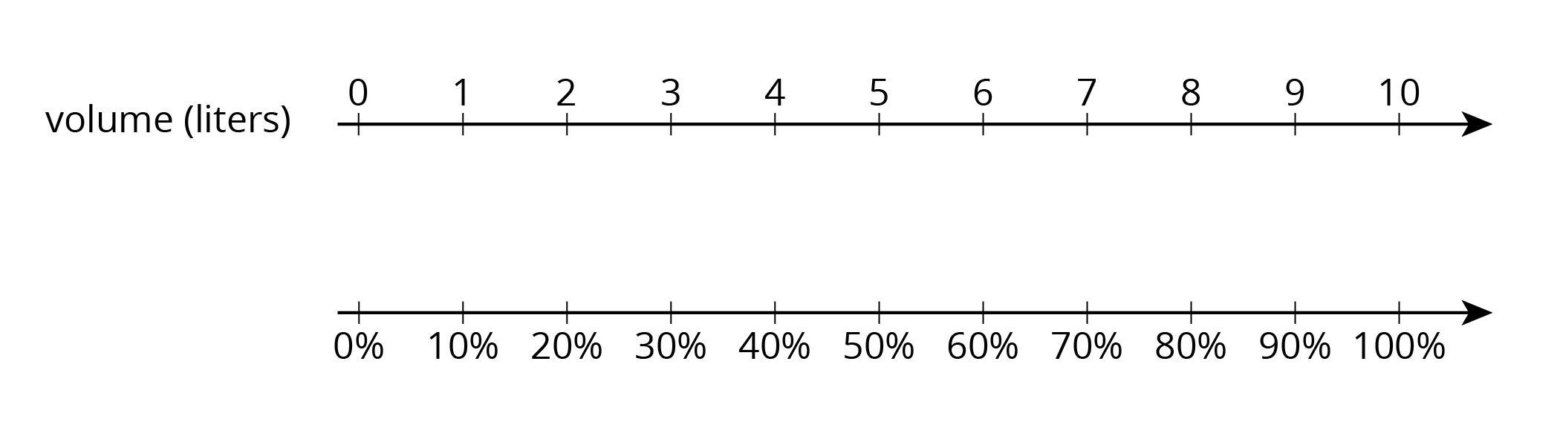
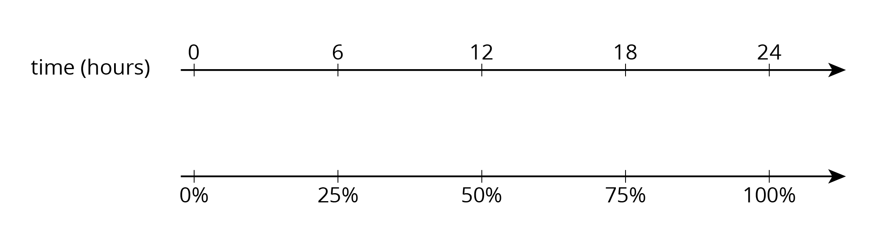

3 Nine is . . .

Student Task Statement
Explain how you can calculate each value mentally.
- 9 is 50% of what number?
- 9 is 25% of what number?
- 9 is 10% of what number?
- 9 is 75% of what number?
- 9 is 150% of what number?
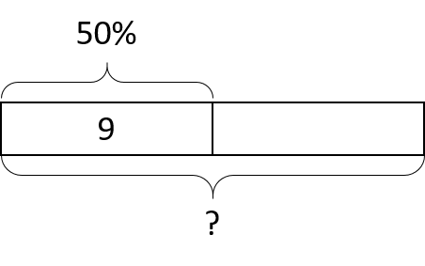

4 Matching the Percentage (Optional)

Student Task Statement
Match the percentage that describes the relationship between each pair of numbers. One percentage will be left over. Be prepared to explain your reasoning.
- 7 is what percentage of 14?
- 5 is what percentage of 20?
- 3 is what percentage of 30?
- 6 is what percentage of 8?
- 20 is what percentage of 5?
- 4%
- 10%
- 25%
- 50%
- 75%
- 400%

Images for Activity Synthesis
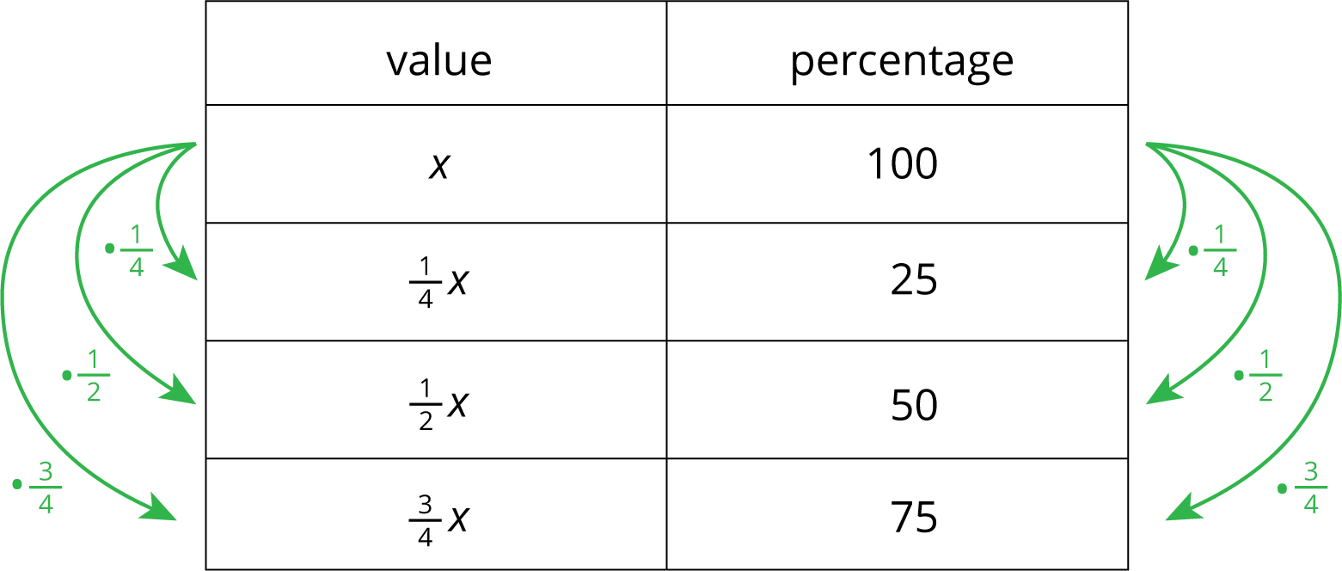
© CC BY Open Up Resources. Adaptations CC BY IM.

