Unit 5 Lesson 1: Interpreting Negative Numbers

1 Using the Thermometer (Warm up)

Student Task Statement
Here is a weather thermometer. Three of the numbers have been left off.
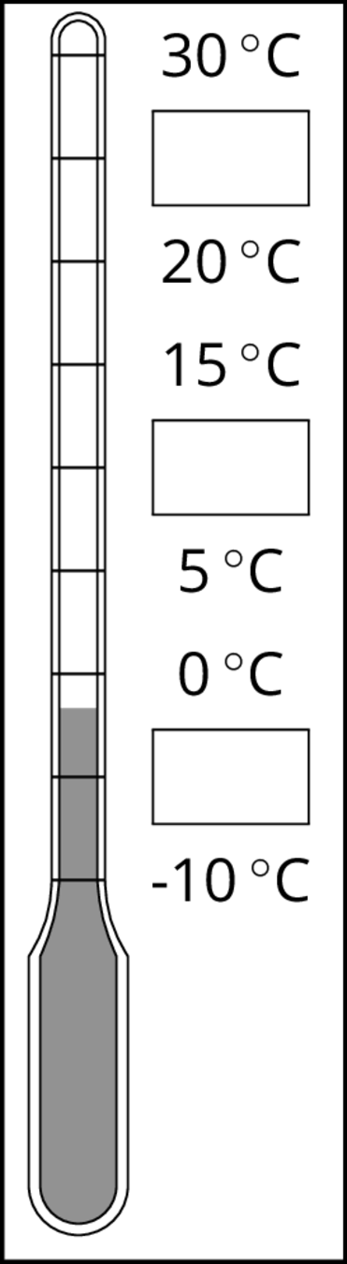
- What numbers go in the boxes?
- What temperature does the thermometer show?

2 Fractions of a Degree

Student Task Statement
- What temperature is shown on each thermometer?
- Which thermometer shows the highest temperature?
- Which thermometer shows the lowest temperature?
- Suppose the temperature outside is $\text{-}4^{∘}\text{C}$. Is that colder or warmer than the coldest temperature shown? How do you know?
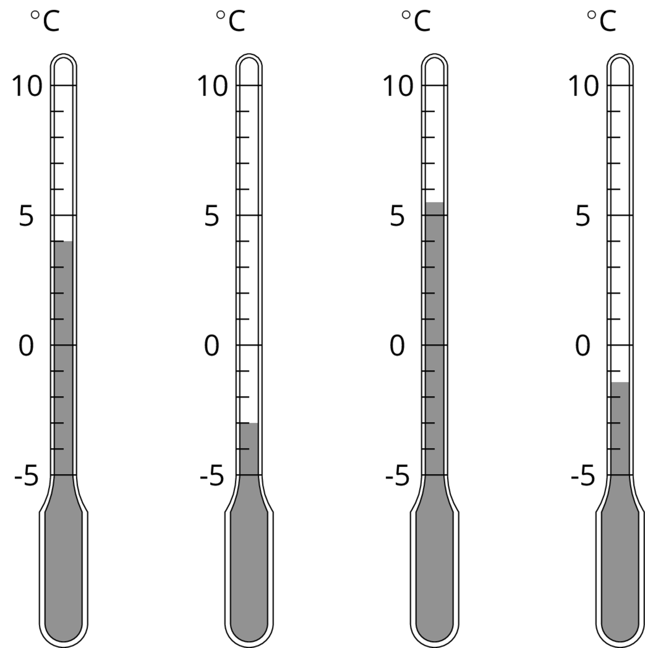

3 Seagulls Soar, Sharks Swim

Student Task Statement
Here is a picture of some sea animals. The number line on the left shows the vertical position of each animal above or below sea level, in meters.
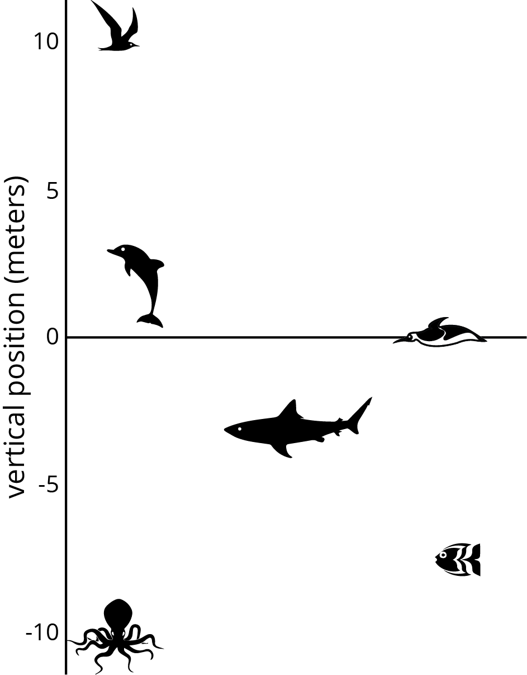
- How far above or below sea level is each animal? Measure to their eye level.
- A mobula ray is 3 meters above the surface of the ocean. How does its vertical position compare to the height or depth of:
- The jumping dolphin?
- The flying seagull?
- The octopus?
- An albatross is 5 meters above the surface of the ocean. How does its vertical position compare to the height or depth of:
- The jumping dolphin?
- The flying seagull?
- The octopus?
- A clownfish is 2 meters below the surface of the ocean. How does its vertical position compare to the height or depth of:
- The jumping dolphin?
- The flying seagull?
- The octopus?
- The vertical distance of a new dolphin from the dolphin in the picture is 3 meters. What is its distance from the surface of the ocean?

4 Card Sort: Rational Numbers (Optional)

Student Task Statement
- Your teacher will give your group a set of cards. Order the cards from least to greatest.
- Pause here so your teacher can review your work. Then, your teacher will give you a second set of cards.
- Add the new set of cards to the first set so that all of the cards are ordered from least to greatest.
© CC BY Open Up Resources. Adaptations CC BY IM.

