Lesson 4: Solving for Unknown Angles

4.1: True or False: Length Relationships
Here are some line segments.
Decide if each of these equations is true or false. Be prepared to explain your reasoning.
$CD+BC=BD$
$AB+BD=CD+AD$
$AC−AB=AB$
$BD−CD=AC−AB$

4.2: Info Gap: Angle Finding
Your teacher will give you either a problem card or a data card. Do not show or read your card to your partner.
If your teacher gives you the problem card:
- Silently read your card and think about what information you need to be able to answer the question.
- Ask your partner for the specific information that you need.
- Explain how you are using the information to solve the problem.
- Continue to ask questions until you have enough information to solve the problem.
- Share the problem card and solve the problem independently.
- Read the data card and discuss your reasoning.
If your teacher gives you the data card:
- Silently read your card.
- Ask your partner “What specific information do you need?” and wait for them to ask for information.
- If your partner asks for information that is not on the card, do not do the calculations for them. Tell them you don’t have that information.
- Before sharing the information, ask “Why do you need that information?” Listen to your partner’s reasoning and ask clarifying questions.
- Read the problem card and solve the problem independently.
- Share the data card and discuss your reasoning.
Pause here so your teacher can review your work. Ask your teacher for a new set of cards and repeat the activity, trading roles with your partner.

4.3: What’s the Match?
Match each figure to an equation that represents what is seen in the figure. For each match, explain how you know they are a match.
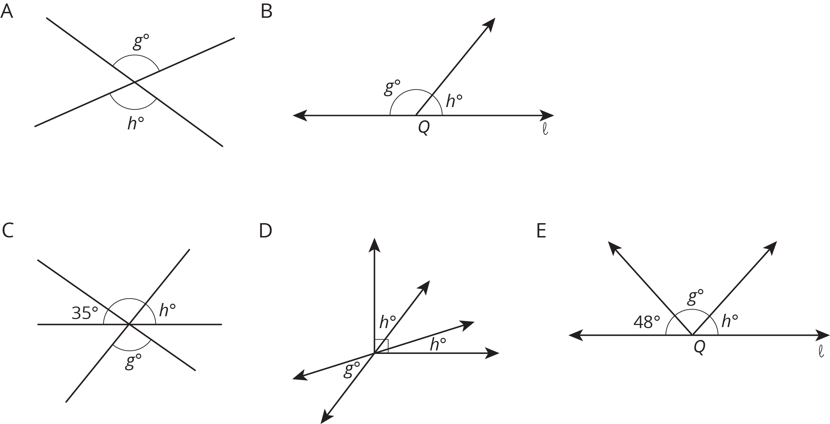

- $g+h=180$
- $g=h$
- $2h+g=90$
- $g+h+48=180$
- $g+h+35=180$

Are you ready for more?
- What is the angle between the hour and minute hands of a clock at 3:00?
- You might think that the angle between the hour and minute hands at 2:20 is 60 degrees, but it is not! The hour hand has moved beyond the 2. Calculate the angle between the clock hands at 2:20.
- Find a time where the hour and minute hand are 40 degrees apart. (Assume that the time has a whole number of minutes.) Is there just one answer?

Lesson 4 Summary
We can write equations that represent relationships between angles.
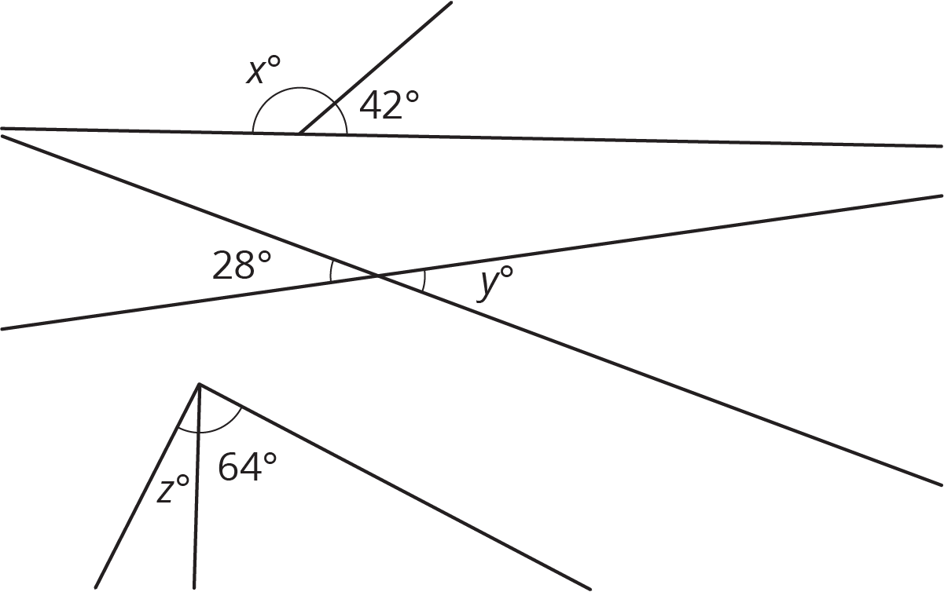
- The first pair of angles are supplementary, so $x+42=180$.
- The second pair of angles are vertical angles, so $y=28$.
- Assuming the third pair of angles form a right angle, they are complementary, so $z+64=90$.
© CC BY Open Up Resources. Adaptations CC BY IM.

