Lesson 22: Now What Can You Build?
- Let’s construct some creative shapes.

22.1: Notice and Wonder: Dramatic Designs
What do you notice? What do you wonder?
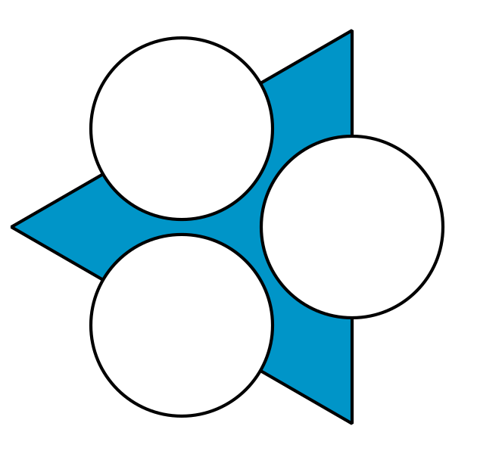
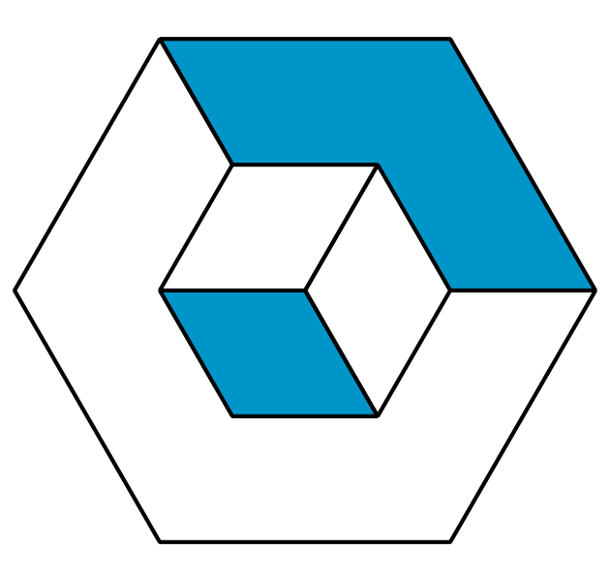
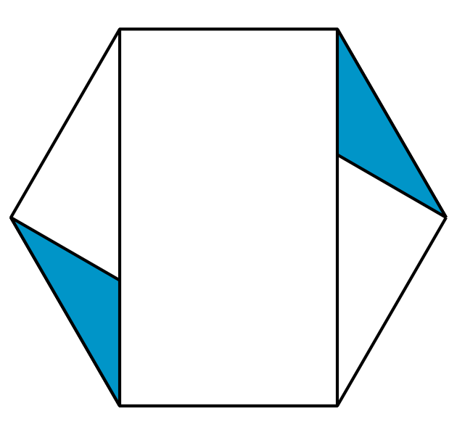

22.2: Duplicate a Design
Your teacher will give you a collection of designs that all began from the construction of a regular hexagon. Choose one to use.
- Record any rigid motions (rotation, reflection, or translation) you see in your design.
- Use straightedge and compass moves to recreate the design.
- Write down instructions for how to construct it.

22.3: Make Your Own Design
Use straightedge and compass moves to create a new design.
Write down the moves you followed on that same sheet of paper so someone else can recreate your design.

Are you ready for more?
Construct a tessellation with rotation, reflection, and translation symmetry.

22.4: Make Their Design
- Follow the instructions to make a design.
- List everything in the design that is congruent. Explain how you know.

Lesson 22 Summary
There is a deep connection between geometry and art. Using simple construction tools, it’s possible to create beautiful patterns. Precisely recording instructions for a pattern allows other people to make the same pattern and enjoy it for themselves! These same ideas can be applied in three-dimensional space to create the objects we use and appreciate every day.
© CC BY 2019 by Illustrative Mathematics®

