Lesson 12 Practice Problems
- Add the number that would make the expression a perfect square. Next, write an equivalent expression in factored form.
  - $x^{2}−6x$
  - $x^{2}+2x$
  - $x^{2}+14x$
  - $x^{2}−4x$
  - $x^{2}+24x$
- Mai is solving the equation $x^{2}+12x=13$. She writes:
- $\begin{matrix}x^{2}+12x & =13 \\ {\left(x+6\right)}^{2} & =49 \\ x & =1\text{ or }x=\text{-}13\end{matrix}$
- Jada looks at Mai’s work and is confused. She doesn’t see how Mai got her answer.
- Complete Mai’s missing steps to help Jada see how Mai solved the equation.

- Match each equation to an equivalent equation with a perfect square on one side.
  - $x^{2}+8x=2$
  - $x^{2}+10x=\text{-}13$
  - $x^{2}−14x=5$
  - $x^{2}+2x=0$
  - $x^{2}+4x−5=0$
  - $x^{2}−20x=\text{-}9$
  - ${\left(x−7\right)}^{2}=54$
  - ${\left(x+5\right)}^{2}=12$
  - ${\left(x−10\right)}^{2}=91$
  - ${\left(x+4\right)}^{2}=18$
  - ${\left(x+1\right)}^{2}=1$
  - ${\left(x+2\right)}^{2}=9$
- Solve each equation by completing the square.
- $x^{2}−6x+5=12$
- $x^{2}−2x=8$
- $11=x^{2}+4x−1$
- $x^{2}−18x+60=\text{-}21$
- Rewrite each expression in standard form.
  - $\left(x+3\right)\left(x−3\right)$
  - $\left(7+x\right)\left(x−7\right)$
  - $\left(2x−5\right)\left(2x+5\right)$
  - $\left(x+\frac{1}{8}\right)\left(x−\frac{1}{8}\right)$
- (From Unit 7, Lesson 8.)
- To find the product $203⋅197$ without a calculator, Priya wrote $\left(200+3\right)\left(200−3\right)$. Very quickly, and without writing anything else, she arrived at 39,991. Explain how writing the two factors as a sum and a difference may have helped Priya.
- (From Unit 7, Lesson 8.)
- A basketball is dropped from the roof of a building and its height in feet is modeled by the function $h$.
- Here is a graph representing $h$.
- Select all the true statements about this situation.
- 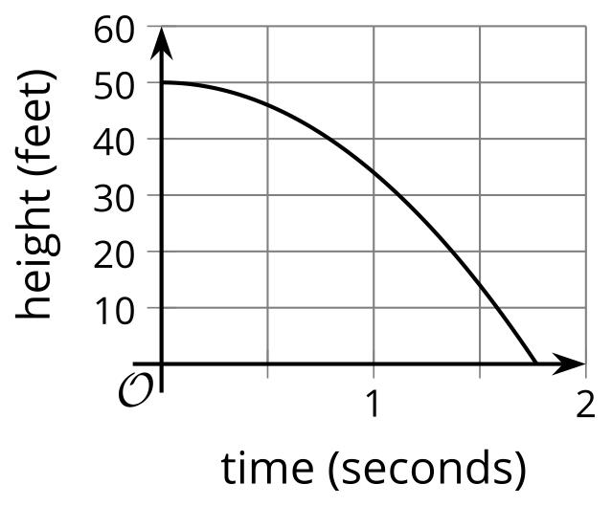
  - When $t=0$ the height is 0 feet.
  - The basketball falls at a constant speed.
  - The expression that defines $h$ is linear.
  - The expression that defines $h$ is quadratic.
  - When $t=0$ the ball is about 50 feet above the ground.
  - The basketball lands on the ground about 1.75 seconds after it is dropped.
- (From Unit 6, Lesson 5.)
- A group of students are guessing the number of paper clips in a small box.
- The guesses and the guessing errors are plotted on a coordinate plane.
- What is the actual number of paper clips in the box?​​​​​​
- 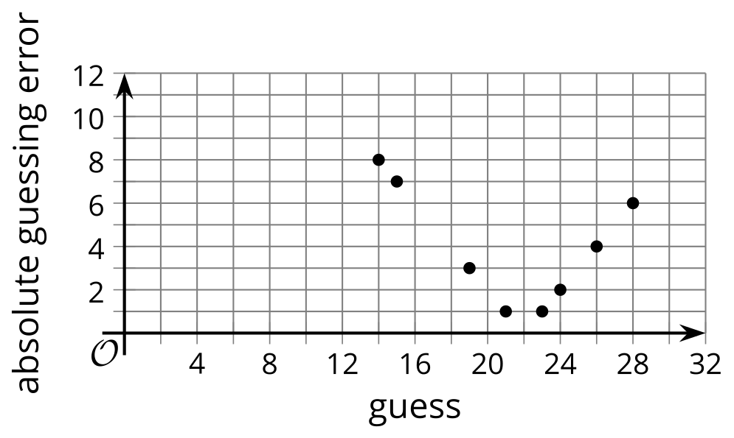
- ​​​​​
- (From Unit 4, Lesson 13.)
© CC BY 2019 by Illustrative Mathematics®

