Lesson 15 Practice Problems
- A cylinder and cone have the same height and radius. The height of each is 5 cm, and the radius is 2 cm. Calculate the volume of the cylinder and the cone.
- The volume of this cone is $36π$ cubic units.
- What is the volume of a cylinder that has the same base area and the same height?
- 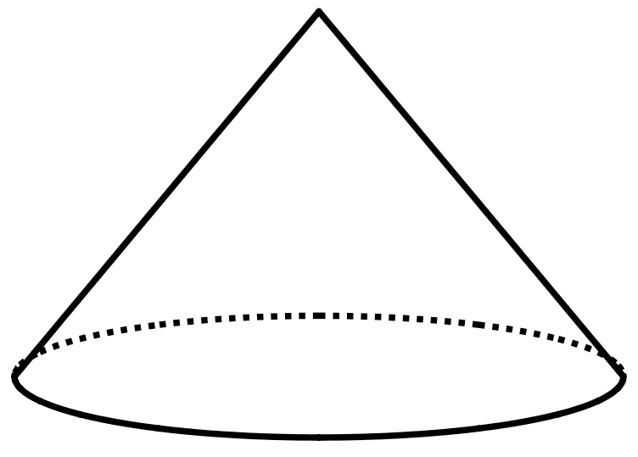
- A cylinder has a diameter of 6 cm and a volume of $36π$ cm³.
  - Sketch the cylinder.
  - Find its height and radius in centimeters.
  - Label your sketch with the cylinder’s height and radius.
- (From Unit 5, Lesson 14.)
- Lin wants to get some custom T-shirts printed for her basketball team. Shirts cost $10 each if you order 10 or fewer shirts and $9 each if you order 11 or more shirts.
  - Make a graph that shows the total cost of buying shirts, for 0 through 15 shirts.
  - There are 10 people on the team. Do they save money if they buy an extra shirt? Explain your reasoning.
  - What is the slope of the graph between 0 and 10? What does it mean in the story?
  - What is the slope of the graph between 11 and 15? What does it mean in the story?
- (From Unit 5, Lesson 10.)
- In the following graphs, the horizontal axis represents time and the vertical axis represents distance from school. Write a possible story for each graph.
- 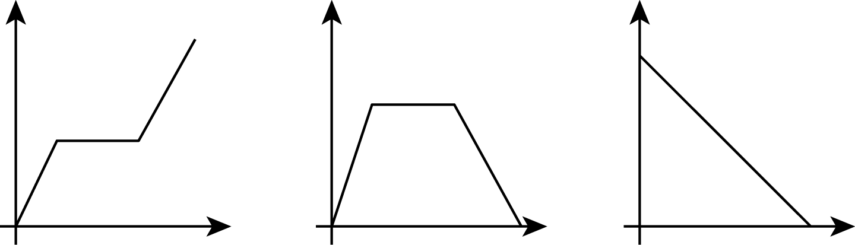
- (From Unit 5, Lesson 6.)
© CC BY Open Up Resources. Adaptations CC BY IM.

