Lesson 4 Practice Problems
- Technology required. Open a blank spreadsheet. In A1, type 2 and enter.
  - What should you type into cell A2 to generate the sequence 2, 4, 8, 16, 32, . . . when you fill down the column?
  - What should you type into cell A2 to generate the sequence 2, 4, 6, 8, 10, . . . when you fill down the column?
- Technology required. Open a blank spreadsheet. In A1, type 400 and enter.
  - What should you type into cell A2 to generate the sequence 400, 200, 100, 50, 25, . . . when you fill down the column?
  - What should you type into cell A2 to generate the sequence 400, 325, 250, 175, 100, . . . when you fill down the column?
- Technology required. Open a blank spreadsheet.
  - If cell A1 = 5 and cell A2 = A1 * 3 + 2, what are the first 5 terms of the sequence?
  - If cell A1 = 1 and cell A2 = (A1 + 2) * 3, what are the first 5 terms of the sequence?
  - If cell A1 = 2 and cell A2 = (A1 + 2) * 3, what are the first 5 terms of the sequence?
- Technology required. Open a blank spreadsheet.
  - Find the first 5 terms of a geometric sequence that starts with -5 and has a growth factor of -1.
  - Find the first 5 terms of a geometric sequence that starts with -20 and has a growth factor of 0.5.
  - Find the first 5 terms of an arithmetic sequence that starts with -20 and has an rate of change of 5.
  - Find the first 5 terms of an arithmetic sequence that starts with 43 and has an rate of change of -7.
- Here is the graph of a sequence.
- 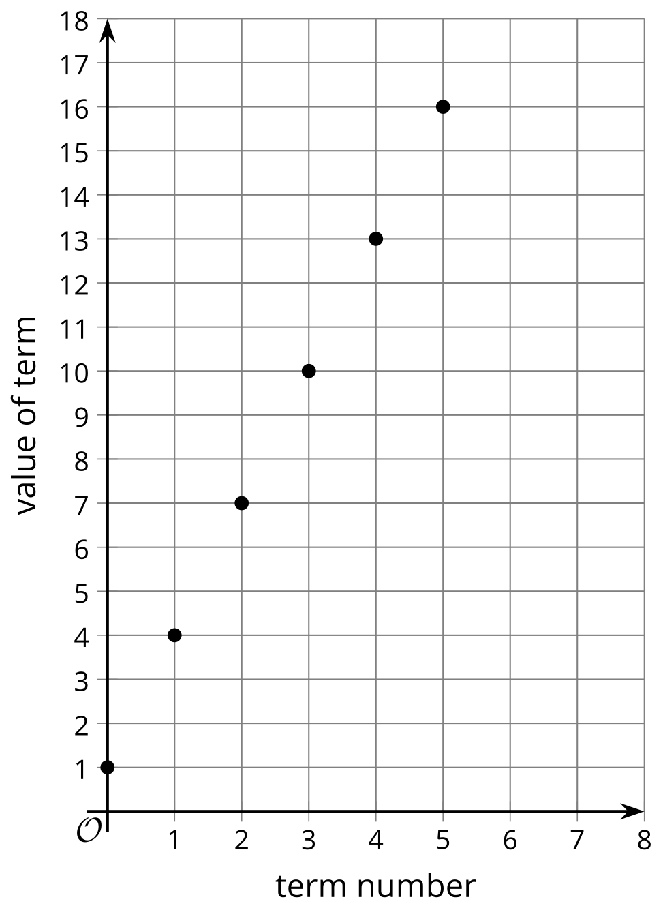
- ​​​​​​
  - Explain how you know this sequence is arithmetic.
  - Explain how you know this sequence is not geometric.
- (From Unit 1, Lesson 3.)
- The first two terms of a geometric sequence are 6 and 3.
  - Explain why there is only one geometric sequence with these first two terms.
  - What are the next 3 terms of this geometric sequence?
- (From Unit 1, Lesson 2.)
© CC BY 2019 by Illustrative Mathematics®

