Lesson 9: What’s the Equation?
- Let’s define sequences.

9.1: Math Talk: Multiplying Fractions
For the function $f\left(x\right)=32⋅{\left(\frac{3}{4}\right)}^{x}$, evaluate mentally:
$f\left(0\right)$
$f\left(1\right)$
$f\left(2\right)$
$f\left(3\right)$

9.2: Take the Cake!
A large cake is in a room. The first person who comes in takes $\frac{1}{3}$ of the cake. Then a second person takes $\frac{1}{3}$ of what is left. Then a third person takes $\frac{1}{3}$ of what is left. And so on.
- Complete the table for $C\left(n\right)$, the fraction of the original cake left after $n$ people take some.
- Write two definitions for $C$: one recursive and one non-recursive.
- What is a reasonable domain for this function? Be prepared to explain your reasoning.
$n$ | $C\left(n\right)$
0
1 | $\frac{2}{3}$
2
3
4

9.3: Fibonacci Squares
- On graph paper, draw a square of side length 1. Draw another square of side length 1 that shares a side with the first square. Next, add a 2-by-2 square, with one side along the sides of both of the first two squares. Next, add a square with one side that goes along the sides of the previous two squares you created. Next, do it again.
Pause here for your teacher to check your work.
- Write a sequence that lists the side lengths of the squares you drew.
- Predict the next two terms in the sequence and draw the corresponding squares to check your predictions.
- Describe how each square’s side length depends on previous side lengths.
- Let $F\left(n\right)$ be the side length of the $n$^{th} square. So $F\left(1\right)=1$ and $F\left(2\right)=1$. Write a recursive definition for $F$.

Are you ready for more?
- Is the Fibonacci sequence arithmetic, geometric, or neither? Explain how you know.
- Look at quotients $\frac{F\left(1\right)}{F\left(0\right)},\frac{F\left(2\right)}{F\left(1\right)},\frac{F\left(3\right)}{F\left(2\right)},\frac{F\left(4\right)}{F\left(3\right)},\frac{F\left(5\right)}{F\left(4\right)}$. What do you notice about this sequence of numbers?
- The 15th through 19th Fibonacci numbers are 610, 987, 1597, 2584, 4181. What do you notice about the quotients $\frac{F\left(16\right)}{F\left(15\right)},\frac{F\left(17\right)}{F\left(16\right)},\frac{F\left(18\right)}{F\left(17\right)},\frac{F\left(19\right)}{F\left(18\right)}$?

Lesson 9 Summary
The model we use for a function can depend on what we want to do.
For example, an 8-by-10 piece of paper has area 80 square inches. Picture a set of pieces of paper, each half the length and half the width of the previous piece.
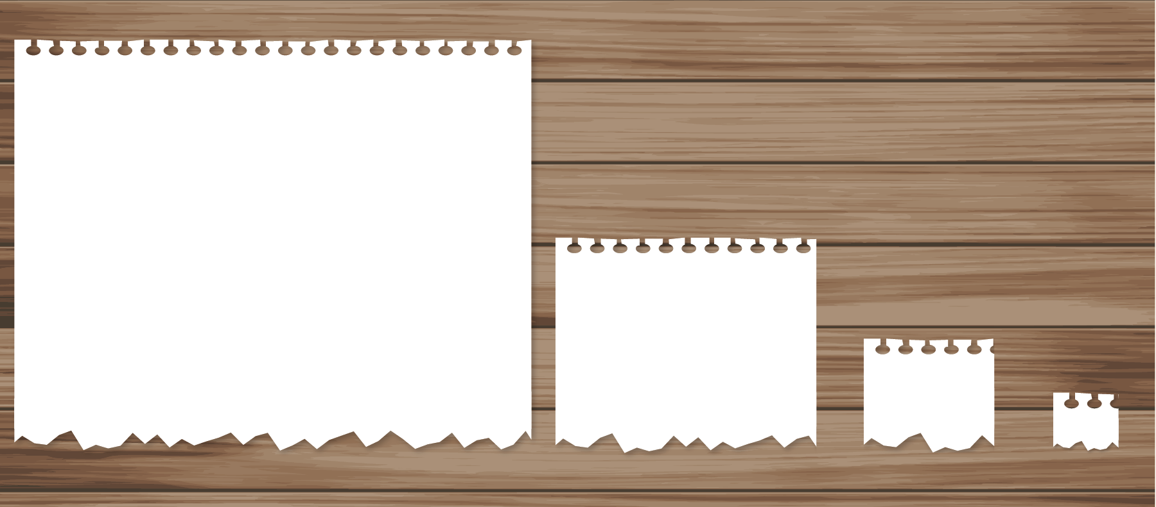
Define the sequence $A$ so that $A\left(n\right)$ is the area, in square inches, of the $n^{\text{th}}$ piece. Each new area is $\frac{1}{4}$ the previous area, so we can define $A$ recursively as
$A\left(1\right)=80,A\left(n\right)=\frac{1}{4}⋅A\left(n−1\right)\text{ for }n≥2$
But for $n$-values larger than 5 or 6, the model isn't realistic since cutting a sheet of paper accurately when it is less than $\frac{1}{50}$ of a square inch isn't something we can do well with a pair of scissors. We can see this by looking at the graph of $y=A\left(n\right)$ shown here.
If we wanted to define the $n^{\text{th}}$ term of $A$, it's helpful to first notice that the area of the $n^{\text{th}}$ piece is given by $80⋅\frac{1}{4}⋅\frac{1}{4}⋅⋯⋅\frac{1}{4}$, where there are $n−1$ factors of $\frac{1}{4}$. Then we can write
$A\left(n\right)=80⋅{\left(\frac{1}{4}\right)}^{n−1},n≥1$
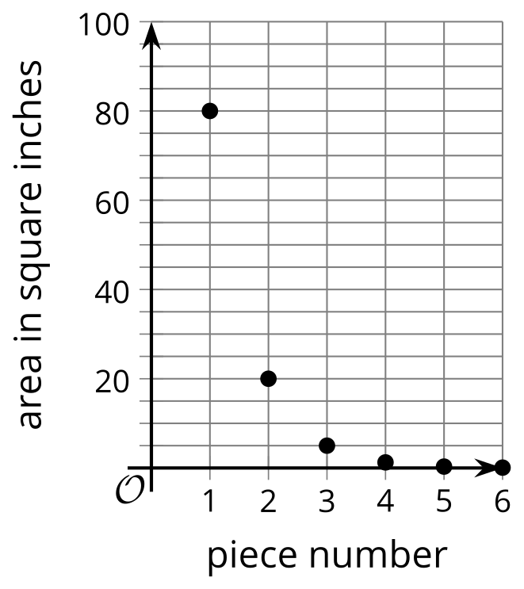
We can use this definition to calculate a value of $A$ without having to calculate all the ones that came before it. But since there are fewer than 10 values that make sense for $A,$ since we can’t cut very tiny pieces using scissors, in this situation we could just use the first definition we found to calculate different values of $A$.
© CC BY 2019 by Illustrative Mathematics®

