Lesson 7: Circles in Triangles
- Let’s construct the largest possible circle inside of a triangle.

7.1: The Largest Circle
Use a compass to draw the largest circle you can find that fits inside each triangle.
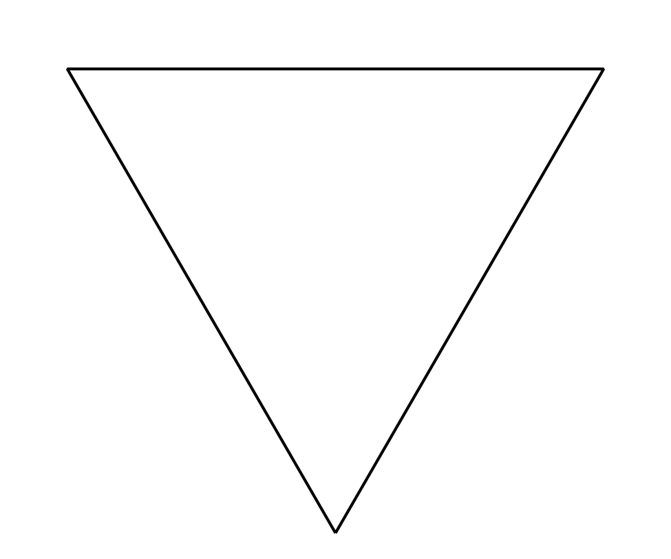

7.2: The Inner Circle
- Mark 3 points and connect them with a straightedge to make a large triangle. The triangle should not be equilateral.
- Construct the incenter of the triangle.
- Construct the segments that show the distance from the incenter to the sides of the triangle.
- Construct a circle centered at the incenter using one of the segments you just constructed as a radius.
- Would it matter which of the three segments you use? Explain your thinking.

7.3: Equilateral Centers
The image shows an equilateral triangle $ABC$. The angle bisectors are drawn. The incenter is plotted and labeled $D$.
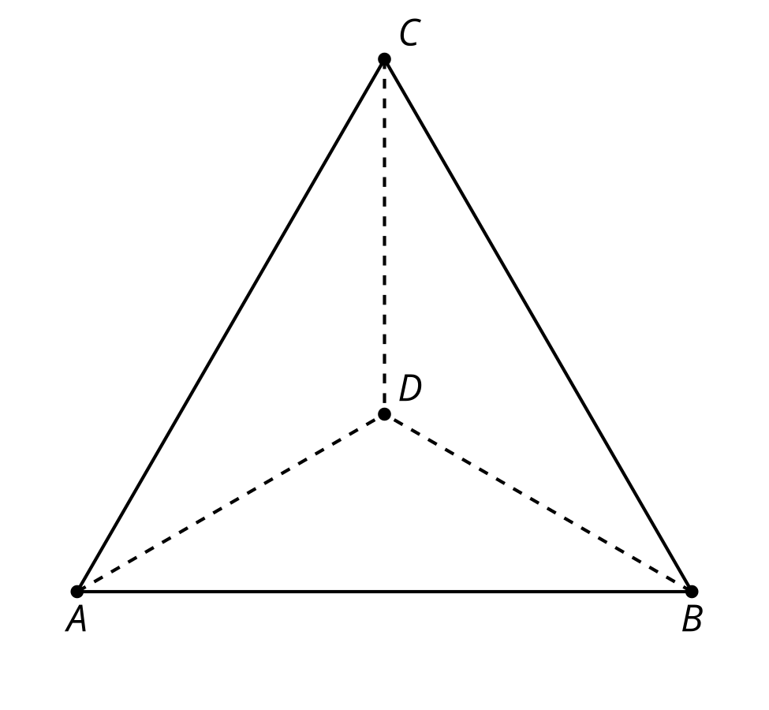
Prove that the incenter is also the circumcenter.

Are you ready for more?
- Suppose we have an equilateral triangle. Find the ratio of the area of the triangle’s circumscribed circle to the area of its inscribed circle.
- Is this ratio the same for all triangles? Explain or show your reasoning.

Lesson 7 Summary
We have seen that the incenter of a triangle is the same distance from all 3 sides of the triangle. If we draw the congruent segments representing the distance from the incenter to the triangle’s sides, we can think of them as radii of a circle centered at the incenter. This circle is the triangle’s inscribed circle.
In this diagram, segments $BD,CD,$ and $AD$ are angle bisectors. Point $D$ is the triangle’s incenter, and the circle is inscribed in the triangle.
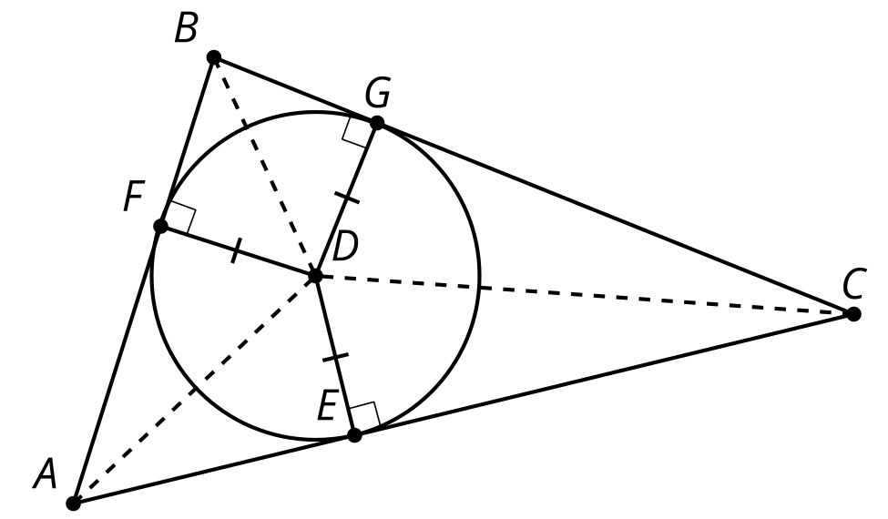
The inscribed circle is the largest possible circle that can be drawn inside a triangle. Also, the 3 radii that represent the distances from the incenter to the sides of the triangle are by definition perpendicular to the sides of the triangle. This means the circle is tangent to all 3 sides of the triangle.
© CC BY 2019 by Illustrative Mathematics®

