Unit 3 Lesson 13: Using the Pythagorean Theorem and Similarity

1 Similar, Right? (Warm up)

Student Task Statement
Is triangle $ADC$ similar to triangle $CDB$? Explain or show your reasoning.
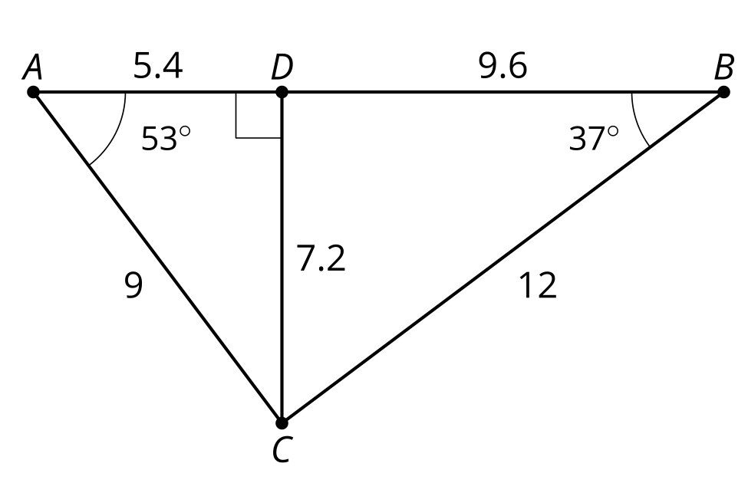

2 Tangled Triangles

Student Task Statement
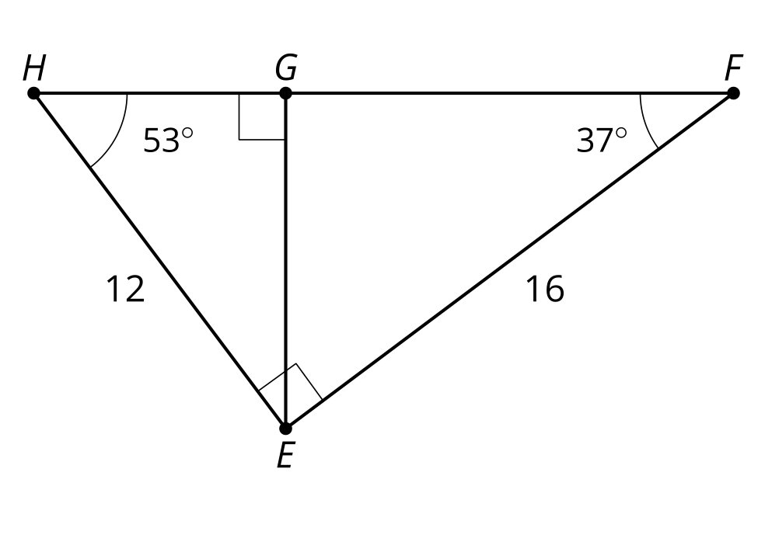
Trace the 2 smaller triangles onto separate pieces of tracing paper.
- Turn your tracing paper and convince yourself all 3 triangles are similar.
- Write 3 similarity statements.
- Determine the scale factor for each pair of triangles.
- Determine the lengths of sides $HG$, $GF$, and $HF$.

3 More Tangled Triangles

Student Task Statement
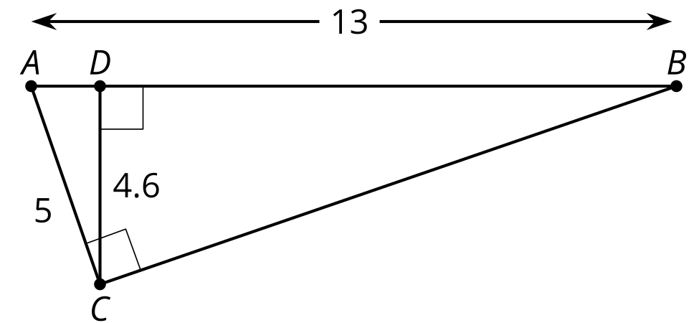
- Convince yourself there are 3 similar triangles. Write a similarity statement for the 3 triangles.
- Write as many equations about proportional side lengths as you can.
- What do you notice about these equations?

Images for Activity Synthesis
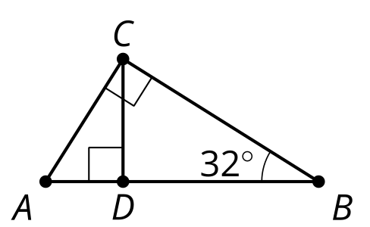
© CC BY 2019 by Illustrative Mathematics®

