Lesson 2 Practice Problems
- Line $SD$ is a line of symmetry for figure $AXPDZHMS$. Noah says that $AXPDS$ is congruent to $HMZDS$ because sides $AX$ and $HM$ are corresponding.
  - Why is Noah’s congruence statement incorrect?
  - Write a correct congruence statement for the pentagons.
- 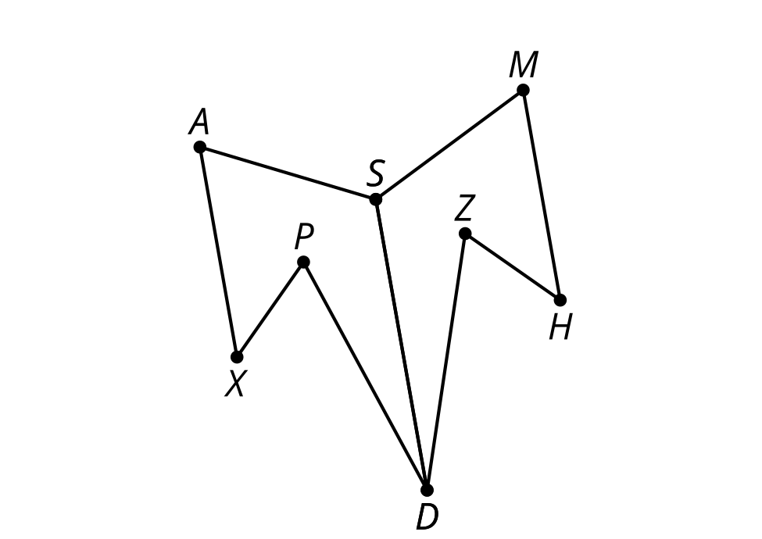
- FIgure $MBJKGH$ is the image of figure $AFEKJB$ after being rotated 90 degrees counterclockwise about point $K$. Draw a segment in figure $AFEKJB$ to create a quadrilateral. Draw the image of the segment when rotated 90 degrees counterclockwise about point $K$.
- Write a congruence statement for the quadrilateral you created in figure $AFEKJB$ and the image of the quadrilateral in figure $MBJKGH$.
- 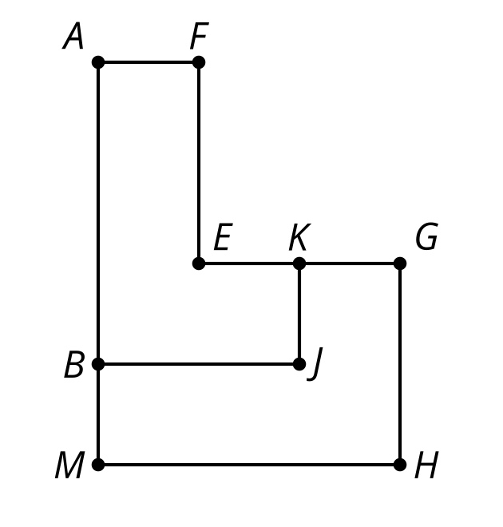

- Triangle $HEF$ is the image of triangle $FGH$ after a 180 degree rotation about point $K$. Select all statements that must be true.
- 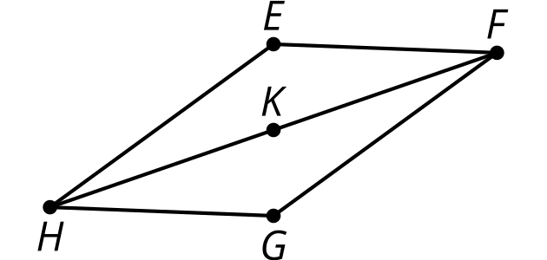
  - Triangle $FGH$ is congruent to triangle $FEH$.
  - Triangle $EFH$ is congruent to triangle $GFH$.
  - Angle $KHE$ is congruent to angle $KFG$.
  - Angle $GHK$ is congruent to angle $KHE$.
  - Segment $EH$ is congruent to segment $FG$.
  - Segment $GH$ is congruent to segment $EF$.
- When triangle $ABC$ is reflected across line $AB$, the image is triangle $ABD$. Why are segment $AD$ and segment $AC$ congruent?
- 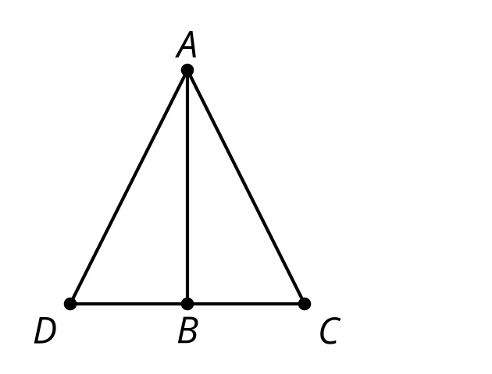
  - Congruent parts of congruent figures are corresponding.
  - Corresponding parts of congruent figures are congruent.
  - An isosceles triangle has a pair of congruent sides.
  - Segment $AB$ is a perpendicular bisector of segment $DC$.
- (From Unit 2, Lesson 1.)
- Elena needs to prove angles $BED$ and $BCA$ are congruent. Provide reasons to support each of her statements.
  - Line $m$ is parallel to line $l$.
  - Angles $BED$ and $BCA$ are congruent.
- 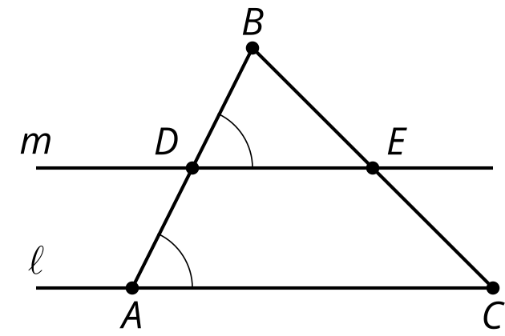
- (From Unit 1, Lesson 20.)
- Triangle $FGH$ is the image of isosceles triangle $FEH$ after a reflection across line $HF$. Select all the statements that are a result of corresponding parts of congruent triangles being congruent.
- 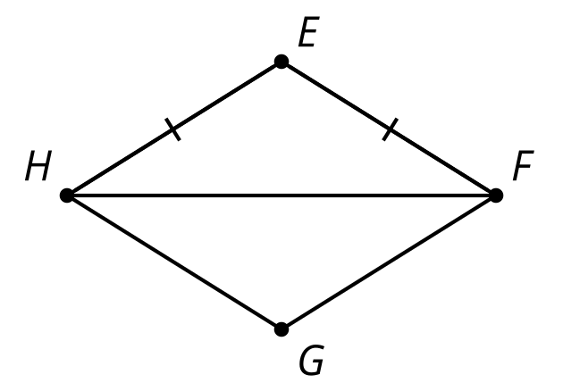
  - $EFGH$ is a rectangle.
  - $EFGH$ is a rhombus.
  - Diagonal $FH$ bisects angles $EFG$ and $EHG$.
  - Diagonal $FH$ is perpendicular to side $FE$.
  - Angle $EHF$ is congruent to angle $FGH$.
  - Angle $FEH$ is congruent to angle $FGH$.
- (From Unit 2, Lesson 1.)
- This design began from the construction of a regular hexagon.
  - Draw 1 segment so the diagram has another hexagon that is congruent to hexagon $ABCIHG$.
  - Explain why the hexagons are congruent.
- 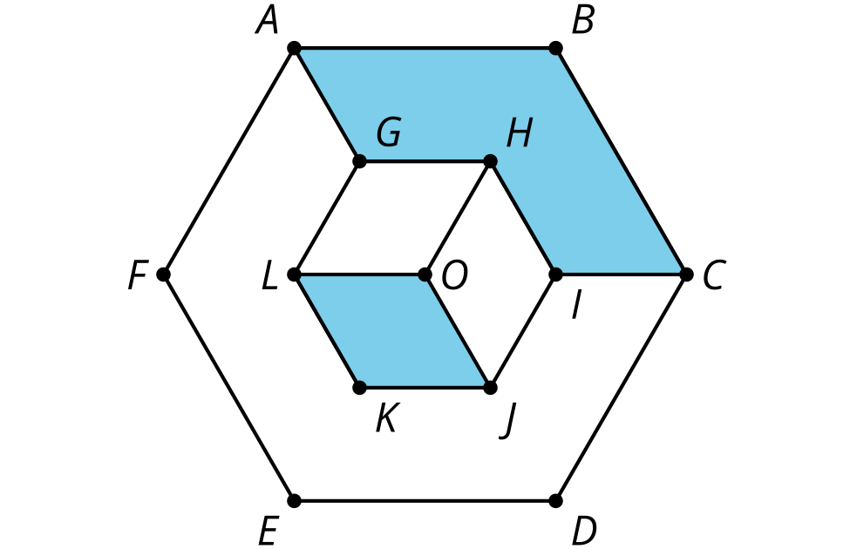
- (From Unit 1, Lesson 22.)
© CC BY 2019 by Illustrative Mathematics®

