Lesson 5: Construction Techniques 3: Perpendicular Lines and Angle Bisectors
- Let’s use tools to solve some construction challenges.

5.1: Two Circles
Points $A$ and $B$ are each at the centers of circles of radius $AB$.
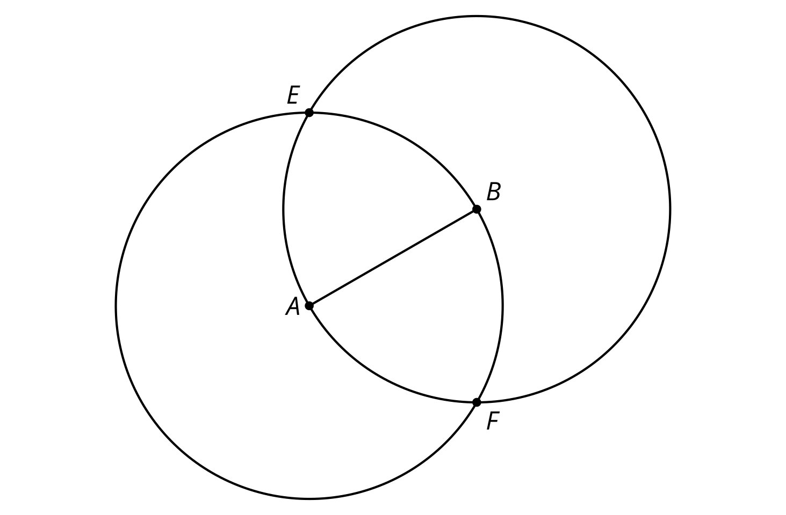
- Compare the distance $EA$ to the distance $EB$. Be prepared to explain your reasoning.
- Compare the distance $FA$ to the distance $FB$. Be prepared to explain your reasoning.
- Draw line $EF$ and write a conjecture about its relationship with segment $AB$.

5.2: Make It Right
Here is a line $ℓ$ with a point labeled $C$. Use straightedge and compass moves to construct a line perpendicular to $ℓ$ that goes through $C$.

5.3: Bisect This
Here is an angle:
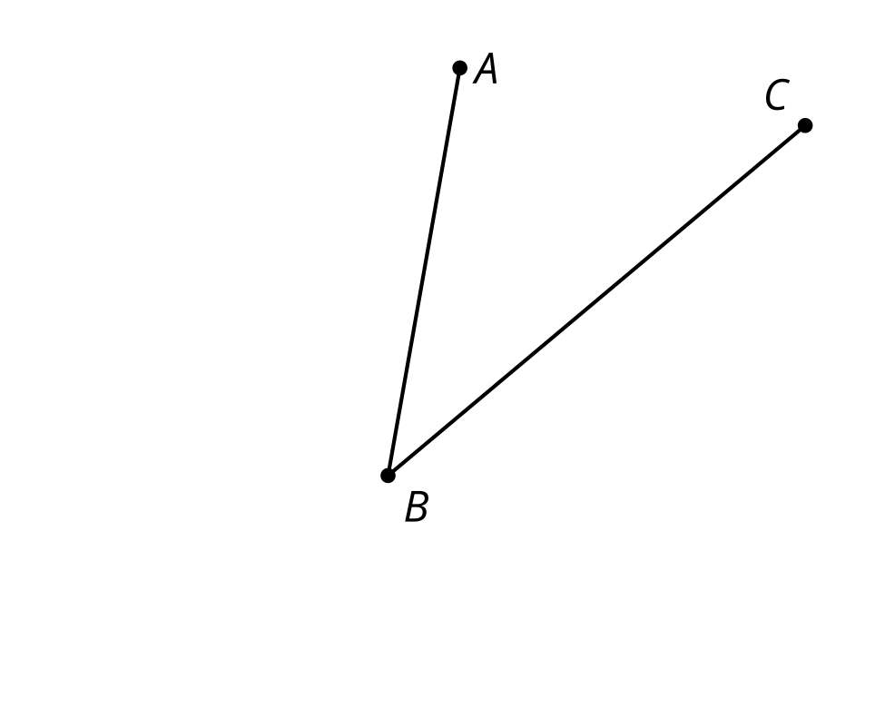
- Estimate the location of a point $D$ so that angle $ABD$ is approximately congruent to angle $CBD$.
- Use compass and straightedge moves to create a ray that divides angle $CBA$ into 2 congruent angles. How close is the ray to going through your point $D$?
- Take turns with your partner, drawing and bisecting other angles.
  - For each angle that you draw, explain to your partner how each straightedge and compass move helps you to bisect it.
  - For each angle that your partner draws, listen carefully to their explanation. If you disagree, discuss your thinking and work to reach an agreement.

Are you ready for more?
For thousands of years since the ancient Greeks started playing with straightedge and compass constructions, people strived to find a construction to trisect an arbitrary angle into three equal angles. Many claimed to have found such a construction, but there was always some flaw in their reasoning. Finally, in 1837, Pierre Wantzel used a new field of mathematics to prove it was impossible—which still did not stop some from claiming to have found a construction. If we allow other tools besides just a straightedge and compass, though, it is possible. For example, try this method of using origami (paper folding) to trisect an angle.
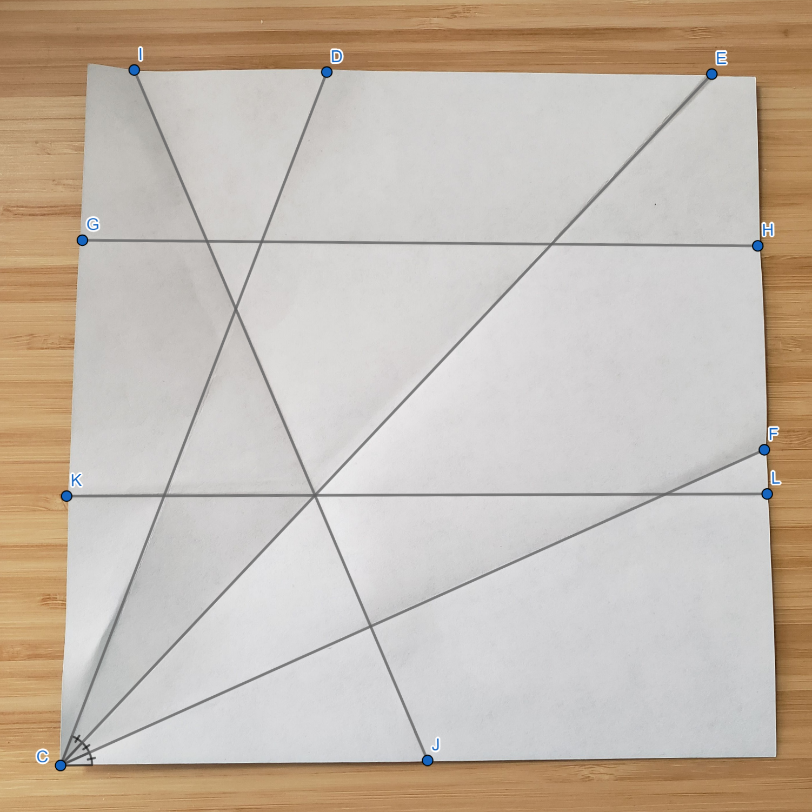
Video 'Trisecting an Angle with Origami' available here: https://player.vimeo.com/video/298418799.

Lesson 5 Summary
We can construct a line that is perpendicular to a given line. We can also bisect a given angle using only a straightedge and compass. The line that bisects an angle is called the angle bisector. Both constructions use 2 circles that go through each other’s centers:
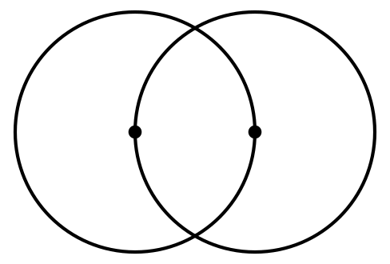
For the perpendicular line, start by finding 2 points on the line the same distance from the given point. Then create the 2 circles that go through each other’s centers. Connect the intersection points of those circles to draw a perpendicular line.
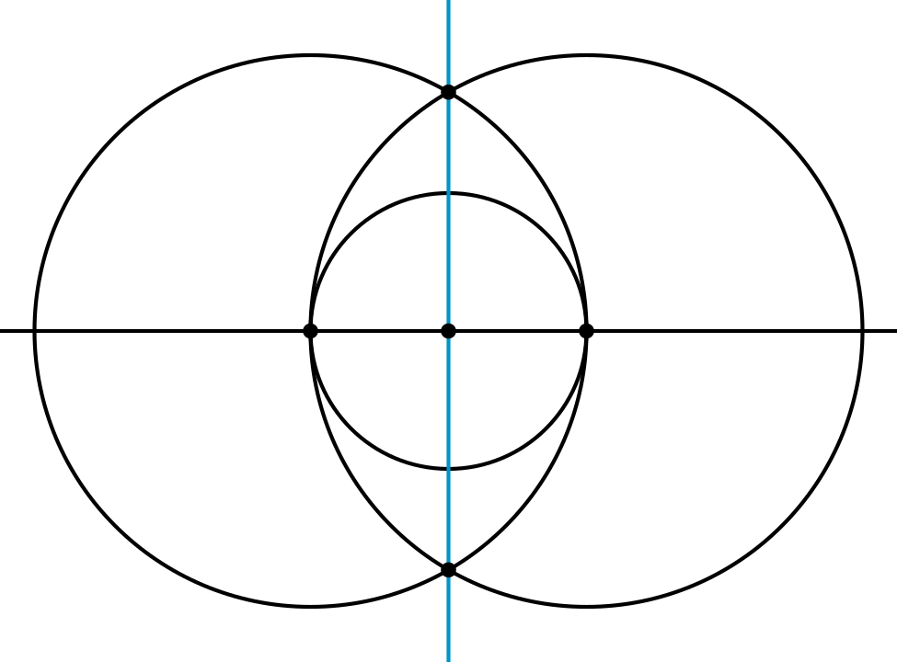
For the angle bisector, start by finding 2 points on the rays the same distance from the vertex. Then create the 2 circles that go through each other’s centers. Connect the intersection points of those circles to draw the angle bisector.
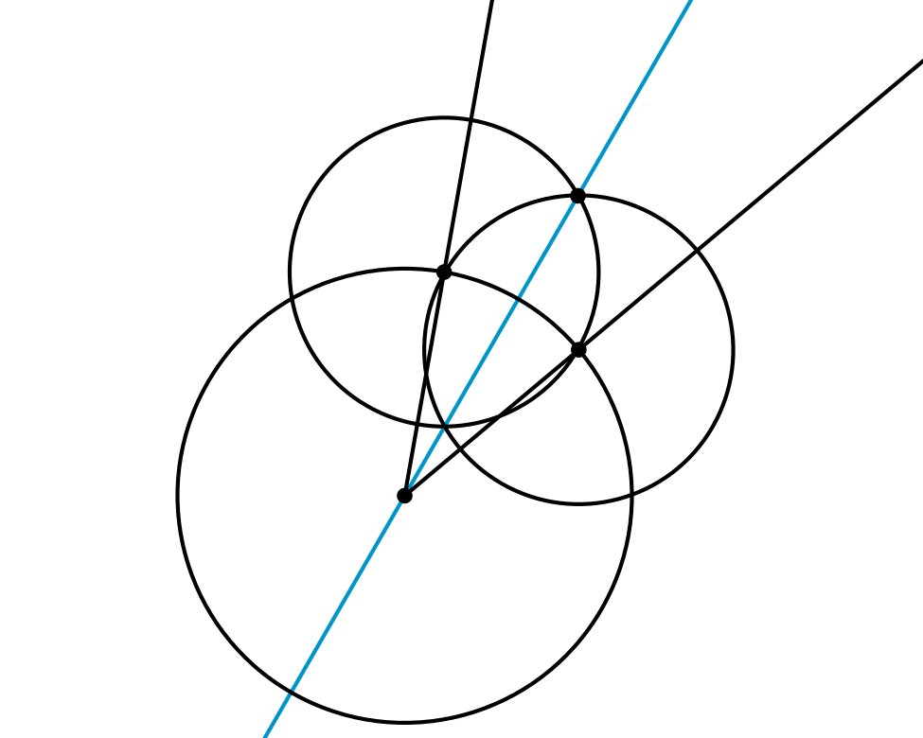
In fact, we can think of creating a perpendicular line as bisecting a 180 degree angle!
© CC BY 2019 by Illustrative Mathematics®

