Unit 3 Lesson 3: Exponents That Are Unit Fractions

1 Sometimes It’s Squared and Sometimes It’s Cubed (Warm up)

Student Task Statement
Find a solution to each equation.
- $x^{2}=25$
- $z^{2}=7$
- $y^{3}=8$
- $w^{3}=19$

2 To the...Half?

Student Task Statement
- Clare said, “I know that $9^{2}=9⋅9$, $9^{1}=9$, and $9^{0}=1$. I wonder what $9^{\frac{1}{2}}$ means?” First, she graphed $y=9^{x}$ for some whole number values of $x$, and estimated $9^{\frac{1}{2}}$ from the graph.
  - Graph the function yourself. What estimate do you get for $9^{\frac{1}{2}}$?
  - 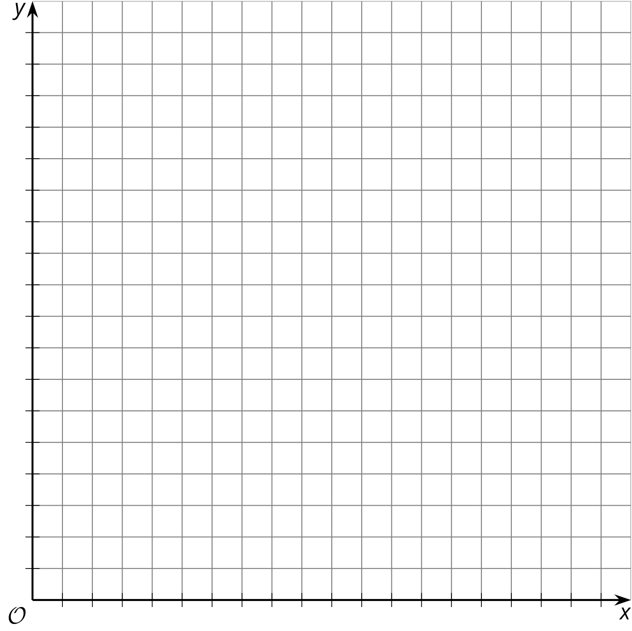
  - Using the properties of exponents, Clare evaluated $9^{\frac{1}{2}}⋅9^{\frac{1}{2}}$. What did she get?
  - For that to be true, what must the value of $9^{\frac{1}{2}}$ be?
- Diego saw Clare’s work and said, “Now I’m wondering about $3^{\frac{1}{2}}$.” First he graphed $y=3^{x}$ for some whole number values of $x$, and estimated $3^{\frac{1}{2}}$ from the graph.
  - Graph the function yourself. What estimate do you get for $3^{\frac{1}{2}}$?
  - Next he used exponent rules to find the value of ${\left(3^{\frac{1}{2}}\right)}^{2}$. What did he find?
  - Then he said, “That looks like a root!” What do you think he means?

3 Fraction of What, Exactly?

Student Task Statement
Use the exponent rules and your understanding of roots to find the exact value of:
- ${25}^{\frac{1}{2}}$
- ${15}^{\frac{1}{2}}$
- $8^{\frac{1}{3}}$
- $2^{\frac{1}{3}}$

4 Exponents and Radicals

Student Task Statement
Match each exponential expression to an equivalent expression.
- $7^{3}$
- $7^{2}$
- $7^{1}$
- $7^{0}$
- $7^{\text{-}1}$
- $7^{\text{-}2}$
- $7^{\text{-}3}$
- $7^{\frac{1}{2}}$
- $7^{\text{-}\frac{1}{2}}$
- $7^{\frac{1}{3}}$
- $7^{\text{-}\frac{1}{3}}$
- $\frac{1}{49}$
- $\frac{1}{343}$
- $\sqrt{7}$
- $\frac{1}{\sqrt[3]{7}}$
- $\sqrt[3]{7}$
- 49
- $\frac{1}{\sqrt{7}}$
- 343
- 7
- $\frac{1}{7}$
- 1

© CC BY 2019 by Illustrative Mathematics®

