Lesson 8: The $n^{\text{th}}$ Term
- Let’s see how to find terms of sequences directly.

8.1: Which One Doesn’t Belong: Repeated Operations
Which one doesn’t belong?
A. $5+2+2+2+2+2+2$
B. $5+6⋅2$
C. $5⋅2^{6}$
D. $5⋅2⋅2⋅2⋅2⋅2⋅2$

8.2: More Paper Slicing
- Clare takes a piece of paper with length 8 inches and width 10 inches and cuts it in half. Then she cuts it in half again, and again. . .
  - Instead of writing a recursive definition, Clare writes $C\left(n\right)=80⋅{\left(\frac{1}{2}\right)}^{n}$, where $C$ is the area, in square inches, of the paper after $n$ cuts. Explain where the different terms in her expression came from.
  - Approximately what is the area of the paper after 10 cuts?
- Kiran takes a piece of paper with length 8 inches and width 10 inches and cuts away one inch of the width. Then he does it again, and again. . .
  - Complete the table for the area of Kiran’s paper $K\left(n\right)$, in square inches, after $n$ cuts.
- $n$ | - $K\left(n\right)$
- 0 | - 80
  - 1
- 2 | - $80−8−8=80−8\left(2\right)=64$
  - 3
  - 4
  - 5
  - Kiran says the area after 6 cuts, in square inches, is $80−8⋅6$. Explain where the different terms in his expression came from.
  - Write a definition for $K\left(n\right)$ that is not recursive.
- Which is larger, $K\left(6\right)$ or $C\left(6\right)$?

8.3: A Sierpinski Triangle
A Sierpinski triangle can be created by starting with an equilateral triangle, breaking the triangle into 4 congruent equilateral triangles, and then removing the middle triangle. Starting from a single black equilateral triangle:
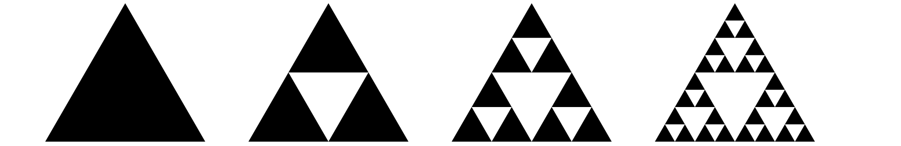
- Let $S$ be the number of black triangles in Step $n$. Define $S\left(n\right)$ recursively.
- Andre and Lin are asked to write an equation for $S$ that isn't recursive. Andre writes $S\left(n\right)=3^{n}$ for $n≥0$ while Lin writes $S\left(n\right)=3^{n−1}$ for $n≥1$. Whose equation do you think is correct? Explain or show your reasoning.

Are you ready for more?
Here is a geometric sequence. Find the missing terms.
3, ____, 6, ____, 12, ____, 24

Lesson 8 Summary
Here’s an arithmetic sequence $f$: 6, 10, 14, 18, 22, . . . . In this sequence, each term is 4 more than the previous term. One recursive definition of this sequence is $f\left(1\right)=6$, for $f\left(n\right)=f\left(n−1\right)+4$ for $n≥2$. We could also write $f\left(0\right)=6,$ $f\left(n\right)=f\left(n−1\right)+4,$ for $n≥1$ since it generates the same sequence. Neither of these definitions is better than the other, we just have to remember how we chose to define the “first term” of the sequence: $f\left(1\right)$ or $f\left(0\right)$. Let's use $f\left(1\right)$ for now.
While defining a sequence recursively works to calculate the current term from the previous, if we wanted to calculate, say, $f\left(100\right)$, it would mean calculating all the terms up to $f\left(99\right)$ to get there! Let's think of a better way.
Since we know that each term has an increasing number of fours, we could write the terms of $f$ organized in a table like the one shown here.
$n$ | $f\left(n\right)$
1 | $6+0=6+4\left(0\right)=6$
2 | $6+4=6+4\left(1\right)=10$
3 | $6+4+4=6+4\left(2\right)=14$
4 | $6+4+4+4=6+4\left(3\right)=18$
5 | $6+4+4+4+4=6+4\left(4\right)=22$
Looking carefully at the pattern in the table, we can say that for the $n^{\text{th}}$ term $f\left(n\right)=6+4\left(n−1\right)$ for $n≥1.$ This is sometimes called an explicit or closed-form definition of a sequence, but it's really just a way to calculate the value of the $n^{\text{th}}$ term without having to calculate all the terms that came before it. Need to know $f\left(100\right)$? Just compute $6+4\left(100−1\right).$ Defining an arithmetic sequence this way takes advantage of the fact that this type of sequence is a linear function with a starting value (in this case 6) and rate of change (in this case 4). If we had decided to start the sequence at $n=0$ so that $f\left(0\right)=6,$ we would have written the equation for the $n^{\text{th}}$ term as $f\left(n\right)=6+4\left(n\right)$ for $n≥0.$
Geometric sequences behave the same way, but with repeated multiplication. The geometric sequence $g$: 3, 15, 75, 375, . . . can be written as $3,3⋅5,3⋅5⋅5,3⋅5⋅5⋅5,...$ This means if $g\left(0\right)=3$, we can define the $n^{\text{th}}$ term directly as $g\left(n\right)=3⋅5^{n}.$
© CC BY 2019 by Illustrative Mathematics®

