Lesson 4: Construction Techniques 2: Equilateral Triangles
- Let’s identify what shapes are possible within the construction of a regular hexagon.

4.1: Notice and Wonder: Circles Circles Circles
What do you notice? What do you wonder?
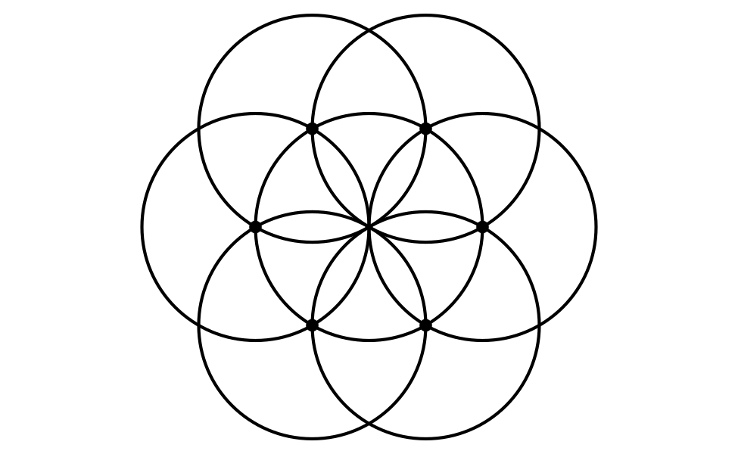

4.2: What Polygons Can You Find?
Here is a straightedge and compass construction of a regular hexagon inscribed in a circle just before the last step of drawing the sides:
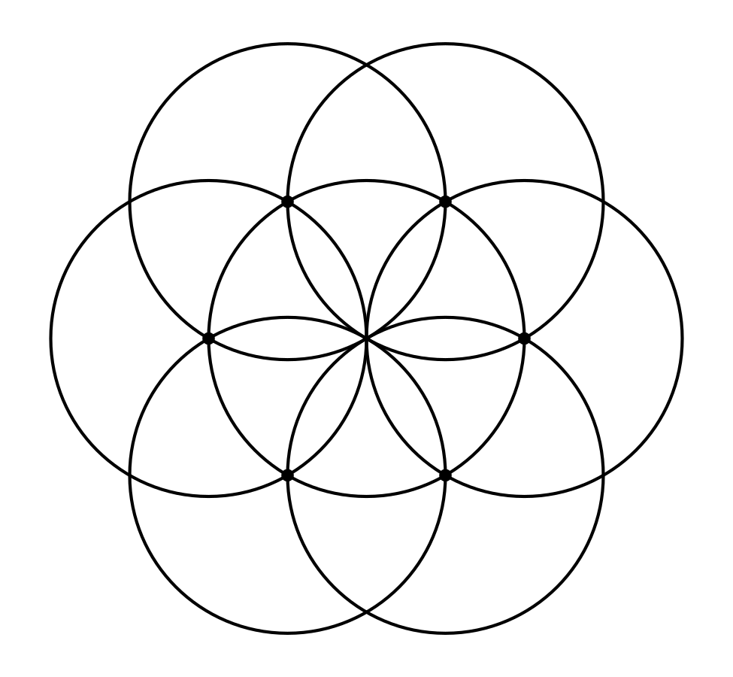
- Use a straightedge to draw at least 2 polygons on the figure. The vertices of your polygon should be intersection points in the figure. Lightly shade in your polygons using different colored pencils to make them easier to see.
- Write at least 2 conjectures about the polygons you made.

4.3: Spot the Equilaterals
Use straightedge and compass moves to construct at least 2 equilateral triangles of different sizes.

Are you ready for more?
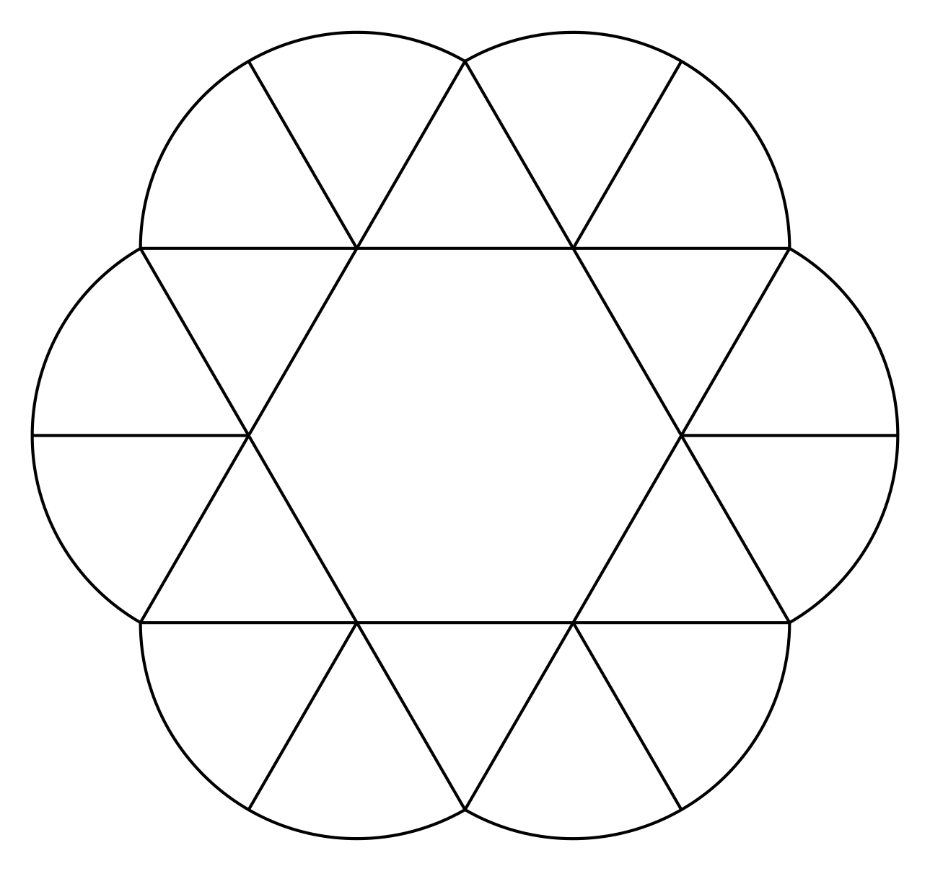
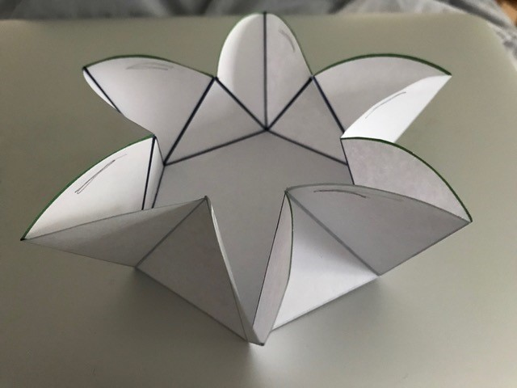
- Examine the figure carefully. What different shapes is it composed of? Be specific.
- Figure out how to construct the figure with a compass and straightedge.
- Then, cut it out, and see if you can fold it up into a container like this.

Lesson 4 Summary
The straightedge allows us to construct lines and line segments, and the compass allows us to make circles with a specific radius. With these tools, we can reason about distances to explain why certain shapes have certain properties. For example, when we construct a regular hexagon using circles of the same radius, we know all the sides have the same length because all the circles are the same size. The hexagon is called inscribed because it fits inside the circle and every vertex of the hexagon is on the circle.
Similarly, we could use the same construction to make an inscribed triangle. If we connect every other point around the center circle, it forms an equilateral triangle. We can conjecture that this triangle has 3 congruent sides and 3 congruent angles because the entire construction seems to stay exactly the same whenever it is rotated $\frac{1}{3}$ of a full turn around the center.
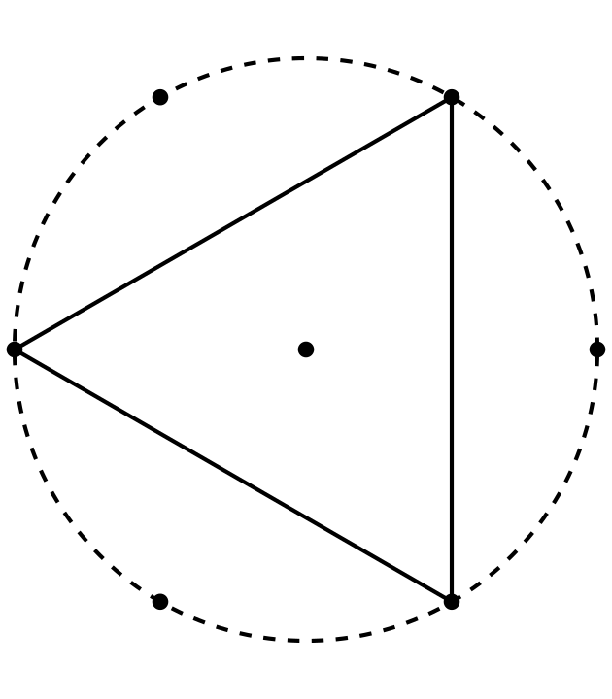
© CC BY 2019 by Illustrative Mathematics®

