Unit 3 Lesson 2: Square Roots and Cube Roots

1 It’s a Square (Warm up)

Student Task Statement
Find the area of square $ABCD$.
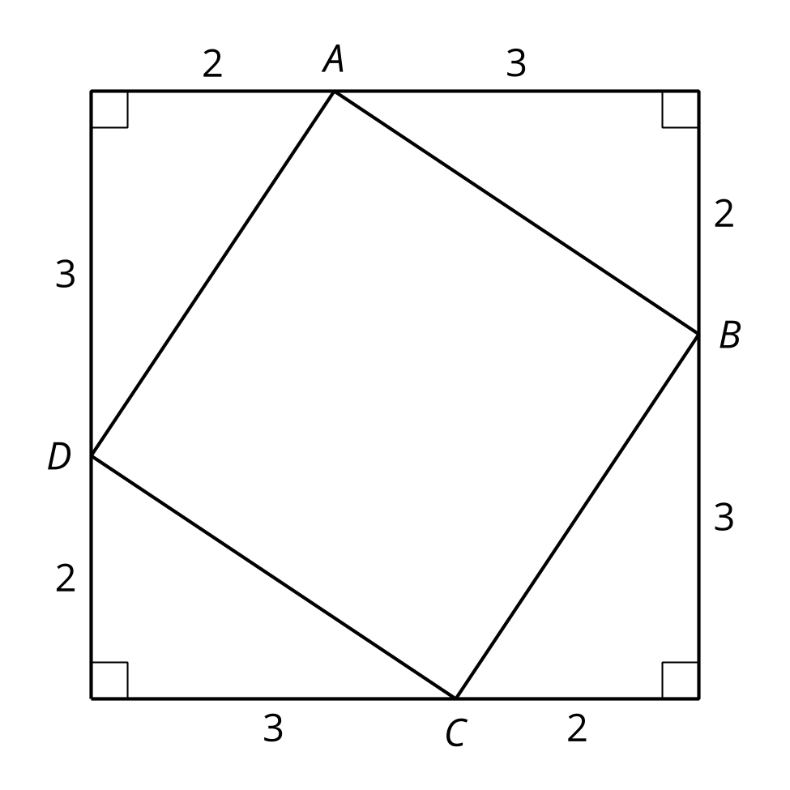

2 Squares and Their Side Lengths (Optional)

Student Task Statement
- Complete the table with the area of each square in square units, and its exact side length in units.
- 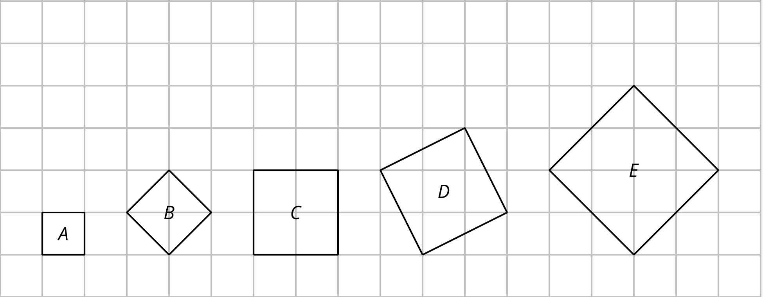
- figure | - A | - B | - C | - D | - E
- area
- side length
- This table includes areas in square units and side lengths in units of some more squares. Complete the table.
- area | - 9 |  | - 23 |  | - 89
- side length |  | - 4 |  | - 6.4

3 Cube It (Optional)

Student Task Statement
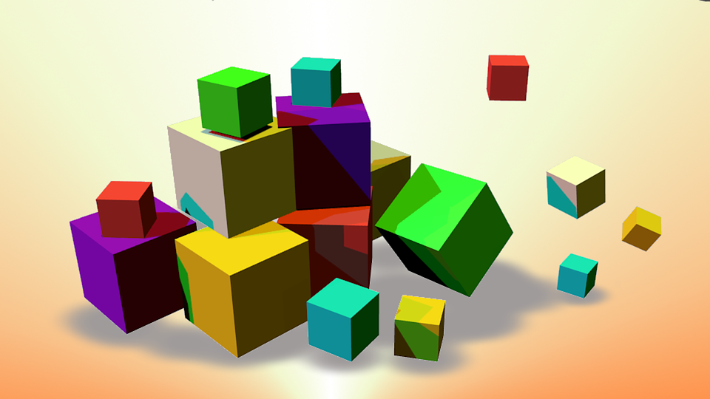
- A cube has edge length 3 units. What is the volume of the cube?
- A cube has edge length 4 units. What is the volume of the cube?
- A cube has volume 8 units. What is the edge length of the cube?
- A cube has volume 7 units. What is the edge length of the cube?
- $\sqrt[3]{1,​200}$ is between 10 and 11 because ${10}^{3}=1,​000$ and ${11}^{3}=1,​331$. Determine the whole numbers that each of these cube roots lies between:
- $\sqrt[3]{5}$ | - $\sqrt[3]{10}$ | - $\sqrt[3]{50}$ | - $\sqrt[3]{100}$ | - $\sqrt[3]{500}$

between | 1 and 2 | 2 and 3 | 3 and 4 | 4 and 5 | 5 and 6 | 6 and 7 | 7 and 8 | 8 and 9
© CC BY 2019 by Illustrative Mathematics®

