Lesson 7: Representing More Sequences
- Let's learn about Info Gaps

7.1: Which One Doesn’t Belong: Recursive Definitions
Which one doesn’t belong?
A. $f\left(1\right)=6$
$f\left(n\right)=f\left(n−1\right)−5$ for $n≥2$
B. $f\left(1\right)=6$
$f\left(n\right)=\frac{1}{2}⋅f\left(n−1\right)$ for $n≥2$
C. $f\left(0\right)=6$
$f\left(n\right)=10⋅f\left(n−1\right)$ for $n≥1$
D. $f\left(1\right)=6$
$f\left(n\right)=f\left(n−1\right)+n^{2}$ for $n≥2$

7.2: Info Gap: Ways To Represent A Sequence
Your teacher will give you either a problem card or a data card. Do not show or read your card to your partner.
If your teacher gives you the data card:
- Silently read the information on your card.
- Ask your partner “What specific information do you need?” and wait for your partner to ask for information. Only give information that is on your card. (Do not figure out anything for your partner!)
- Before telling your partner the information, ask “Why do you need to know (that piece of information)?”
- Read the problem card, and solve the problem independently.
- Share the data card, and discuss your reasoning.
If your teacher gives you the problem card:
- Silently read your card and think about what information you need to answer the question.
- Ask your partner for the specific information that you need.
- Explain to your partner how you are using the information to solve the problem.
- When you have enough information, share the problem card with your partner, and solve the problem independently.
- Read the data card, and discuss your reasoning.

Are you ready for more?
Make a visual pattern (for example, using dots or boxes), starting with Step 0, so the pattern for Step $n$ contains $n^{2}+3n+3$ dots.

Lesson 7 Summary
Sometimes we only need a little bit of information to say a lot about a function. Let's say we know the function $H$ is a geometric sequence with a growth factor of $\frac{2}{3}$ and a starting term of 20.25. From here, we can calculate that the terms in the sequence after 20.25 are 13.5, 9, 6, 4 and so on because in a geometric sequence we multiply the current term by the growth factor to get to the next term.
We can also make a table of values showing how the terms are calculated. Or we can make a graph, which would help us see that $H$ isn't linear if we didn't already know it is a geometric sequence.
$n$ | $H\left(n\right)$
1 | 20.25
2 | $20.25⋅\frac{2}{3}=13.5$
3 | $20.25⋅\frac{2}{3}⋅\frac{2}{3}=9$
4 | $20.25⋅\frac{2}{3}⋅\frac{2}{3}⋅\frac{2}{3}=6$
5 | $20.25⋅\frac{2}{3}⋅\frac{2}{3}⋅\frac{2}{3}⋅\frac{2}{3}=4$
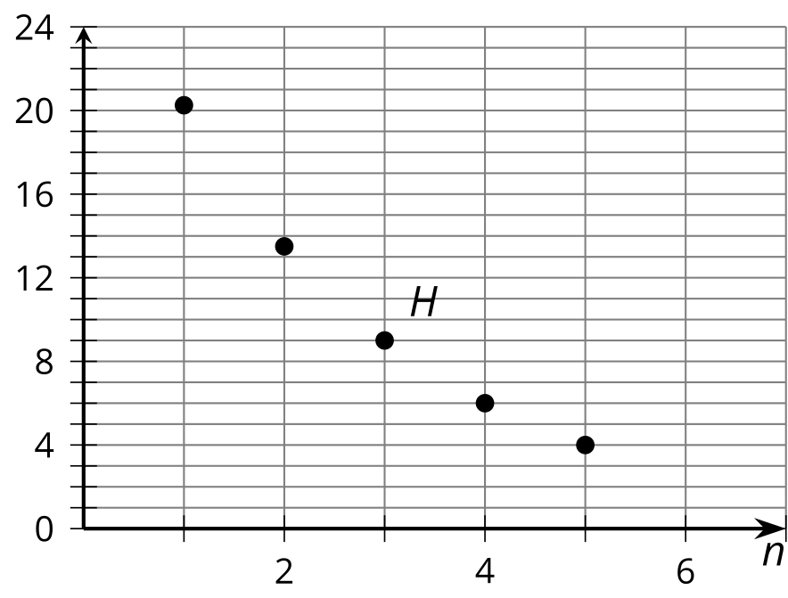
Using function notation, we can say that $H\left(1\right)=20.25,H\left(n\right)=H\left(n−1\right)⋅\frac{2}{3}$ for $n≥2.$
© CC BY 2019 by Illustrative Mathematics®

