Unit 3 Lesson 11: Splitting Triangle Sides with Dilation, Part 2

1 Notice and Wonder: Parallel Segments (Warm up)

Student Task Statement
What do you notice? What do you wonder?

$\overset{↔}{AC}∥\overset{↔}{MN}$
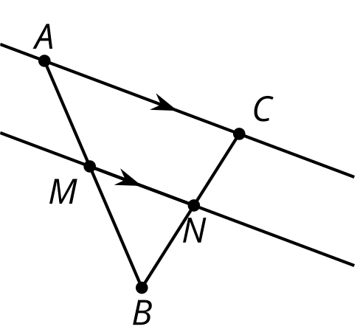

2 Prove It: Parallel Segments

Student Task Statement
Does a line parallel to one side of a triangle always create similar triangles?
- Create several examples. Decide if the conjecture is true or false. If it’s false, make a more specific true conjecture.
- Find any additional information you can be sure is true.
Label it on the diagram.

- $\overset{↔}{AC}∥\overset{↔}{MN}$
- Write an argument that would convince a skeptic that your conjecture is true.

3 Preponderance of Proportional Relationships

Student Task Statement
Find the length of each unlabelled side.
- Segments $AB$ and $EF$ are parallel.

- $\overset{¯}{AB}∥\overset{¯}{EF},\overset{¯}{AD}⊥\overset{¯}{DB}$
- 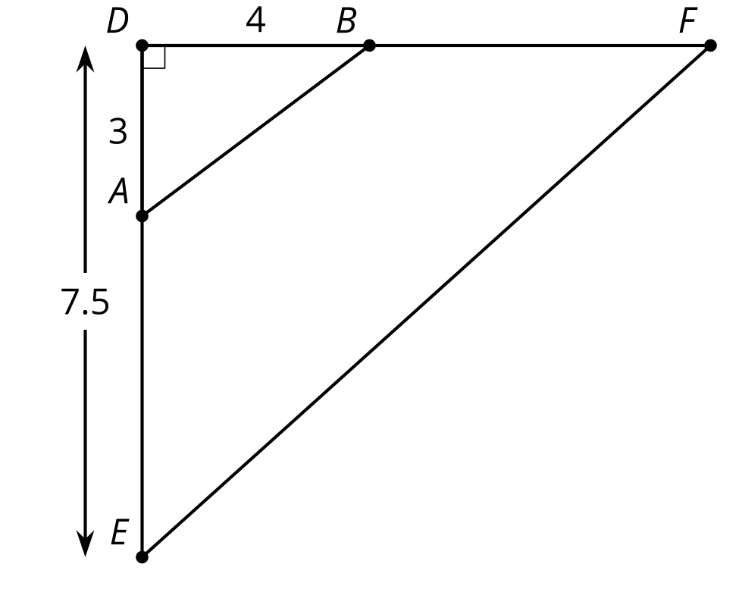
- Segments $BD$ and $FG$ are parallel. Segment $EG$ is 12 units long. Segment $EB$ is 2.5 units long.

- $\overset{¯}{BD}∥\overset{¯}{FG}$
- 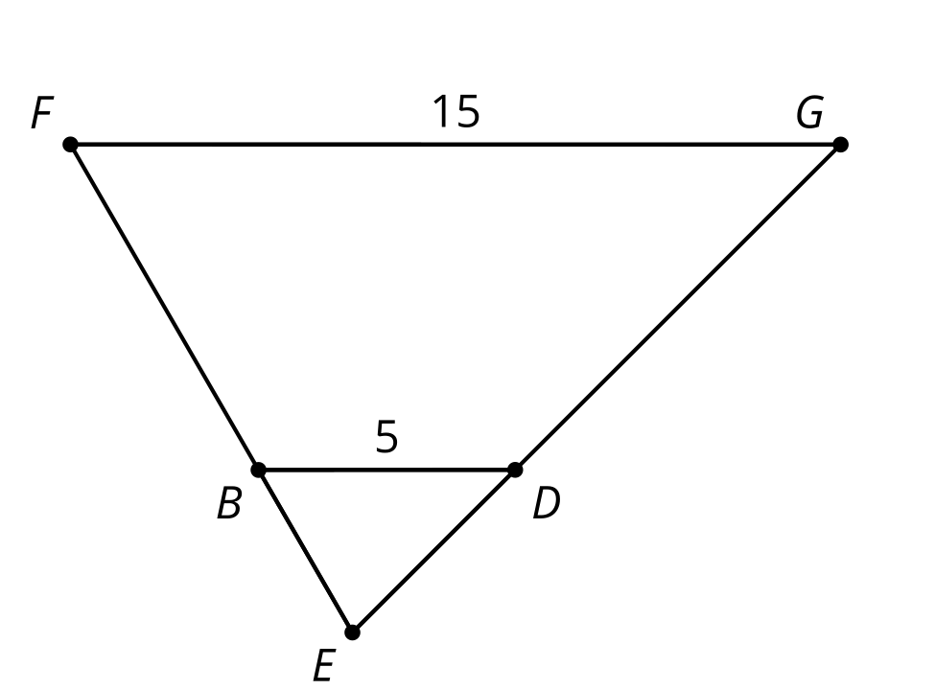
© CC BY 2019 by Illustrative Mathematics®

