Lesson 3: Construction Techniques 1: Perpendicular Bisectors
- Let’s explore equal distances.

3.1: Find All the Points!
Here are 2 points labeled $A$ and $B$, and a line segment $CD$:
- Mark 5 points that are a distance $CD$ away from point $A$. How could you describe all points that are a distance $CD$ away from point $A$?
- Mark 5 points that are a distance $CD$ away from point $B$. How could you describe all points that are a distance $CD$ away from point $B$?
- In a different color, mark all the points that are a distance $CD$ away from both $A$ and $B$ at the same time.

3.2: Human Perpendicular Bisector
Your teacher will mark points $A$ and $B$ on the floor. Decide where to stand so you are the same distance from point $A$ as you are from point $B$. Think of another place you could stand in case someone has already taken that spot.
After everyone sits down, draw a diagram of what happened.

Are you ready for more?
In this activity, we thought about the set of points on the floor—a two-dimensional plane—that were equidistant from two given points $A$ and $B$. What would happen if we didn’t confine ourselves to the floor? Start with two points $A$ and $B$ in three-dimensional space. What would the set of points equidistant from $A$ and $B$ look like?

3.3: How Well Can You Slice It?
Use the tools available to find the perpendicular bisector of segment $PQ$.
After coming up with a method, make a copy of segment $PQ$ on tracing paper and look for another method to find its perpendicular bisector.
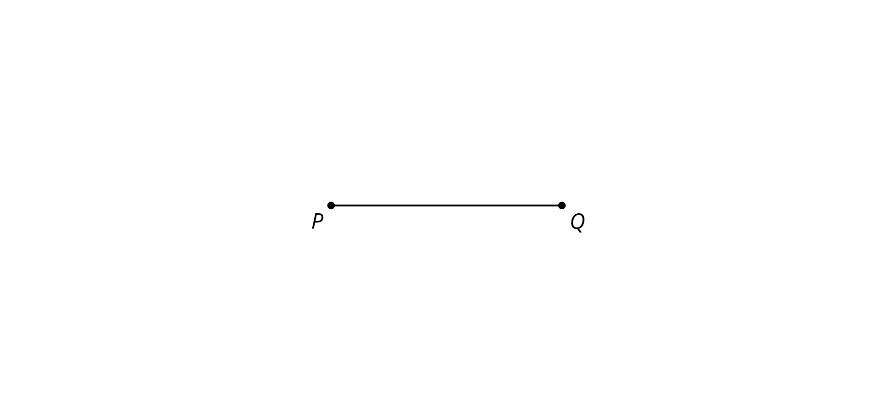

Lesson 3 Summary
A perpendicular bisector of a segment is a line through the midpoint of the segment that is perpendicular to it. Recall that a right angle is the angle made when we divide a straight angle into 2 congruent angles. Lines that intersect at right angles are called perpendicular.
A conjecture is a guess that hasn't been proven yet. We conjectured that the perpendicular bisector of segment $AB$ is the set of all points that are the same distance from $A$ as they are from $B$. This turns out to be true. The perpendicular bisector of any segment can be constructed by finding points that are the same distance from the endpoints of the segment. Intersecting circles centered at each endpoint of the segment can be used to find points that are the same distance from each endpoint, because circles show all the points that are a given distance from their center point.
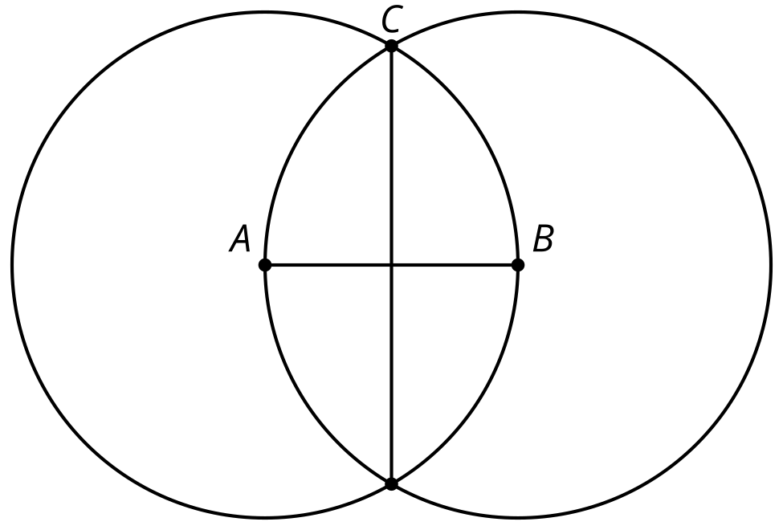
© CC BY 2019 by Illustrative Mathematics®

