Unit 5 Lesson 21: Predicting Populations

1 Notice and Wonder: Changing Populations (Warm up)

Student Task Statement
Here are the populations of three cities during different years.
City | 1950 | 1960 | 1970 | 1980 | 1990 | 2000
Paris | 6,300,000 | 7,400,000 | 8,200,000 | 8,700,000 | 9,300,000 | 9,700,000
Austin | 132,000 | 187,000 | 254,000 | 346,000 | 466,000 | 657,000
Chicago | 3,600,000 | 3,550,000 | 3,400,000 | 3,000,000 | 2,800,000 | 2,900,000
What do you notice? What do you wonder?

2 Population Predictions 1

Student Task Statement
Here are population data for three cities at different times between 1950 and 2000. What does the data tell us, if anything, about the current population in the cities or what the population will be in 2050?
City | 1950 | 1960 | 1970 | 1980 | 1990 | 2000
Paris | 6,300,000 | 7,400,000 | 8,200,000 | 8,700,000 | 9,300,000 | 9,700,000
Austin | 132,000 | 187,000 | 254,000 | 346,000 | 466,000 | 657,000
Chicago | 3,600,000 | 3,550,000 | 3,400,000 | 3,000,000 | 2,800,000 | 2,900,000
- How would you describe the population change in each city during this time period? Write one to two sentences for each city. Then discuss with your group.
- What kind of model, linear or exponential, both, or neither do you think is appropriate for each city population?
- For each population that you think can be modeled by a linear and or exponential function:
  - Write an equation for the function(s).
  - Graph the function(s).
- Compare the graphs of your functions with the actual population data. How well do the models fit the data?

  - Use your models to predict the population in each city in 2010, the current year, and 2050.
  - Do you think that these predictions are (or will be) accurate? Explain your reasoning.

3 Population Predictions 2

Student Task Statement
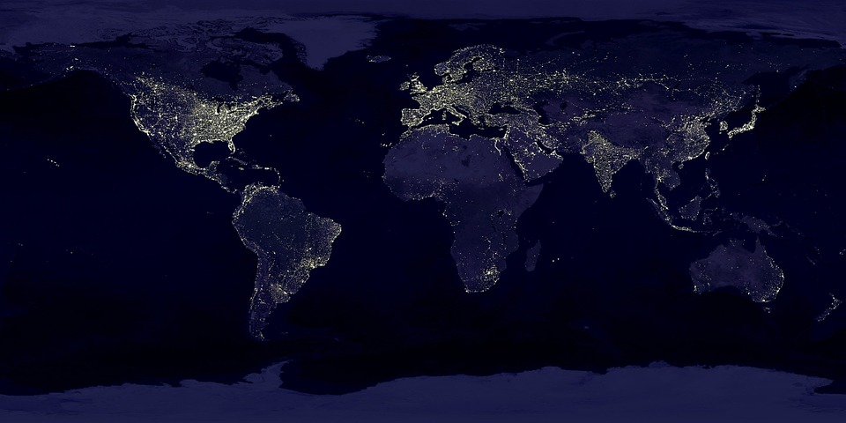
year | 1804 | 1927 | 1960 | 1974 | 1987 | 1999 | 2011
world population in billions | 1 | 2 | 3 | 4 | 5 | 6 | 7
- Would a linear function be appropriate for modeling the world population growth over the last 200 years? Explain. If you think it is appropriate, find a linear model.
- Would an exponential function be appropriate for modeling the world population growth over the last 200 years? Explain. If you think it is appropriate, find an exponential model.
- From 1950 to the present day, by about what percentage has the world population grown each year?
- From 1950 to the present day, by about how many people has the world population grown each year?
- If the growth trend continues, what will the world population be in 2050? How long do you think the growth will continue? Explain your reasoning.
© CC BY 2019 by Illustrative Mathematics®

