Lesson 9: Increasing and Decreasing Functions
- Let’s look at what a graph does based on a situation.

9.1: Comparing Values
For each pair of numbers, write $=,<$, or $>$ in the blank to make a true equation or inequality. Be prepared to share your reasoning.
- -6 $\underset{_}{​}$ -9
- $\frac{7}{3} \underset{_}{​} \frac{13}{6}$
- 5.2 $\underset{_}{​} \frac{53}{11}$
- $5\left(3−6\right) \underset{_}{​} 15−6$
- Let $f\left(x\right)=5−2x$.
  - $f\left(3\right) \underset{_}{​} f\left(5\right)$
  - $f\left(\text{-}3\right) \underset{_}{​} f\left(\text{-}4\right)$
  - $f\left(\text{-}1\right) \underset{_}{​} f\left(1\right)$

9.2: What Could It Be?
Describe $f\left(x\right)$ and $g\left(x\right)$ with a situation that could fit the given graphs. Explain your reasoning.
- 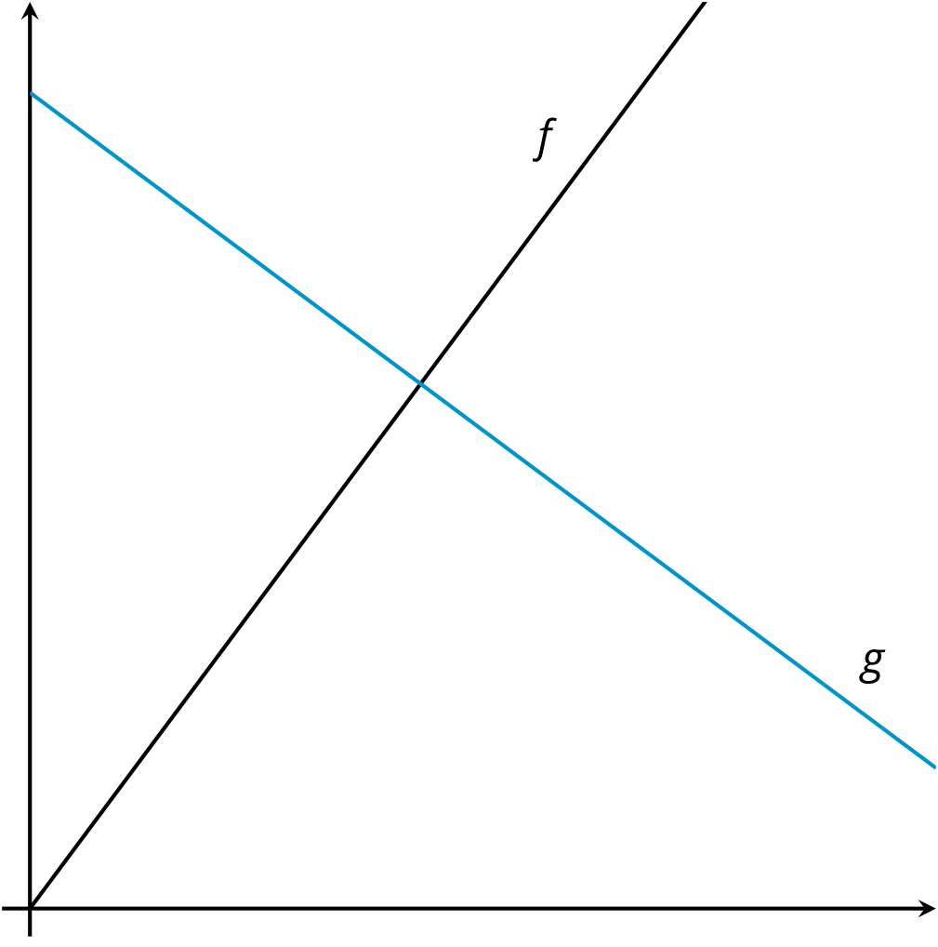
- 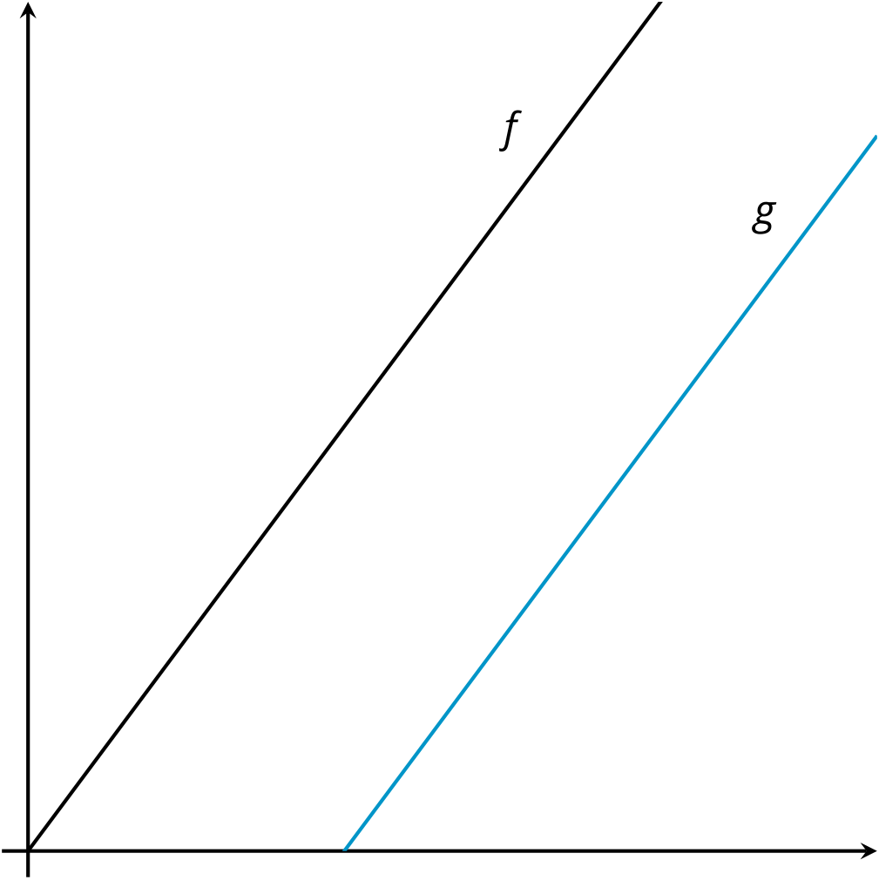
- 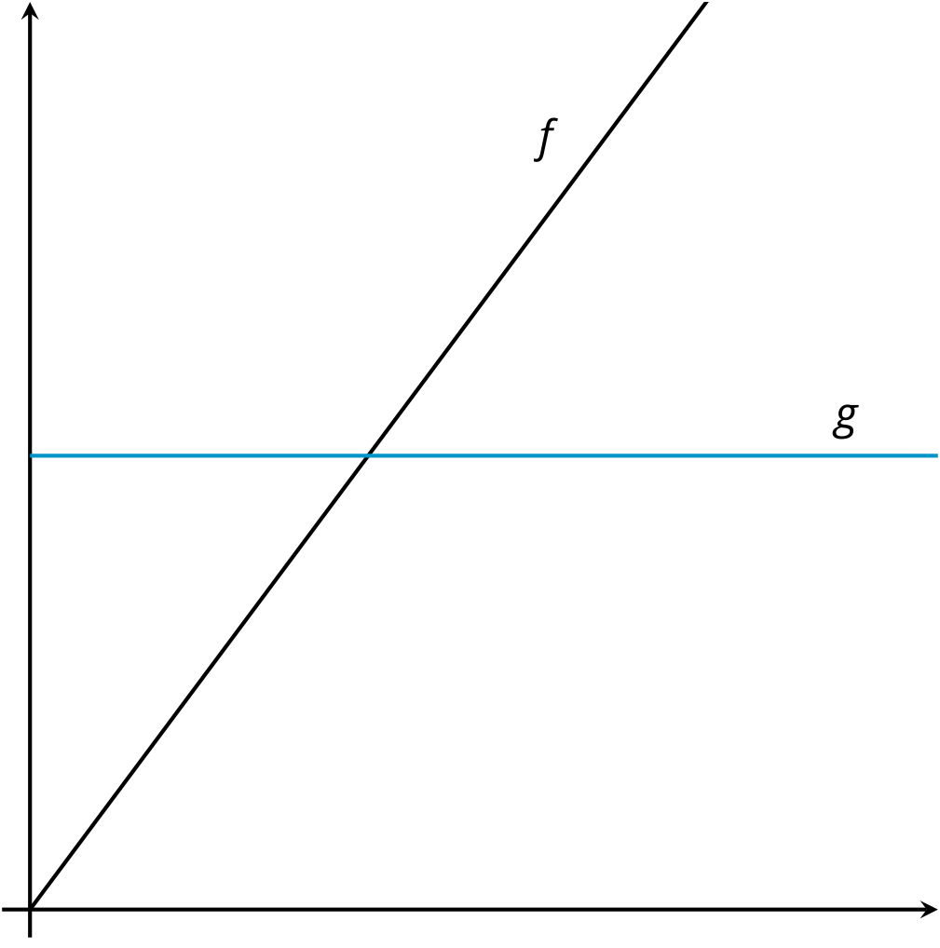
- 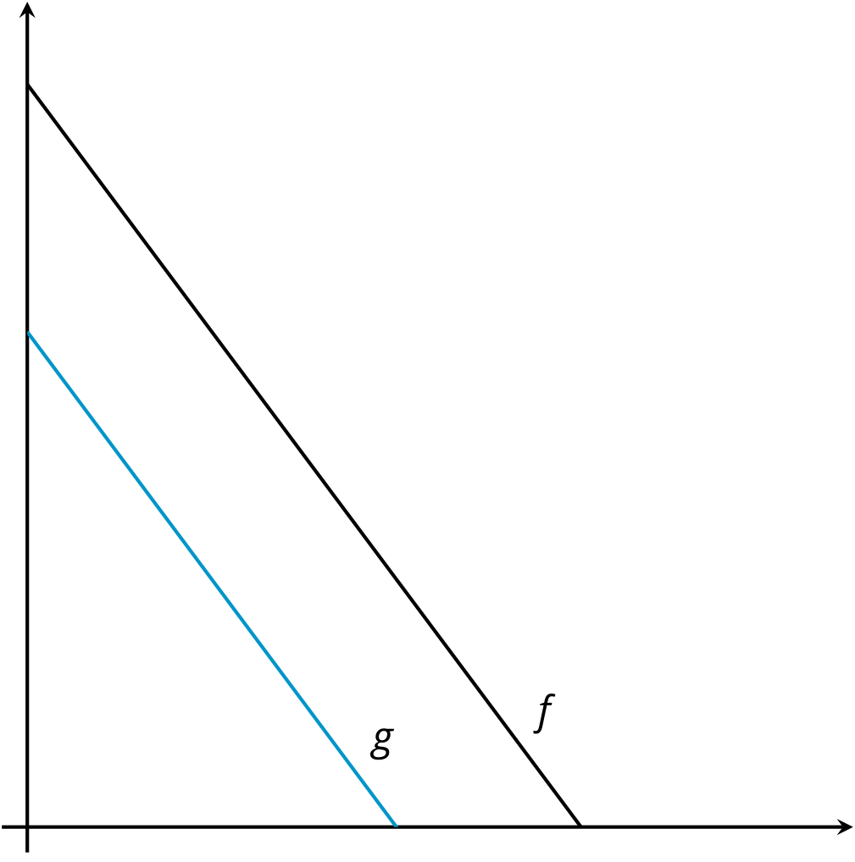

9.3: Cities, Towns, and Villages
Draw an example of a graph that shows two functions as they are described. Make sure to label the functions.
- The population of 2 cities as functions of time so that city A always has more people than city B.
- 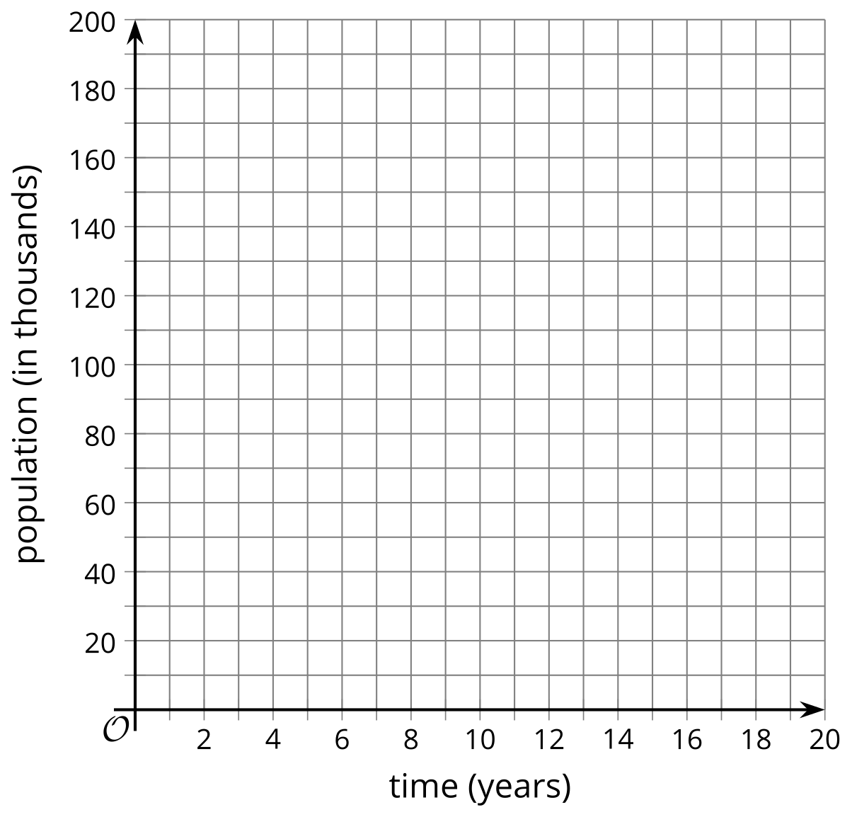
- The population of 2 towns as functions of time so that town A is larger to start, but then town B gets larger.
- The population of 2 villages as functions of time so that village A has a steady population and village B has a population that is initially large, but decreases.
© CC BY 2019 by Illustrative Mathematics®

