Unit 7 Lesson 7: Changing Elevation

1 That's the Opposite (Warm up)

Student Task Statement
- Draw arrows on a number line to represents these situations:​
  - The temperature was -5 degrees. Then the temperature rose 5 degrees.
  - ​
  - A climber was 30 feet above sea level. Then she descended 30 feet.
  - ​
- What’s the opposite?
  - Running 150 feet east.
  - Jumping down 10 steps.
  - Pouring 8 gallons into a fish tank.

2 Cliffs and Caves

Student Task Statement
- A mountaineer is climbing on a cliff. She is 400 feet above the ground. If she climbs up, this will be a positive change. If she climbs down, this will be a negative change.
  - Complete the table.
 | - starting  elevation  (feet) | - change  (feet) | - final  elevation  (feet)
- A | - +400 | - 300 up
- B | - +400 | - 150 down
- C | - +400 | - 400 down
- D | - +400 |  | - +50
  - 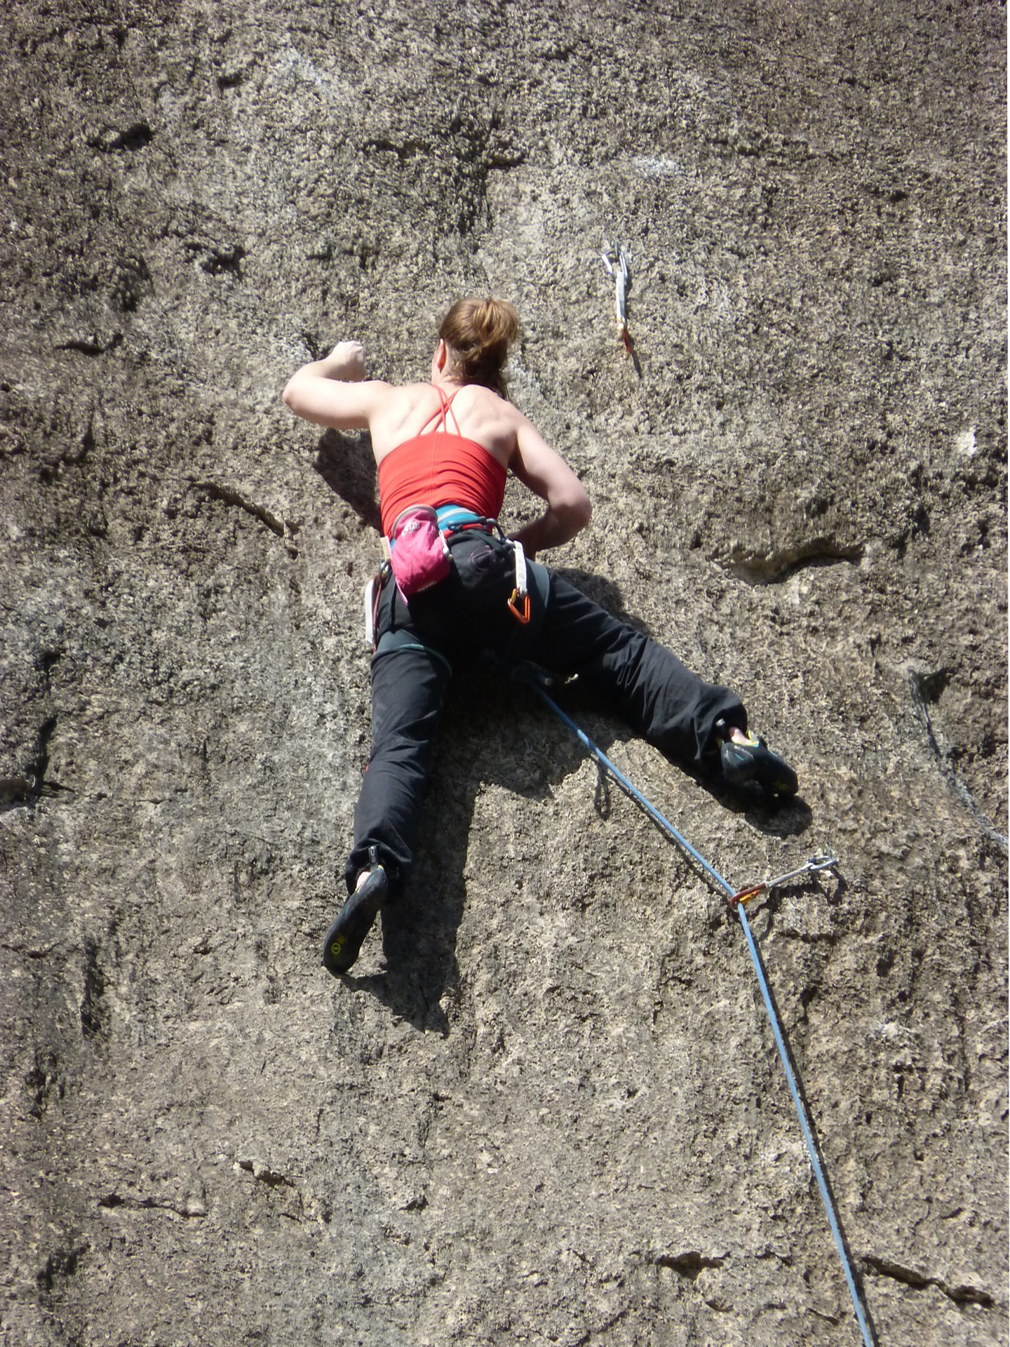
  - Write an addition equation and draw a number line diagram for B. Include the starting elevation, change, and final elevation in your diagram.
  - ​
- A spelunker is down in a cave next to the cliff. If she climbs down deeper into the cave, this will be a negative change. If she climbs up, whether inside the cave or out of the cave and up the cliff, this will be a positive change.
  - Complete the table.
 | - starting elevation  (feet) | - change  (feet) | - final elevation  (feet)
- A | - -200 | - 150 down
- B | - -200 | - 100 up
- C | - -200 | - 200 up
- D | - -200 | - 250 up
- E | - -200 |  | - -500
  - Write an addition equation and draw a number line diagram for C and D. Include the starting elevation, change, and final elevation in your diagram.
  - ​
  - ​
  - What does the expression $\text{-}75+100$ tell us about the spelunker? What does the value of the expression tell us?

3 Adding Rational Numbers

Student Task Statement
Find the sums.
- $\text{-}35+\left(30+5\right)$
- $\text{-}0.15+\left(\text{-}0.85\right)+12.5$
- $\frac{1}{2}+\left(\text{-}\frac{3}{4}\right)$

4 School Supply Number Line (Optional)

Student Task Statement
Your teacher will give you a long strip of paper.
Follow these instructions to create a number line.
- Fold the paper in half along its length and along its width.
- Unfold the paper and draw a line along each crease.
- Label the line in the middle of the paper 0. Label the right end of the paper $+$ and the left end of the paper $−$.
- Select two objects of different lengths, for example a pen and a gluestick. The length of the longer object is $a$ and the length of the shorter object is $b$.
- Use the objects to measure and label each of the following points on your number line.
- $a$
- $b$
- $2a$
- $2b$
- $a+b$
- $\text{-}a$
- $\text{-}b$
- $a+\text{-}b$
- $b+\text{-}a$
- Complete each statement using <, >, or =. Use your number line to explain your reasoning.
  - $a$ _____ $b$
  - $\text{-}a$ _____ $\text{-}b$
  - $a+\text{-}a$ _____ $b+\text{-}b$
  - $a+\text{-}b$ _____ $b+\text{-}a$
  - $a+\text{-}b$ _____ $\text{-}a+b$
© CC BY Open Up Resources. Adaptations CC BY IM.

