Lesson 5: Sequences are Functions
- Let's learn how to define a sequence recursively.

5.1: Bowling for Triangles (Part 1)
Describe how to produce one step of the pattern from the previous step.
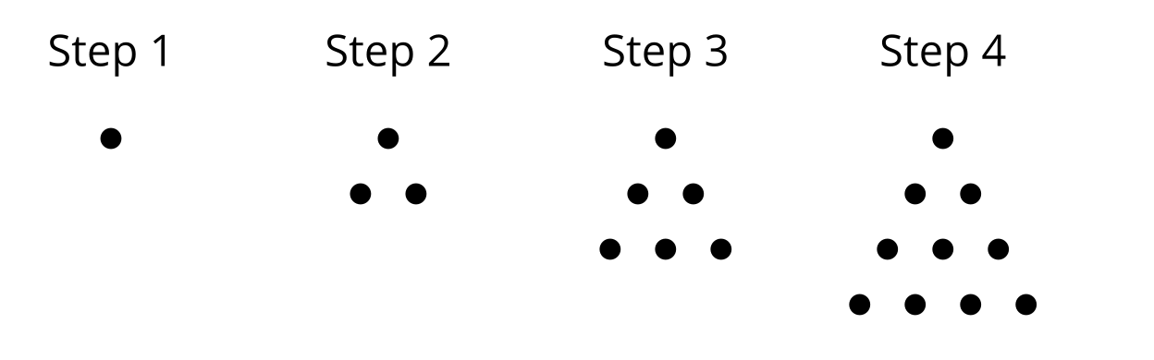

5.2: Bowling for Triangles (Part 2)
Here is a visual pattern of dots. The number of dots $D\left(n\right)$ is a function of the step number $n$.
- What values make sense for $n$ in this situation? What values don't make sense for $n$?
- Complete the table for Steps 1 to 5.
- $n$ | - $D\left(n\right)$
- 1 | - 1
- 2 | - $D\left(1\right)+2=3$
- 3 | - $D\left(2\right)+3=6$
- 4
- 5
- Following the pattern in the table, write an equation for $D\left(n\right)$ in terms of the previous step. Be prepared to explain your reasoning.

Are you ready for more?
Consider the same triangular pattern.
- Is the sequence defined by the number of dots in each step arithmetic, geometric, or neither? Explain how you know.
- Can you write an expression for the number of dots in Step $n$ without using the value of $D$ from a previous step?

5.3: Let's Define Some Sequences
Use the first 5 terms of each sequence to state if the sequence is arithmetic, geometric, or neither. Next, define the sequence recursively using function notation.
- $A$: 30, 40, 50, 60, 70, . . .
- $B$: 80, 40, 20, 10, 5, 2.5, . . .
- $C$: 1, 2, 4, 8, 16, 32, . . .
- $D$: $1,\frac{1}{2},\frac{1}{4},\frac{1}{8},\frac{1}{16},$ . . .
- $E$: 20, 13, 6, -1, -8, . . .
- $F$: 1, 3, 7, 15, 31, . . .

Lesson 5 Summary
Sometimes we can define a sequence recursively. That is, we can describe how to calculate the next term in a sequence if we know the previous term.
Here’s a sequence: 6, 10, 14, 18, 22, . . . This is an arithmetic sequence, where each term is 4 more than the previous term. Since sequences are functions, let's call this sequence $f$ and then we can use function notation to write $f\left(n\right)=f\left(n−1\right)+4$. Here, $f\left(n\right)$ is the term, $f\left(n−1\right)$ is the previous term, and + 4 represents the rate of change since $f$ is an arithmetic sequence.
When we define a function recursively, we also must say what the first term is. Without that, there would be no way of knowing if the sequence defined by $f\left(n\right)=f\left(n−1\right)+4$ started with 6 or 81 or any other number. Here, one possible initial condition is $f\left(1\right)=6$. (It could also make sense to number the terms starting with 0, using $f\left(0\right)=6,$ and we'll talk more about this later.)
Combining this information gives the recursive definition: $f\left(1\right)=6$ and $f\left(n\right)=f\left(n−1\right)+4$ for $n≥2$, where $n$ is an integer. We include the $n≥2$ at the end since the value of $f$ at 1 is already given and the other terms in the sequence are generated by inputting integers larger than 1 into the definition.
© CC BY 2019 by Illustrative Mathematics®

