Unit 3 Lesson 9: Conditions for Triangle Similarity

1 Math Talk: Angle-Side-Angle As A Helpful Tool (Warm up)

Student Task Statement
How could you justify each statement?
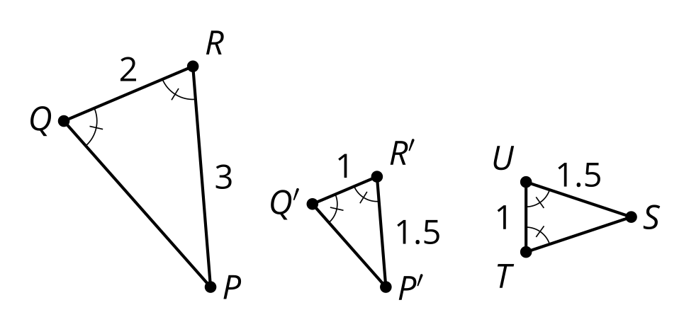
Triangle $P^{′}Q^{′}R^{′}$ is congruent to triangle $STU$.
Triangle $PQR$ is similar to triangle $STU$.
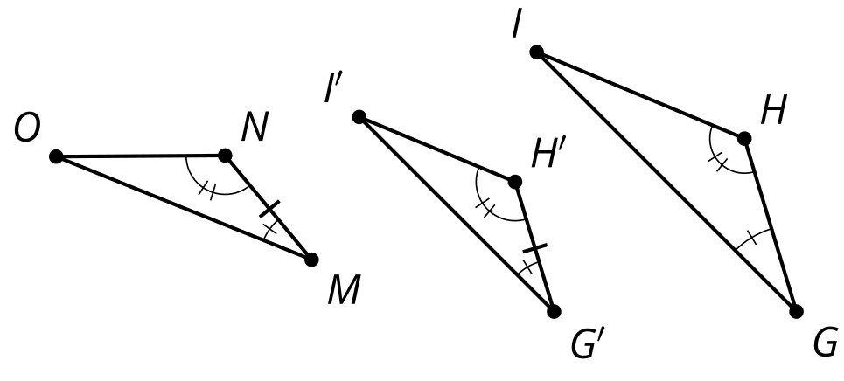
Triangle $G^{′}H^{′}I^{′}$ is congruent to triangle $MNO$.
Triangle $GHI$ is similar to triangle $MNO$.

2 How Many Pieces?

Student Task Statement
For each problem, draw 2 triangles that have the listed properties. Try to make them as different as possible.
- One angle is 45 degrees.
- One angle is 45 degrees and another angle is 30 degrees.
- One angle is 45 degrees and another angle is 30 degrees. The lengths of a pair of corresponding sides are 2 cm and 6 cm.
- Compare your triangles with your neighbors’ triangles. Which ones seem to be similar no matter what?
- Prove your conjecture.

Activity Synthesis

$∠A≅∠C,∠DEA≅∠BEC,$ so $△DEA∼△BEC$
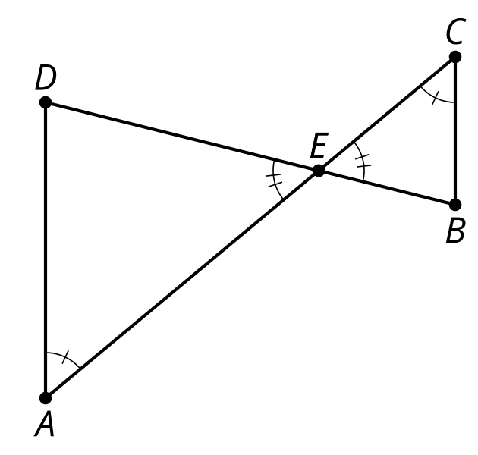

3 Any Two Angles?

Student Task Statement
Here are 2 triangles. One triangle has a 60 degree angle and a 40 degree angle. The other triangle has a 40 degree angle and an 80 degree angle.
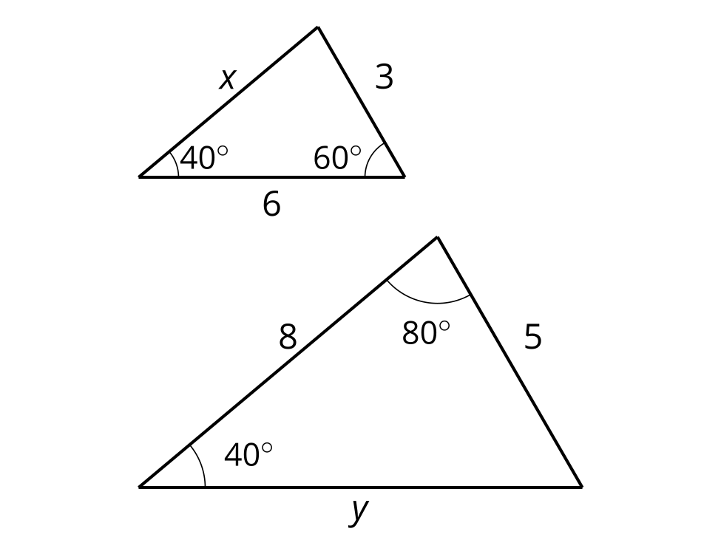
- Explain how you know the triangles are similar.
- How long are the sides labeled $x$ and $y$?
© CC BY 2019 by Illustrative Mathematics®

