Lesson 17: Number of Solutions in One-Variable Equations
- Let's look at the number of solutions an equation may have.

17.1: Notice and Wonder: Three Graphs
What do you notice? What do you wonder?
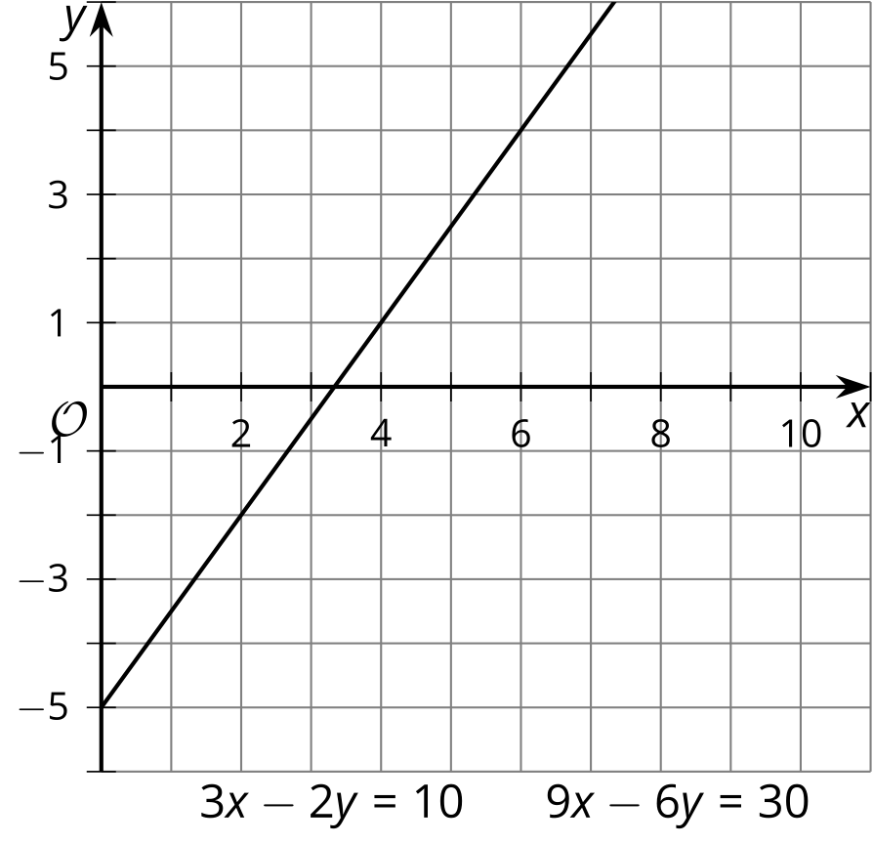
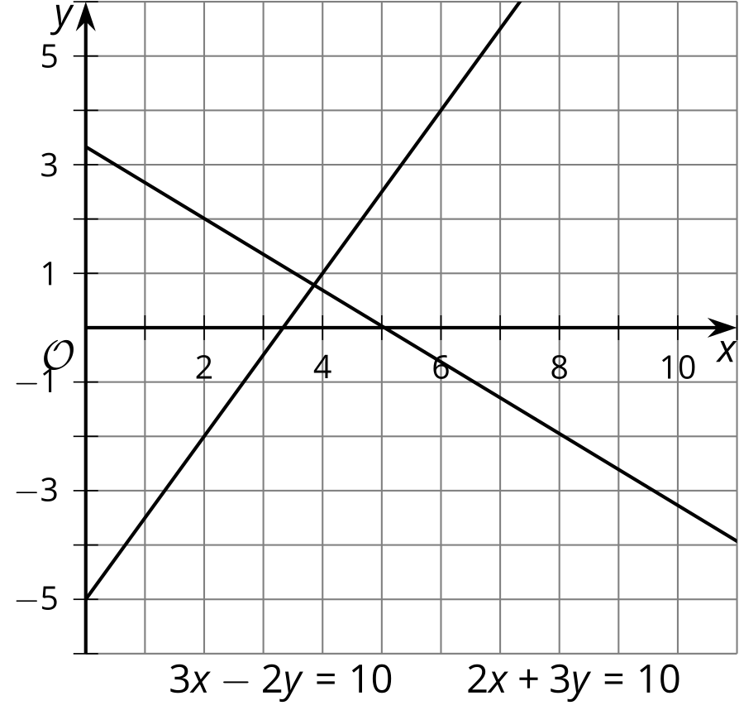
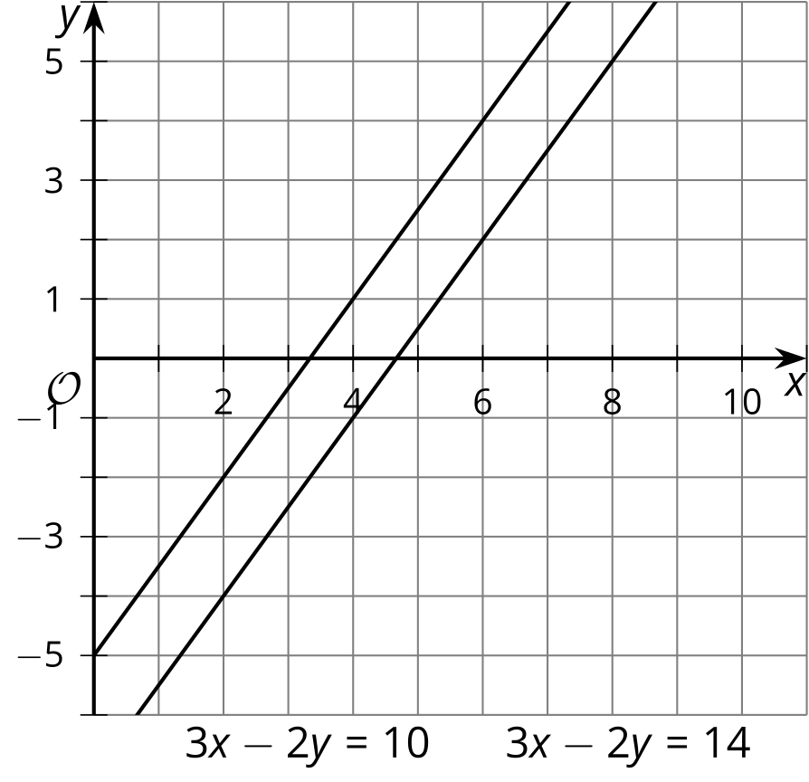

17.2: How Many Answers?
How many values of $x$ make each equation true?
- $3x+1=10$
- $2x+12=2x+10+2$
- $2x=x+2$
- $3\left(x+4\right)=3x+4$
- $\frac{2x+6}{2}=x+6$
- $0=0$
- $x+3x−4=7\left(x−\frac{4}{7}\right)$
- $0=6$
With your partner, discuss what you notice about the equations based on the number of solutions they have.

17.3: Write, Trade, Check
- Write an equation that has either 1, 0, or infinite solutions.
- Trade your equation with your partner. Solve the equation you are given and determine the number of solutions.
- Take turns explaining your reasoning with your partner.
- Repeat the process with a new equation.
© CC BY 2019 by Illustrative Mathematics®

