Lesson 11 Practice Problems
- Find the value of each variable.
  - $a⋅3=\text{-}30$
  - $\text{-}9⋅b=45$
  - $\text{-}89⋅12=c$
  - $d⋅88=\text{-}88,​000$
- (From Unit 5, Lesson 9.)
- Match each equation to its solution and to the story it describes.
- Equations:
  - $5x−7=3$
  - $7=3\left(5+x\right)$
  - $3x+5=\text{-}7$
  - $\frac{1}{3}\left(x+7\right)=5$
- Solutions:
  - -4
  - $\frac{\text{-}8}{3}$
  - 2
  - 8
- Stories:
  - The temperature is $\text{-}7$. Since midnight the temperature tripled and then rose 5 degrees. What was temperature at midnight?
  - Jada has 7 pink roses and some white roses. She gives all of them away: 5 roses to each of her 3 favorite teachers. How many white roses did she give away?
  - A musical instrument company reduced the time it takes for a worker to build a guitar. Before the reduction it took 5 hours. Now in 7 hours they can build 3 guitars. By how much did they reduce the time it takes to build each guitar?
  - A club puts its members into 5 groups for an activity. After 7 students have to leave early, there are only 3 students left to finish the activity. How many students were in each group?
- The baby giraffe weighed 132 pounds at birth. He gained weight at a steady rate for the first 7 months until his weight reached 538 pounds. How much did he gain each month?
- Six teams are out on the field playing soccer. The teams all have the same number of players. The head coach asks for 2 players from each team to come help him move some equipment. Now there are 78 players on the field. Write and solve an equation whose solution is the number of players on each team.
- A small town had a population of 960 people last year. The population grew to 1200 people this year. By what percentage did the population grow?
- 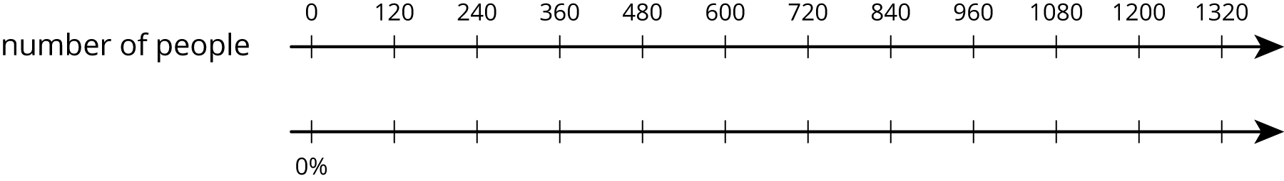

- (From Unit 4, Lesson 7.)
- The gas tank of a truck holds 30 gallons. The gas tank of a passenger car holds 50% less. How many gallons does it hold?
- 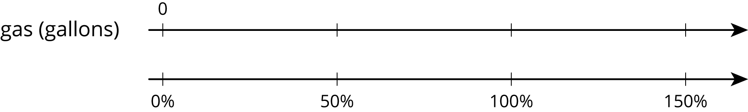
- (From Unit 4, Lesson 7.)
© CC BY Open Up Resources. Adaptations CC BY IM.

