Unit 3 Lesson 8: Are They All Similar?

1 Stretched or Distorted? Rectangles (Warm up)

Student Task Statement
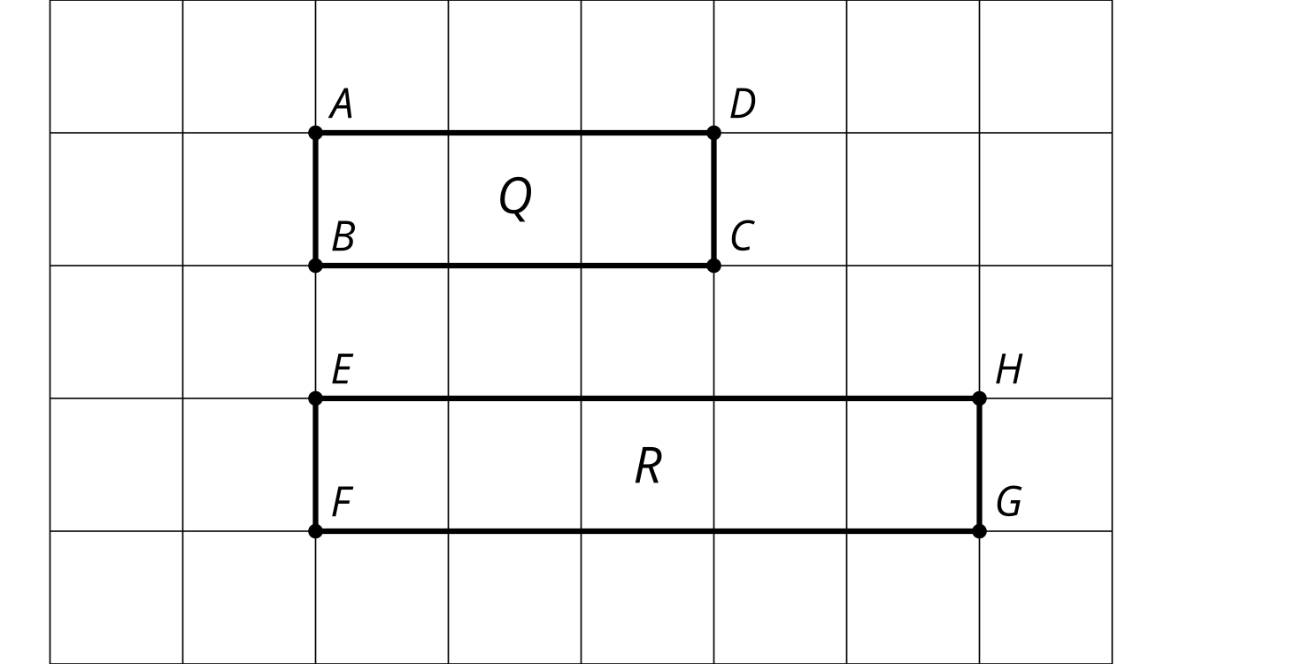
Are these rectangles similar? Explain how you know.

2 Faulty Logic

Student Task Statement
Tyler wrote a proof that all rectangles are similar. Make the image Tyler describes in each step in his proof. Which step makes a false assumption? Why is it false?
- Draw 2 rectangles. Label one $ABCD$ and the other $PQRS$.
- Translate rectangle $ABCD$ by the directed line segment from $A$ to $P$. $A^{′}$ and $P$ now coincide. The points coincide because that’s how we defined our translation.
- Rotate rectangle $A^{′}B^{′}C^{′}D^{′}$ by angle $D^{′}A^{′}S$. Segment $A^{″}D^{″}$ now lies on ray $PS$. The rays coincide because that’s how we defined our rotation.
- Dilate rectangle $A^{″}B^{″}C^{″}D^{″}$ using center $A^{″}$ and scale factor $\frac{PS}{AD}$. Segments $A^{‴}D^{‴}$ and $PS$ now coincide. The segments coincide because $A^{″}$ was the center of the rotation, so $A^{″}$ and $P$ don’t move, and since $D^{″}$ and $S$ are on the same ray from $A^{″}$, when we dilate $D^{″}$ by the right scale factor, it will stay on ray $PS$ but be the same distance from $A^{″}$ as $S$ is, so $S$ and $D^{‴}$ will coincide.
- Because all angles of a rectangle are right angles, segment $A^{‴}B^{‴}$ now lies on ray $PQ$. This is because the rays are on the same side of $PS$ and make the same angle with it. (If $A^{‴}B^{‴}$ and $PQ$ don’t coincide, reflect across $PS$ so that the rays are on the same side of $PS$.)
- Dilate rectangle $A^{‴}B^{‴}C^{‴}D^{‴}$ using center $A^{‴}$ and scale factor $\frac{PQ}{AB}$. Segments $A^{⁗}B^{⁗}$ and $PQ$ now coincide by the same reasoning as in step 4.
- Due to the symmetry of a rectangle, if 2 rectangles coincide on 2 sides, they must coincide on all sides.

3 Always? Prove it!

Student Task Statement
Choose one statement from the list. Decide if it is true or not.
If it is true, write a proof. If it is not, provide a counterexample.
Repeat with another statement.
Statements:
- All equilateral triangles are similar.
- All isosceles triangles are similar.
- All right triangles are similar.
- All circles are similar.

Activity Synthesis
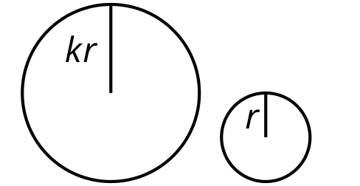
© CC BY 2019 by Illustrative Mathematics®

