Unit 3 Lesson 10: Rectangles and Triangles with Fractional Lengths

1 Areas of Squares (Warm up)

Student Task Statement
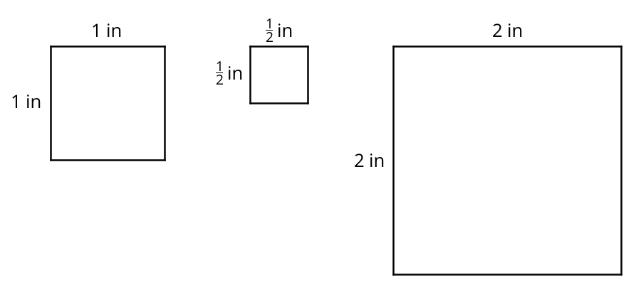
- What do you notice about the areas of the squares?
- Kiran says “A square with side lengths of $\frac{1}{3}$ inch has an area of $\frac{1}{3}$ square inches.” Do you agree? Explain or show your reasoning.

2 How Many Would it Take? (Part 2)

Student Task Statement
Noah would like to cover a rectangular tray with rectangular tiles. The tray has a width of $11\frac{1}{4}$ inches and an area of $50\frac{5}{8}$ square inches.
- Find the length of the tray in inches.
- If the tiles are $\frac{3}{4}$ inch by $\frac{9}{16}$ inch, how many would Noah need to cover the tray completely, without gaps or overlaps? Explain or show your reasoning.
- Draw a diagram to show how Noah could lay the tiles. Your diagram should show how many tiles would be needed to cover the length and width of the tray, but does not need to show every tile.

Activity Synthesis
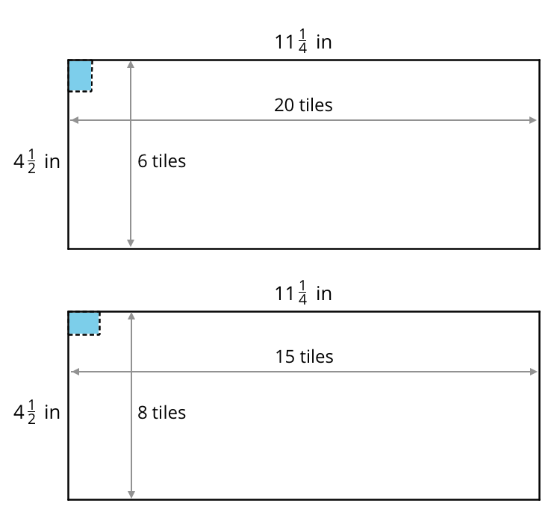

3 Bases and Heights of Triangles

Student Task Statement
- Find the area of Triangle A in square centimeters. Show your reasoning.
- 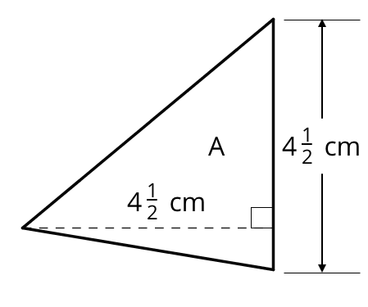
- The area of Triangle B is 8 square units. Find the length of $b$. Show your reasoning.
- 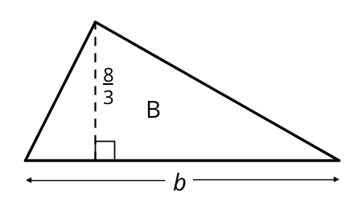
- The area of Triangle C is $\frac{54}{5}$ square units. What is the length of $h$? Show your reasoning.
- 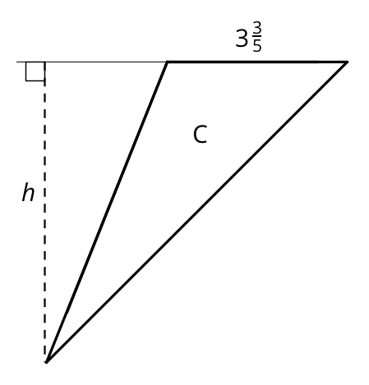
© CC BY Open Up Resources. Adaptations CC BY IM.

