Unit 3 Lesson 7: Reasoning about Similarity with Transformations

1 Notice and Wonder: Nested Triangles (Warm up)

Student Task Statement
What do you notice? What do you wonder?
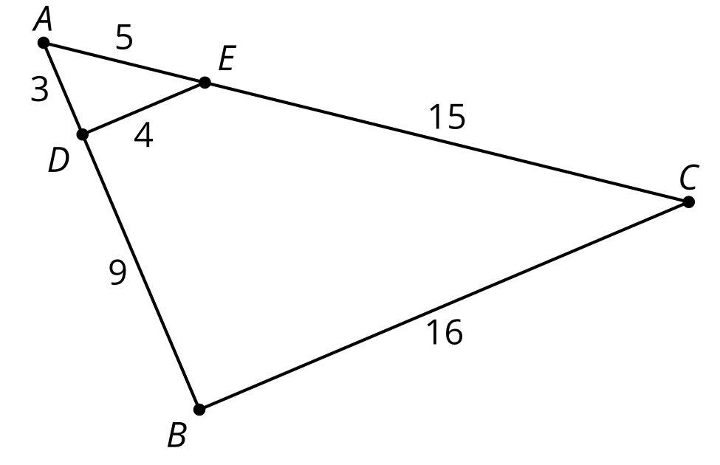

2 Stretched or Distorted? Triangles

Student Task Statement
- Sketch 2 triangles with all pairs of corresponding angles congruent, and with all pairs of corresponding side lengths in the same proportion.
- Label your triangles $ABC$ and $DEF$ so that angle $A$ is congruent to angle $D$, angle $B$ is congruent to angle $E$, and angle $C$ is congruent to angle $F$. Label each side with its length.
- Do the 2 triangles you drew fit the definition of similar? Explain your reasoning.
- Switch sketches with your partner. Find a sequence of rigid motions and dilations that will take one of their triangles onto the other. Will the same sequence work for your triangles?

3 Invisible Triangles: Similarity

Student Task Statement
Player 1: You are the transformer. Take the transformer card.
Player 2: Select a triangle card. Do not show it to anyone. Study the diagram to figure out which sides and which angles correspond. Tell Player 1 what you have figured out.
Player 1: Take notes about what they tell you so that you know which parts of their triangles correspond. Think of a sequence of rigid motions and dilations you could tell your partner to get them to take one of their triangles onto the other. Be specific in your language. The notes on your card can help with this.
Player 2: Listen to the instructions from the transformer. Use tracing paper to follow their instructions. Draw the image after each step. Let them know when they have lined up 1, 2, or all 3 pairs of vertices on your triangles.

Activity Synthesis

$∠A≅∠C,∠D≅∠B,∠DEA≅∠BEC,$ $\frac{AD}{CB}=\frac{DE}{BE}=\frac{EA}{EC}$ so $△DEA∼△BEC$
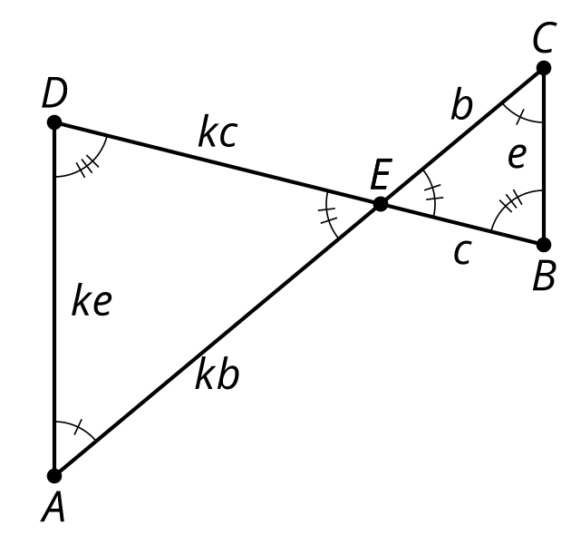
© CC BY 2019 by Illustrative Mathematics®

