Lesson 13 Practice Problems
- For each inequality, find two values for $x$ that make the inequality true and two values that make it false.
  - $x+3>70$
  - $x+3<70$
  - $\text{-}5x<2$
  - $5x<2$
- Here is an inequality: $\text{-}3x>18$.
  - List some values for $x$ that would make this inequality true.
  - How are the solutions to the inequality $\text{-}3x≥18$ different from the solutions to $\text{-}3x>18$? Explain your reasoning.
- Here are the prices for cheese pizza at a certain pizzeria:
- pizza size | - price in dollars
- small | - 11.60
- medium
- large | - 16.25
  - You had a coupon that made the price of a large pizza $13.00. For what percent off was the coupon?
  - Your friend purchased a medium pizza for $10.31 with a 30% off coupon. What is the price of a medium pizza without a coupon?
  - Your friend has a 15% off coupon and $10. What is the largest pizza that your friend can afford, and how much money will be left over after the purchase?
- (From Unit 4, Lesson 12.)
- Select all the stories that can be represented by the diagram.
- 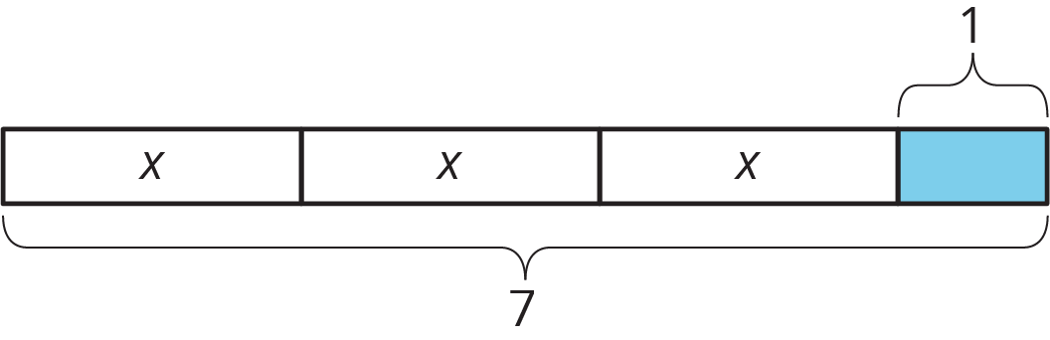
  - Andre studies 7 hours this week for end-of-year exams. He spends 1 hour on English and an equal number of hours each on math, science, and history.
  - Lin spends $3 on 7 markers and a $1 pen.
  - Diego spends $1 on 7 stickers and 3 marbles.
  - Noah shares 7 grapes with 3 friends. He eats 1 and gives each friend the same number of grapes.
  - Elena spends $7 on 3 notebooks and a $1 pen.
- (From Unit 6, Lesson 4.)
© CC BY Open Up Resources. Adaptations CC BY IM.

