Lesson 6: Representing Sequences
- Let’s look at different ways to represent a sequence.

6.1: Reading Representations
For each sequence shown, find either the growth factor or rate of change. Be prepared to explain your reasoning.
- 5, 15, 25, 35, 45, . . .
- Starting at 10, each new term is $\frac{5}{2}$ less than the previous term.

- 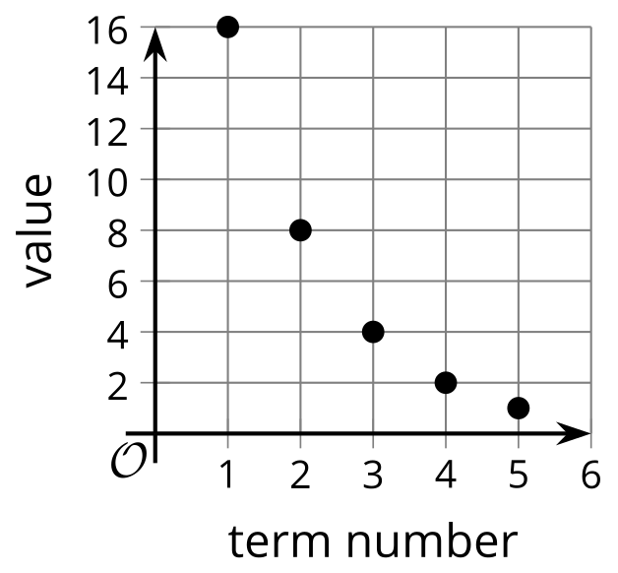
- $g\left(1\right)=\text{-}5,g\left(n\right)=g\left(n−1\right)⋅\text{-}2$ for $n≥2$
- $n$ | - $f\left(n\right)$
- 1 | - 0
- 2 | - 0.1
- 3 | - 0.2
- 4 | - 0.3
- 5 | - 0.4

6.2: Matching Recursive Definitions
Take turns with your partner to match a sequence with a recursive definition. It may help to first figure out if the sequence is arithmetic or geometric.
- For each match that you find, explain to your partner how you know it’s a match.
- For each match that your partner finds, listen carefully to their explanation. If you disagree, discuss your thinking and work to reach an agreement.
There is one sequence and one definition that do not have matches. Create their corresponding match.
Sequences:
- 3, 6, 12, 24
- 18, 36, 72, 144
- 3, 8, 13, 18
- 18, 13, 8, 3
- 18, 9, 4.5, 2.25
- 18, 20, 22, 24
Definitions:
- $G\left(1\right)=18,G\left(n\right)=\frac{1}{2}⋅G\left(n−1\right),n≥2$
- $H\left(1\right)=3,H\left(n\right)=5⋅H\left(n−1\right),n≥2$
- $J\left(1\right)=3,J\left(n\right)=J\left(n−1\right)+5,n≥2$
- $K\left(1\right)=18,K\left(n\right)=K\left(n−1\right)−5,n≥2$
- $L\left(1\right)=18,L\left(n\right)=2⋅L\left(n−1\right),n≥2$
- $M\left(1\right)=3,M\left(n\right)=2⋅M\left(n−1\right),n≥2$

6.3: Squares of Squares
Here is a pattern where the number of small squares increases with each new step.
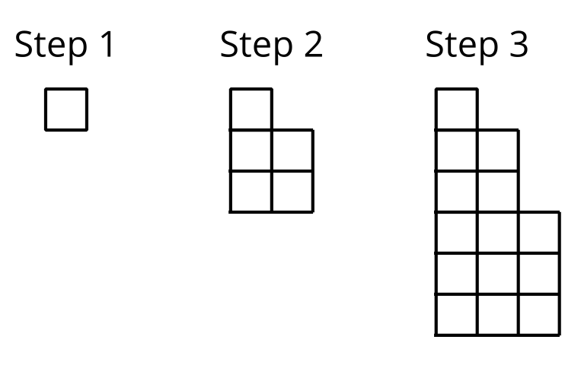
- Write a recursive definition for the total number of small squares $S\left(n\right)$ in Step $n$.
- Sketch a graph of $S$ that shows Steps 1 to 7.
- Is this sequence geometric, arithmetic, or neither? Be prepared to explain how you know.

Are you ready for more?
Start with a circle. If you make 1 cut, you have 2 pieces. If you make 2 cuts, you can have a maximum of 4 pieces. If you make 3 cuts, you can have a maximum of 7 pieces.
- Draw a picture to show how 3 cuts can give 7 pieces.
- Find the maximum number of pieces you can get from 4 cuts.
- From 5 cuts.
- Can you find a function that gives the maximum number of pieces from $n$ cuts?

Lesson 6 Summary
Here are some ways to represent a sequence. Each representation gives a different view of the same sequence.
- A list of terms. Here’s a list of terms for an arithmetic sequence $D$: 4, 7, 10, 13, 16, . . . We can show this sequence is arithmetic by noting that the difference between consecutive terms is always 3, so we can say this sequence has a rate of change of 3.
- A table. A table lists the term number $n$ and value for each term $D\left(n\right)$. It can sometimes be easier to detect or analyze patterns when using a table.
$n$ | $D\left(n\right)$
1 | 4
2 | 7
3 | 10
4 | 13
5 | 16
- A graph. The graph of a sequence is a set of points, because a sequence is a function whose domain is a part of the integers. For an arithmetic sequence, these points lie on a line since arithmetic sequences are a type of linear function.
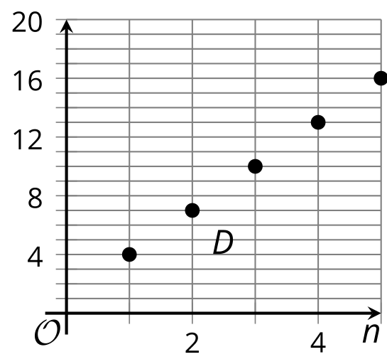
- An equation. We can define sequences recursively using function notation to make an equation. For the sequence 4, 7, 10, 13, 16, . . ., the starting term is 4 and the rate of change is 3, so $D\left(1\right)=4,D\left(n\right)=D\left(n−1\right)+3$ for $n≥2$. This type of definition tells us how to find any term if we know the previous term. It is not as helpful in calculating terms that are far away like $D\left(100\right)$. Some sequences do not have recursive definitions, but geometric and arithmetic sequences always do.
© CC BY 2019 by Illustrative Mathematics®

