Lesson 4: Quadrilaterals in Circles
- Let’s investigate quadrilaterals that fit in a circle.

4.1: Connecting the Dots
For each quadrilateral, use a compass to see if you can draw a circle that passes through all 4 of the quadrilateral’s vertices.

A
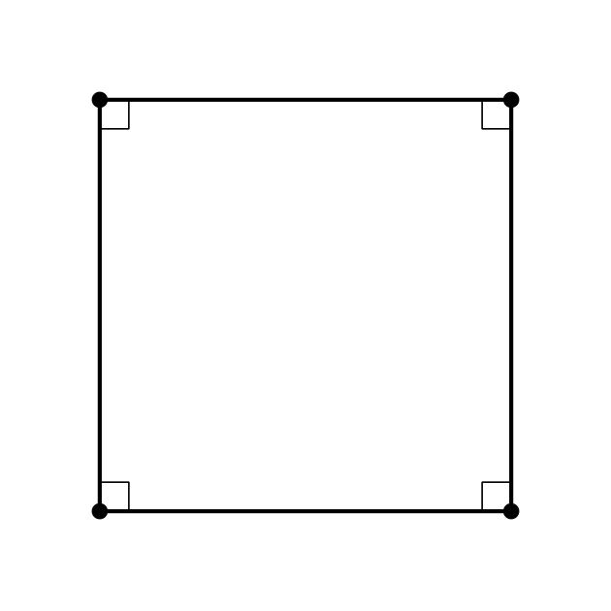

B
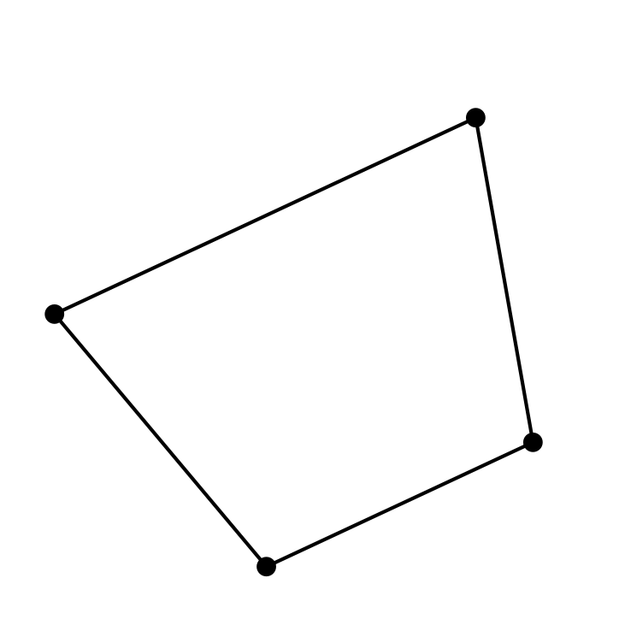

C
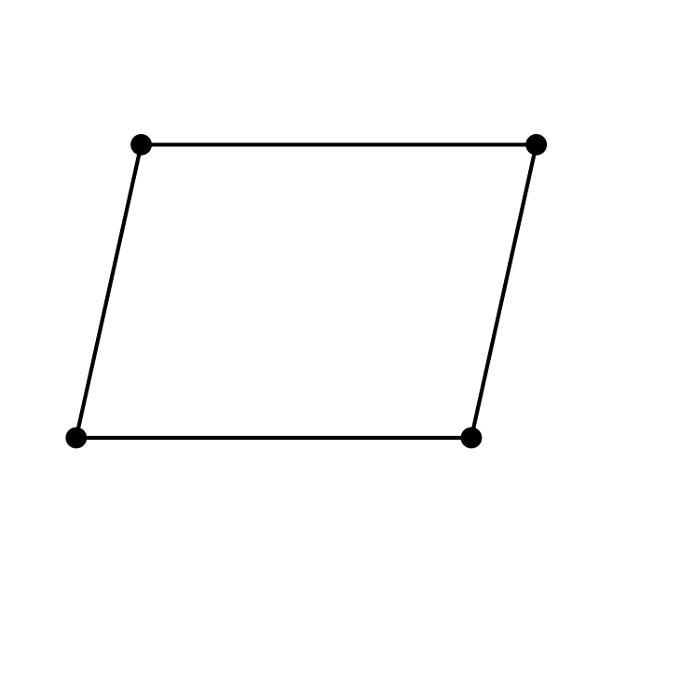

4.2: Inscribed Angles and Circumscribed Circles
- The images show 3 quadrilaterals with circumscribed circles.

- A
- 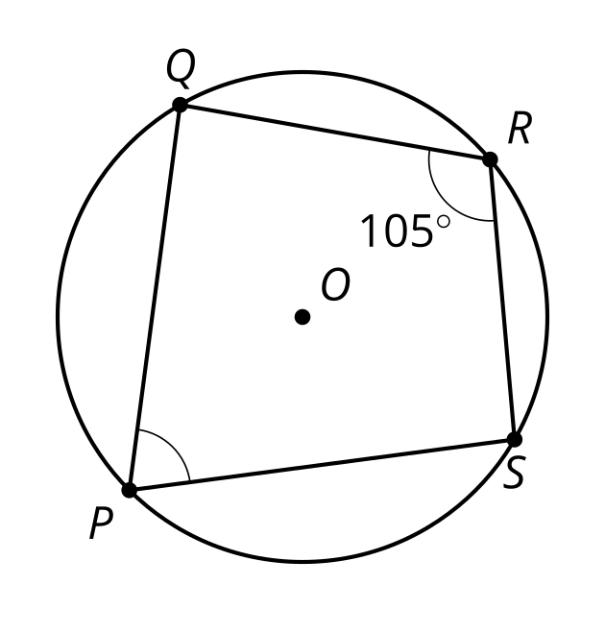

- B
- 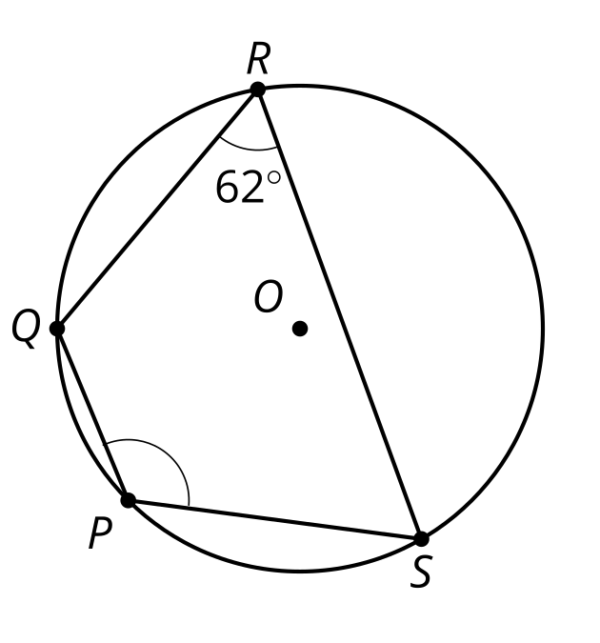

- C
- 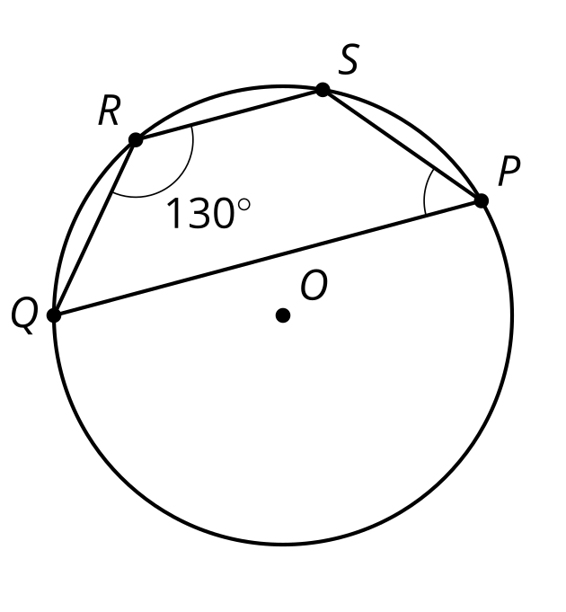
- For each one, highlight the arc from $S$ to $Q$ passing through $P$. Then, find the measures of:
  - the arc you highlighted
  - the other arc from $S$ to $Q$
  - angle $SPQ$
- Here is another quadrilateral with a circumscribed circle. What is the value of $α+β$? Explain or show your reasoning.
- 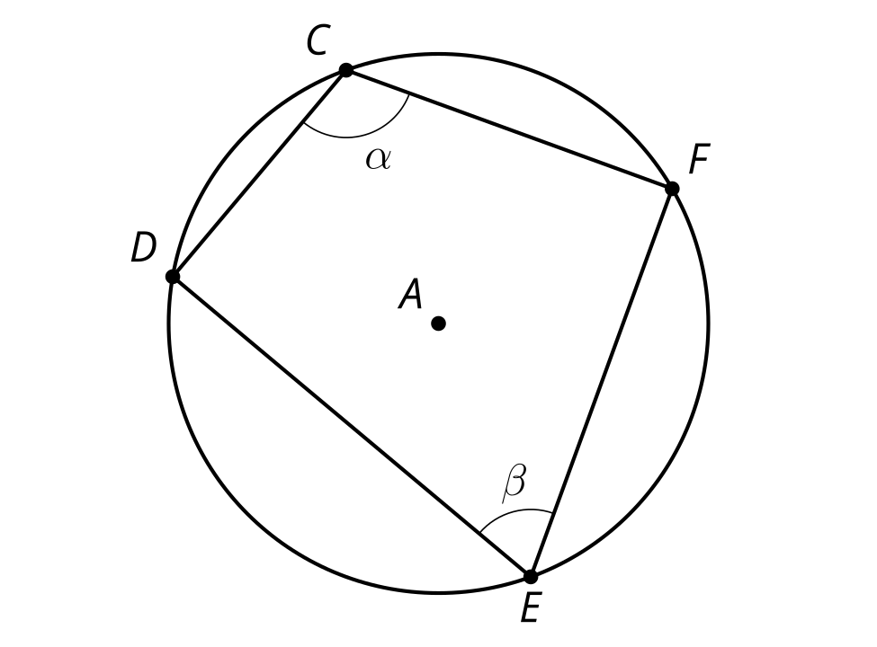

Are you ready for more?
Brahmagupta’s formula states that for a quadrilateral whose vertices all lie on the same circle, the area of the quadrilateral is $\sqrt{\left(s−a\right)\left(s−b\right)\left(s−c\right)\left(s−d\right)}$ where $a,b,c,$ and $d$ are the lengths of the quadrilateral’s sides and $s$ is half its perimeter.
In the cyclic quadrilateral in the image, point $O$ is the center of the quadrilateral’s circumscribed circle. Validate Brahmagupta’s formula for this particular quadrilateral by first finding the sum of the areas of the top and bottom triangles. Then, calculate the area again using Brahmagupta’s formula.
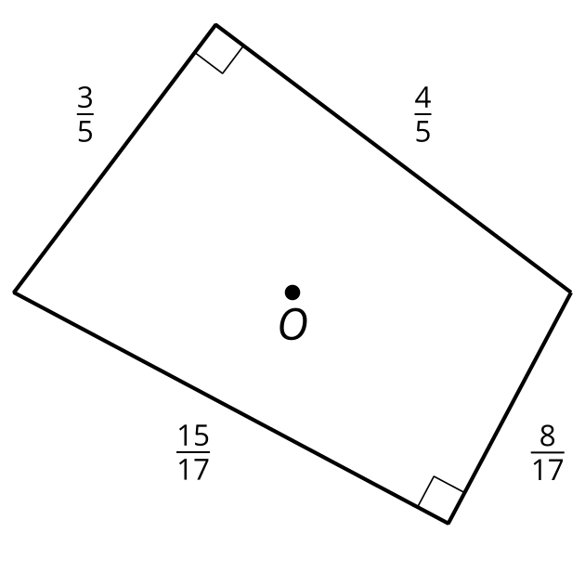

4.3: Construction Ahead
Quadrilateral $ABCD$ is a cyclic quadrilateral.
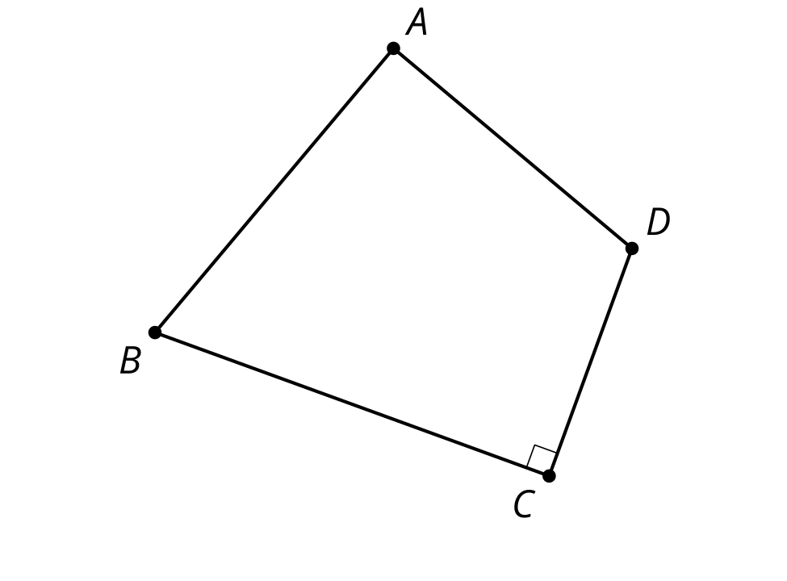
- Draw diagonal $BD$. How will this diagonal relate to the circumscribed circle? Explain your reasoning.
- Construct the center of the circumscribed circle for quadrilateral $ABCD$. Label this point $O$. Explain why your method worked.
- Construct the circumscribed circle for quadrilateral $ABCD$.
- Could we follow this procedure to construct a circumscribed circle for any cyclic quadrilaterals? Explain your reasoning.

Lesson 4 Summary
A circle is said to be circumscribed about a polygon if all the vertices of the polygon lie on the circle. If it is possible to draw a circumscribed circle for a quadrilateral, the figure is called a cyclic quadrilateral. Not all quadrilaterals have this property.
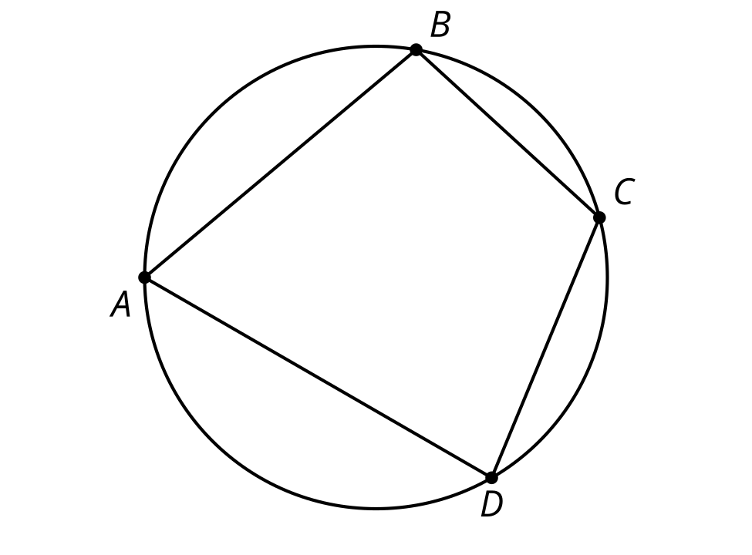
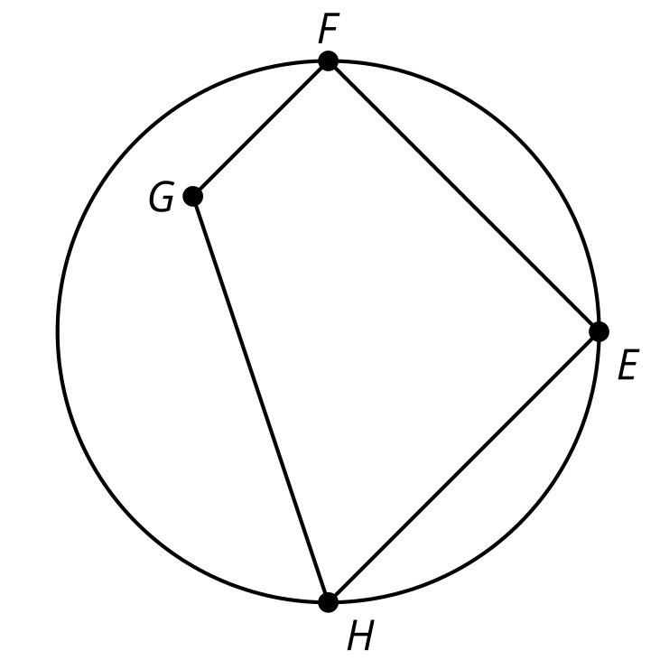
We can prove that the opposite angles of a cyclic quadrilateral are supplementary. Consider opposite angles $BCD$ and $BAD$, labeled $α$ and $β$.
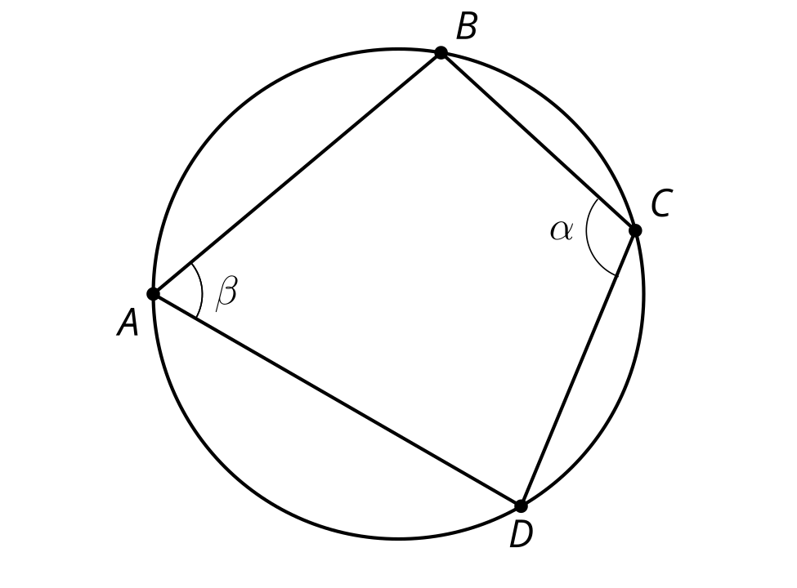
Angle $BAD$ is inscribed in the arc from $B$ to $D$ through $C$. Angle $BCD$ is inscribed in the arc from $B$ to $D$ through $A$. Together, the 2 arcs trace out the entire circumference of the circle, so their measures add to 360 degrees. By the Inscribed Angle Theorem, the sum of $α$ and $β$ must be half of 360 degrees, or 180 degrees. So angles $BAD$ and $BCD$ are supplementary. The same argument can be applied to the other pair of opposite angles.
© CC BY 2019 by Illustrative Mathematics®

