Unit 3 Lesson 10: Other Conditions for Triangle Similarity

1 Math Talk: Triangle Congruence (Warm up)

Student Task Statement
Evaluate mentally. Is there enough information to determine if the pairs of triangles are congruent? If so, what theorem(s) would you use? If not, what additional piece of information could you use?

$\overset{¯}{KM}⊥\overset{¯}{NL},\overset{¯}{KL}≅\overset{¯}{ML}$
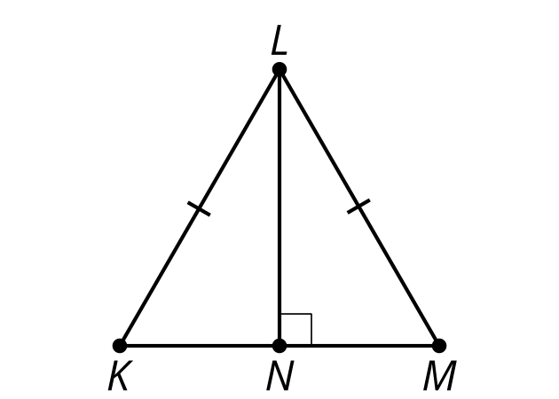

$∠E≅∠D$
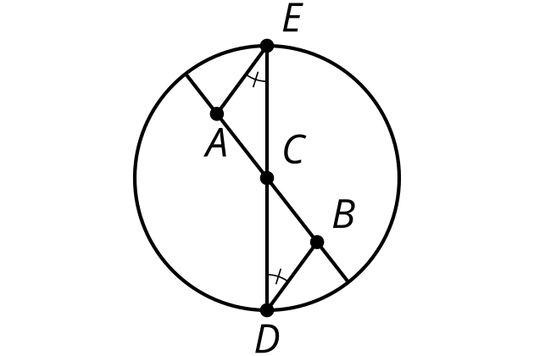

$\overset{¯}{HI}≅\overset{¯}{FG}$
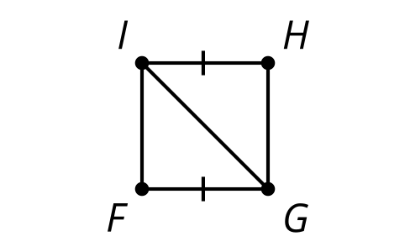

$\overset{↔}{AB}∥\overset{↔}{CD},∠DAC≅∠BCA$
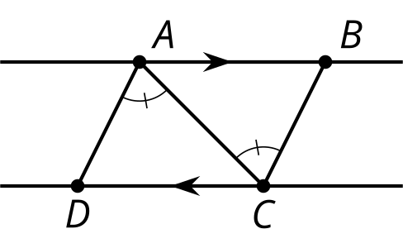

2 Side-Angle-Side Triangle Similarity? (Optional)

Student Task Statement
Andre remembers lots of ways to prove triangles congruent. He asks Clare, “Can we use Angle-Side-Angle to prove triangles are similar?”
Clare: “Sure, but we don’t need the Side part because Angle-Angle is enough to prove triangles are similar.”
Andre: “Hmm, what about Side-Angle-Side or Side-Side-Side? What if we don’t know 2 angles?”
Clare: “Oh! I don’t know. Let’s draw a picture and see if we can prove it.”
Andre: “Uh-oh. If ‘side’ means corresponding sides with the same length, then we’ll only get congruent triangles.”
- What could ‘side’ stand for to prove triangles similar?
- Draw a diagram that would help you prove the Side-Angle-Side Triangle Similarity Theorem.
- Write a proof.

3 Side-Side-Side Triangle Similarity (Optional)

Student Task Statement
Prove that these 2 triangles must be similar.
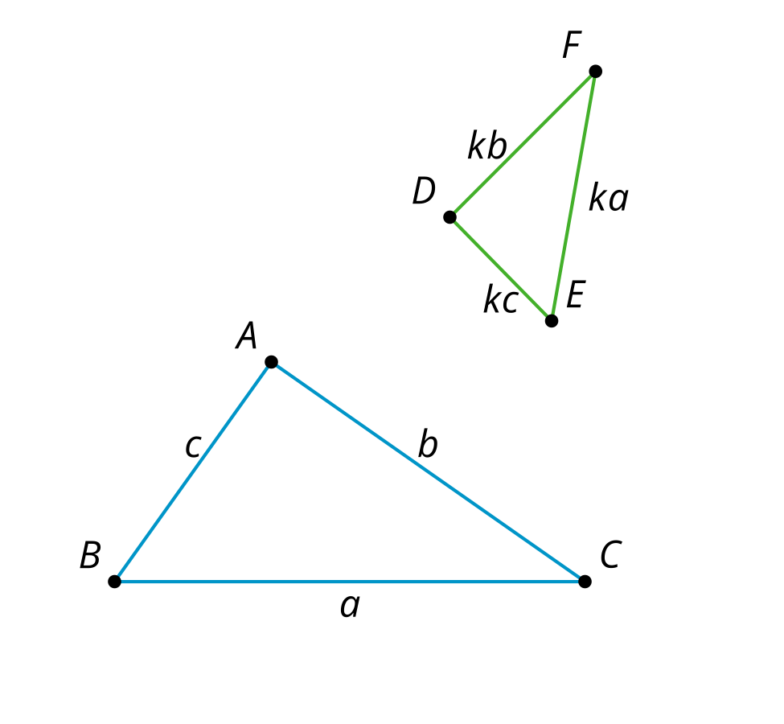

Images for Activity Synthesis

A
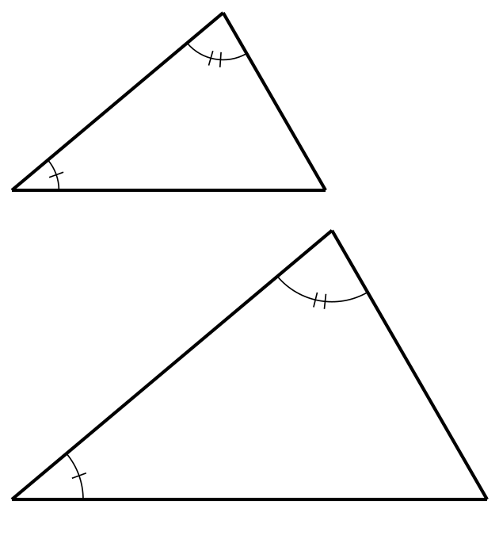

B
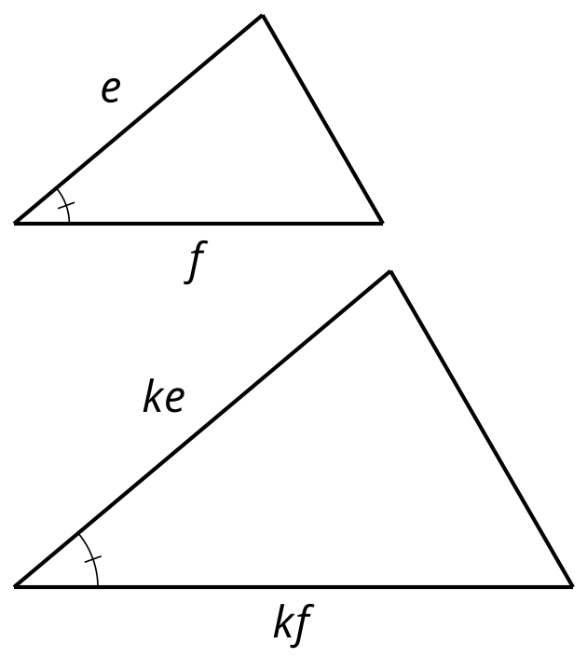

C
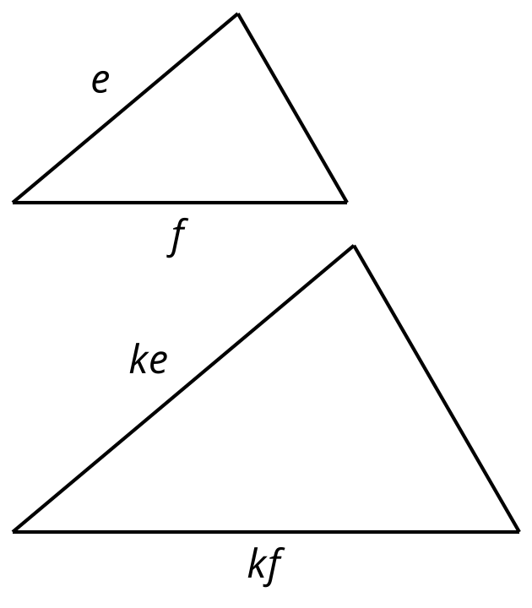

D
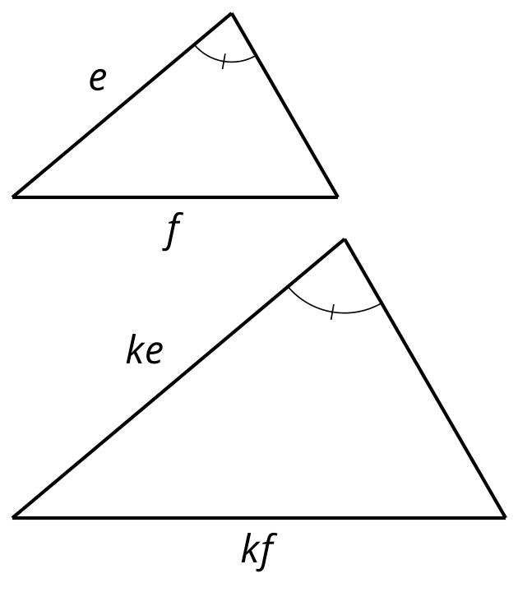

E
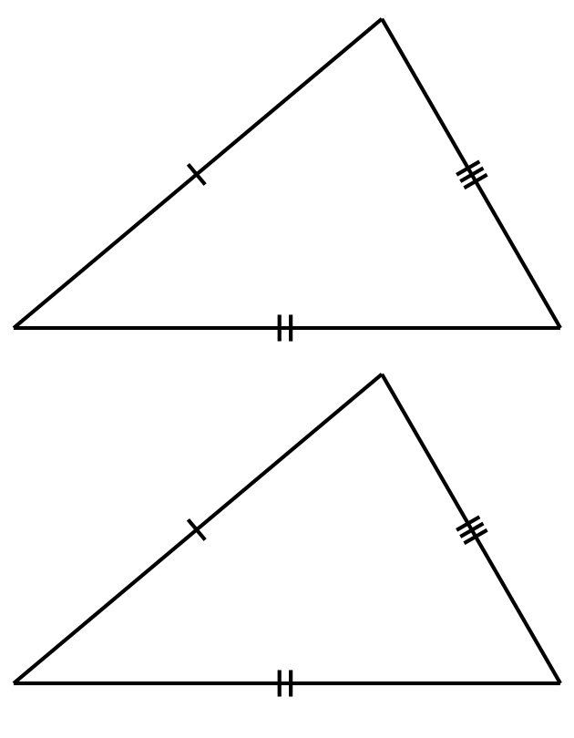
© CC BY 2019 by Illustrative Mathematics®

