Lesson 2: Constructing Patterns
- Let’s use compass and straightedge constructions to make patterns.

2.1: Math Talk: Why Is That True?
Here are 2 circles with centers $A$ and $B$.
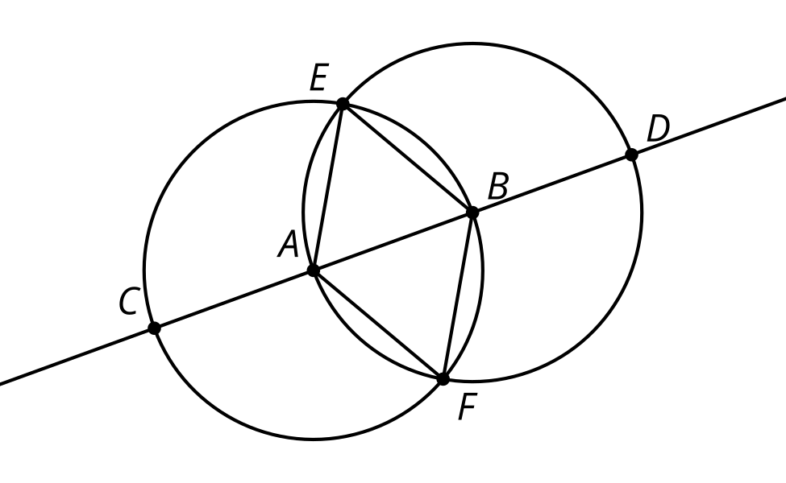
Based on the diagram, explain how you know each statement is true.
The length of segment $EA$ is equal to the length of segment $EB$.
Triangle $ABF$ is equilateral.
$AB=\frac{1}{3}CD$
$CB=DA$

2.2: Make Your Own
Use straightedge and compass moves to build your own pattern using the circle and radius as a place to start. As you make your pattern, record each move on a separate sheet of blank paper. Use precise vocabulary so someone can make a perfect copy without seeing the original. Include instructions about how to shade or color your pattern.
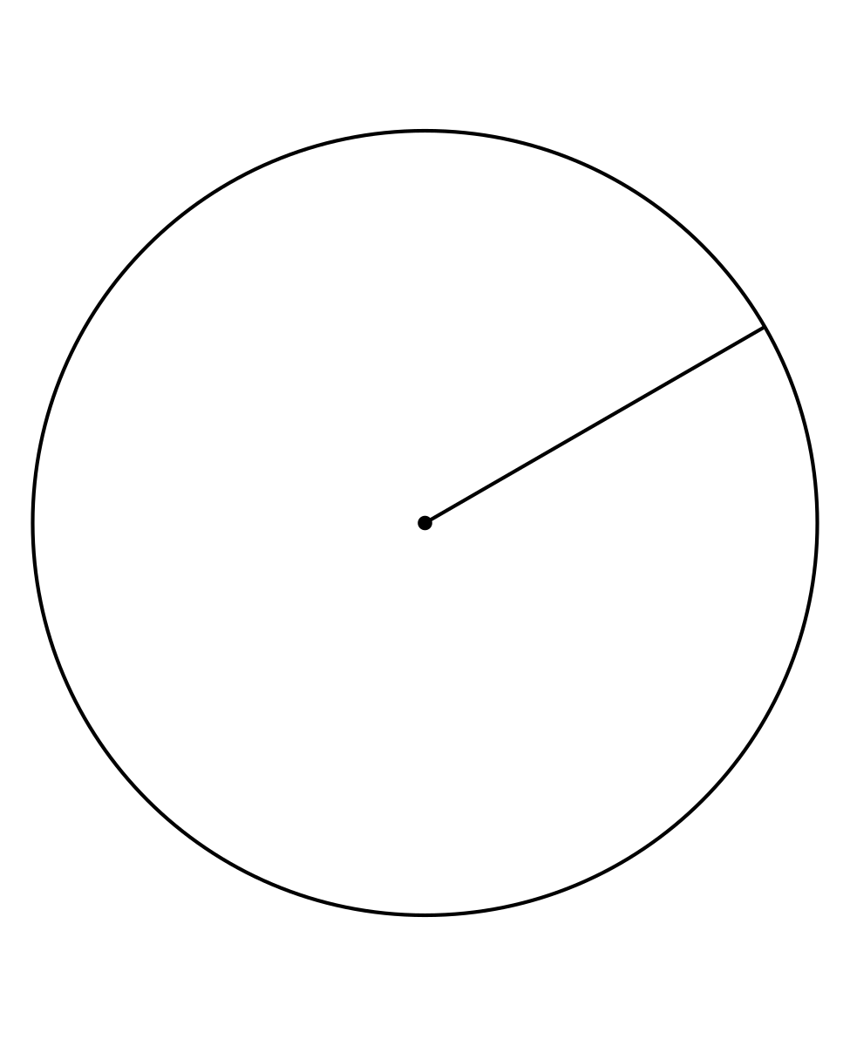

Are you ready for more?
If you have ever visited a mosque, madrasah, or other location where the religion of Islam is practiced, you may have noticed walls decorated with intricate geometric patterns. Throughout history, artists and craftspeople have developed these patterns which are based on compass and straightedge constructions.
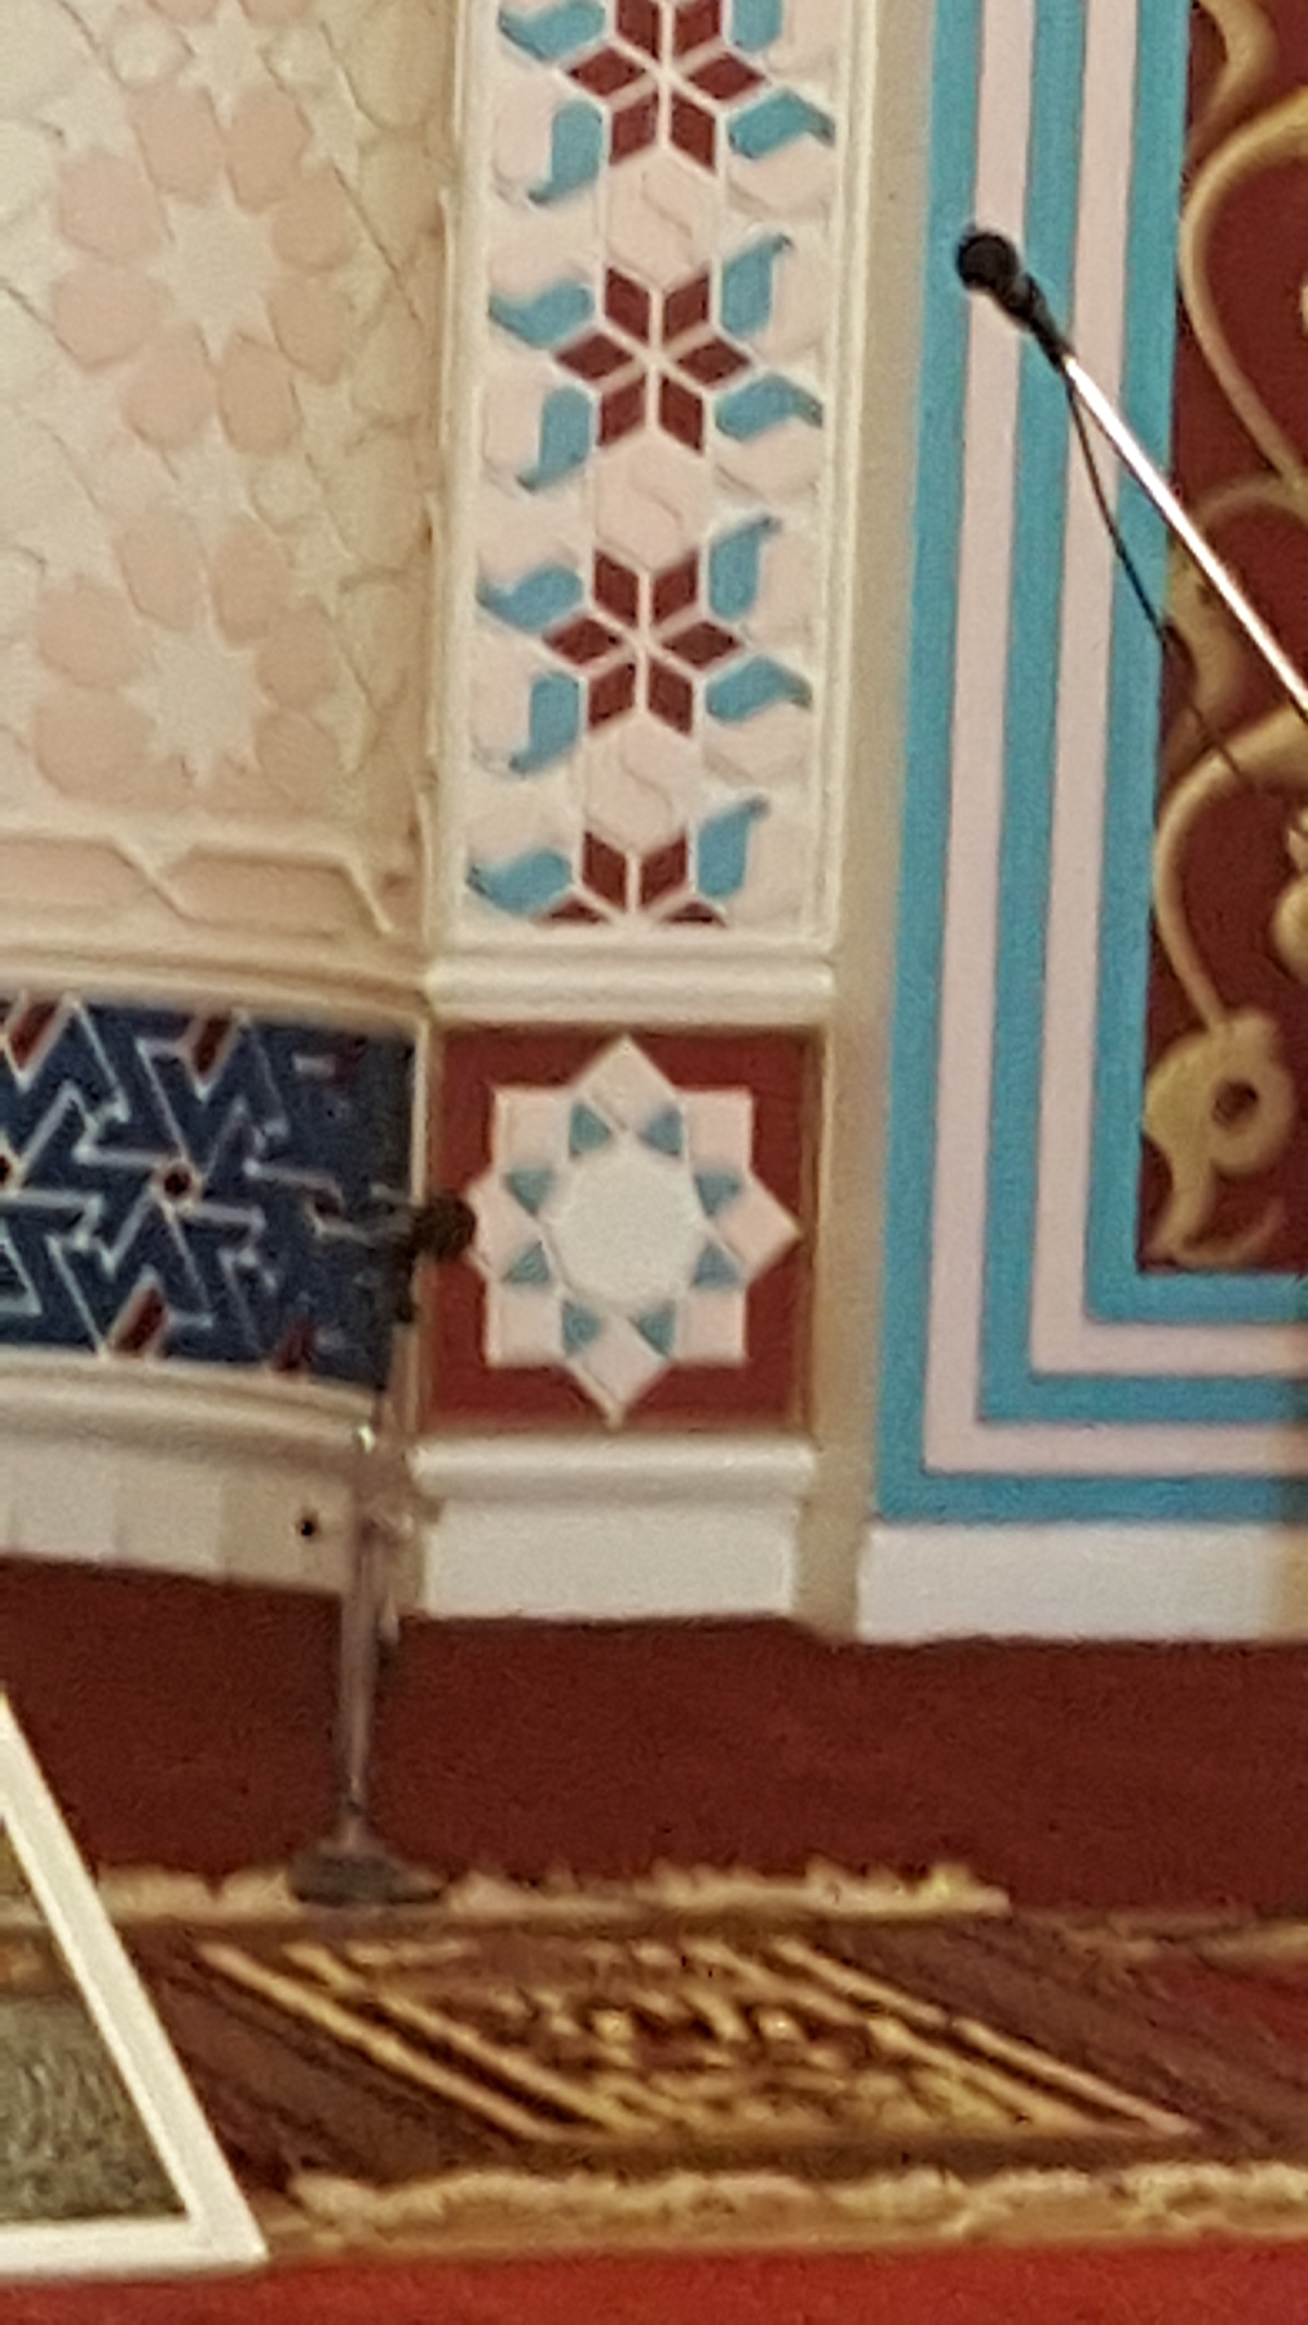
You can find many tutorials online for creating these beautiful designs. Here is one example to try.
Video 'Fes Design' available here: https://player.vimeo.com/video/736665153.
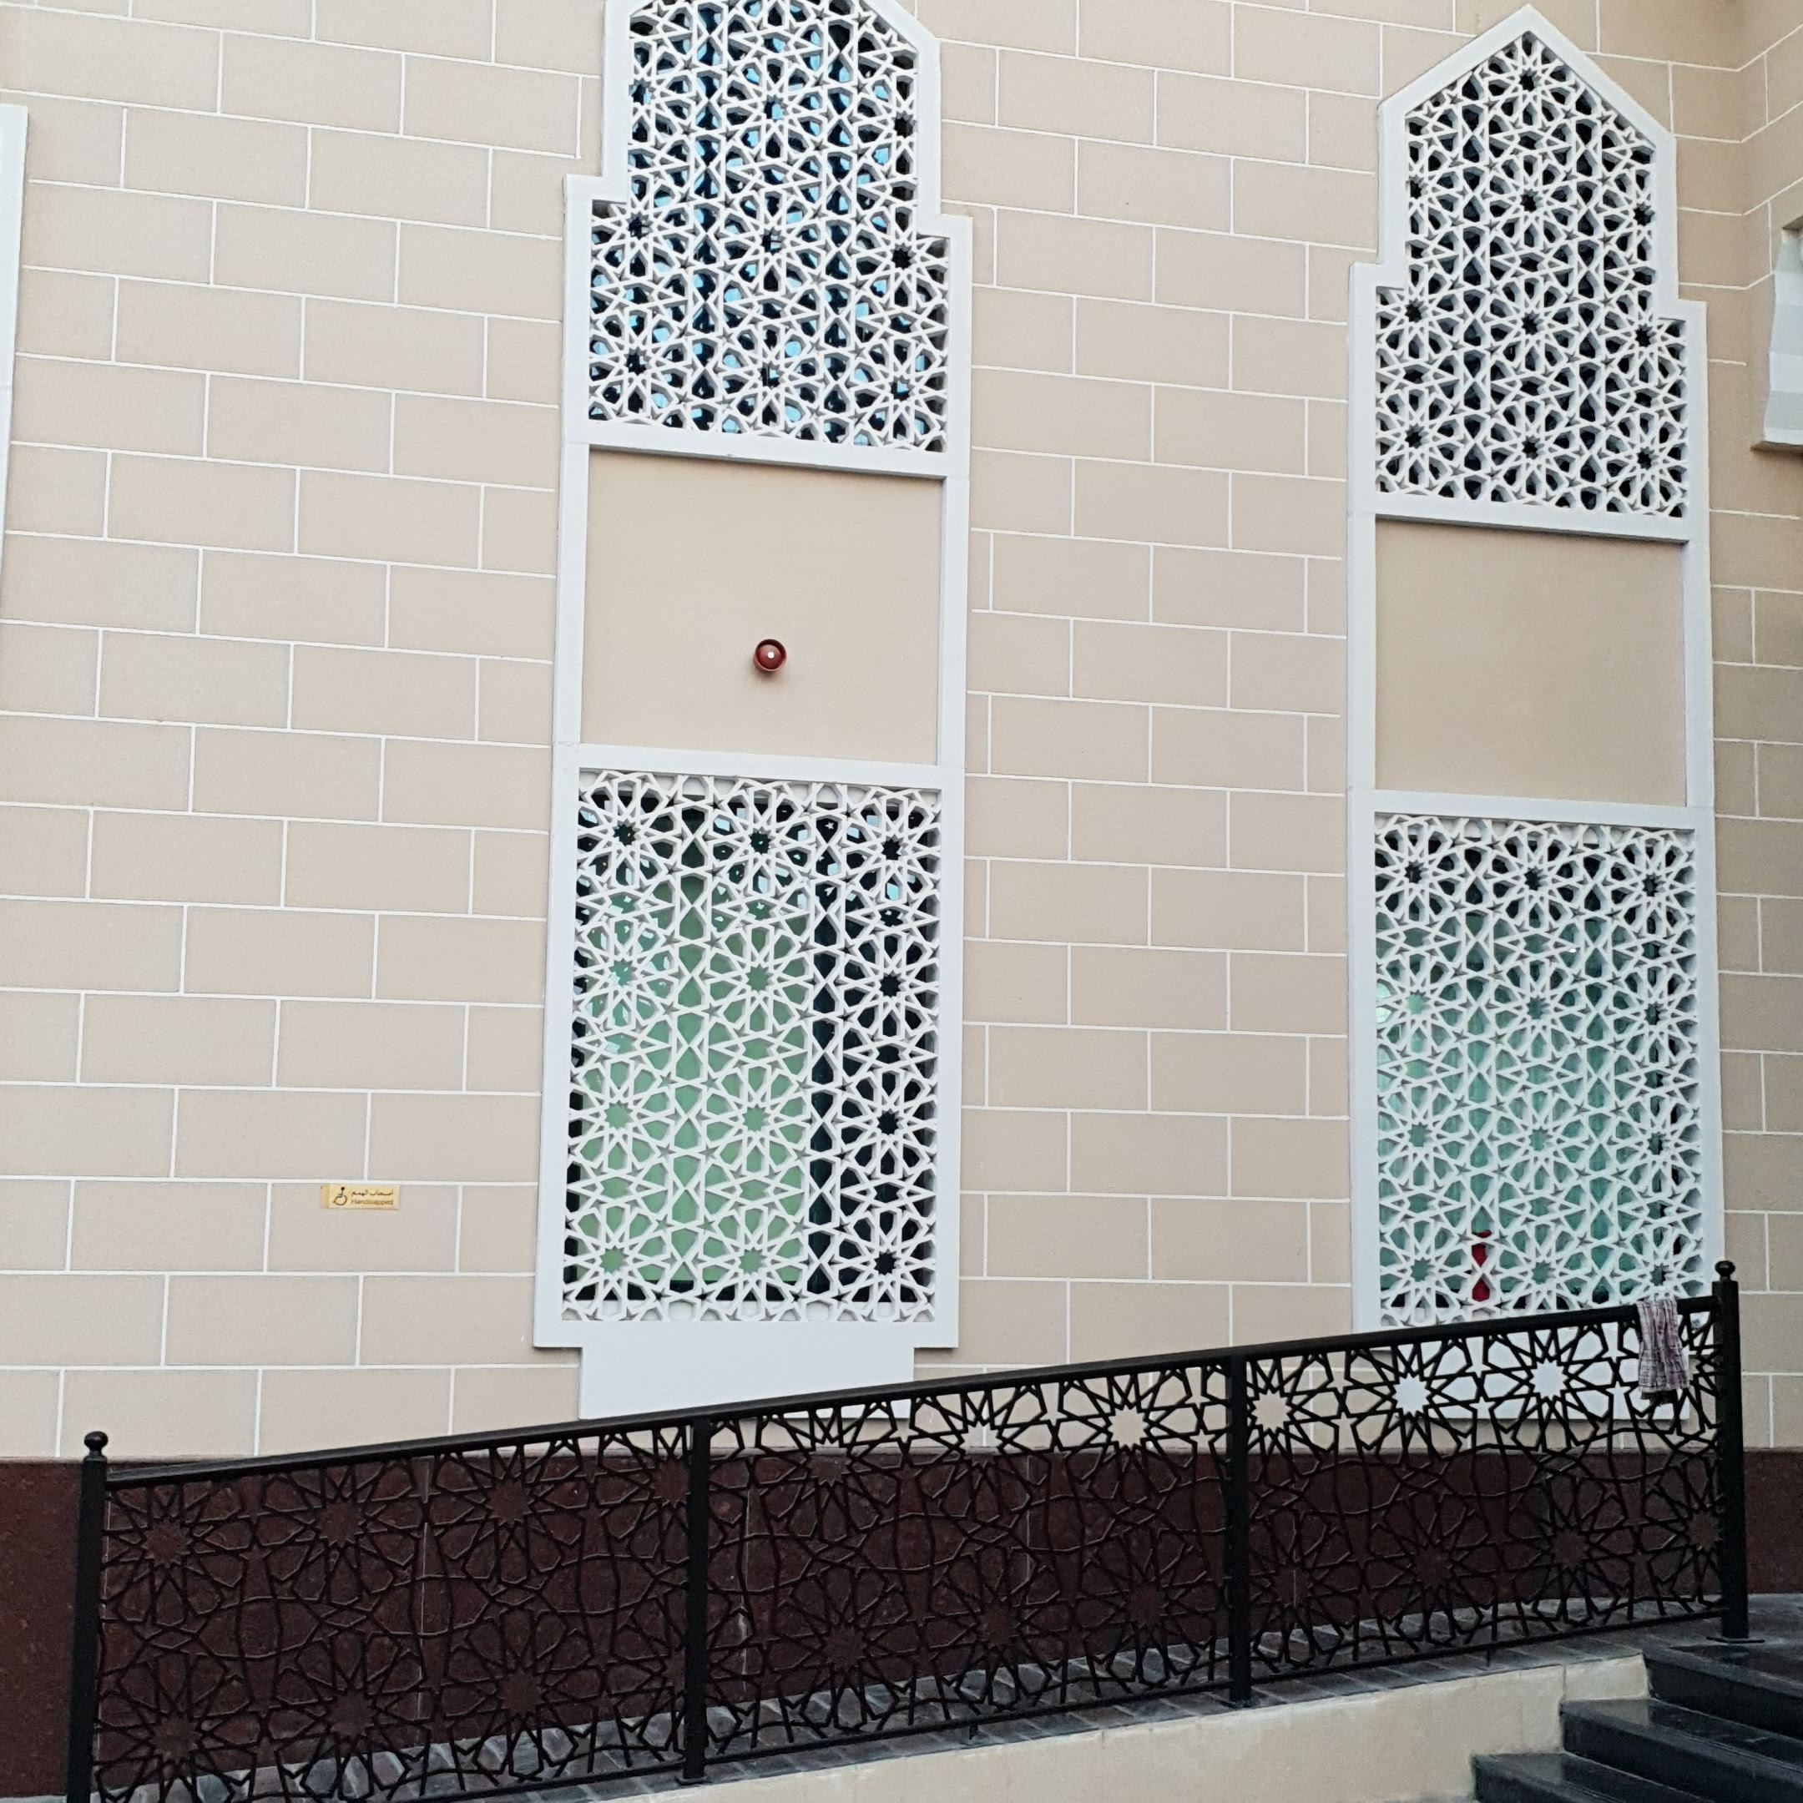

2.3: Make Someone Else’s
Follow the instructions precisely to recreate the pattern.

Lesson 2 Summary
We can use straightedge and compass moves to construct interesting patterns. What if someone else wants to make the same pattern? We need to communicate how to reproduce the pattern precisely. Compare these sets of instructions:
- Start with a line and 2 points.
- Create a line.
- Create a circle.
- Create a circle.
- Create a circle.
- Create a line.
- Start with a line $ℓ$, point $A$ on line $ℓ$ and point $B$ not on line $ℓ$.
- Create a line through $A$ and $B$ extending in both directions. Label this line $p$.
- Create a circle centered at $A$ with radius $AB$. This circle intersects with line $ℓ$ in 2 places. Label the intersection point to the right of $A$ as $C$.
- Create a circle centered at $B$ with radius $BA$. This circle intersects with line $p$ at $A$ and 1 other point. Label the new intersection point as $D$.
- Create a circle centered at $D$ with a radius of length $BC$. This circle intersects with the circle centered at $B$ in 2 places. Label the intersection point to the right of $B$ as $E$.
- Create a line through $B$ and $E$ extending in both directions.
It is important to label points and segments, such as point $A$ or segment $AB$, to communicate precisely.
These are instructions to construct a line parallel to a given line. We say 2 lines are parallel if they don’t intersect. We also say that 2 segments are parallel if they extend into parallel lines.
© CC BY 2019 by Illustrative Mathematics®

