Unit 5 Lesson 20: Changes over Equal Intervals

1 Writing Equivalent Expressions (Warm up)

Student Task Statement
For each given expression, write an equivalent expression with as few terms as possible.
- $7p−3+2\left(p+1\right)$
- $[4\left(n+1\right)+10]−4\left(n+1\right)$
- $9^{5}⋅9^{2}⋅9^{x}$
- $\frac{2^{4n}}{2^{n}}$

2 Outputs of A Linear Function

Student Task Statement
Here is a graph of $y=f\left(x\right)$ where $f\left(x\right)=2x+5$.

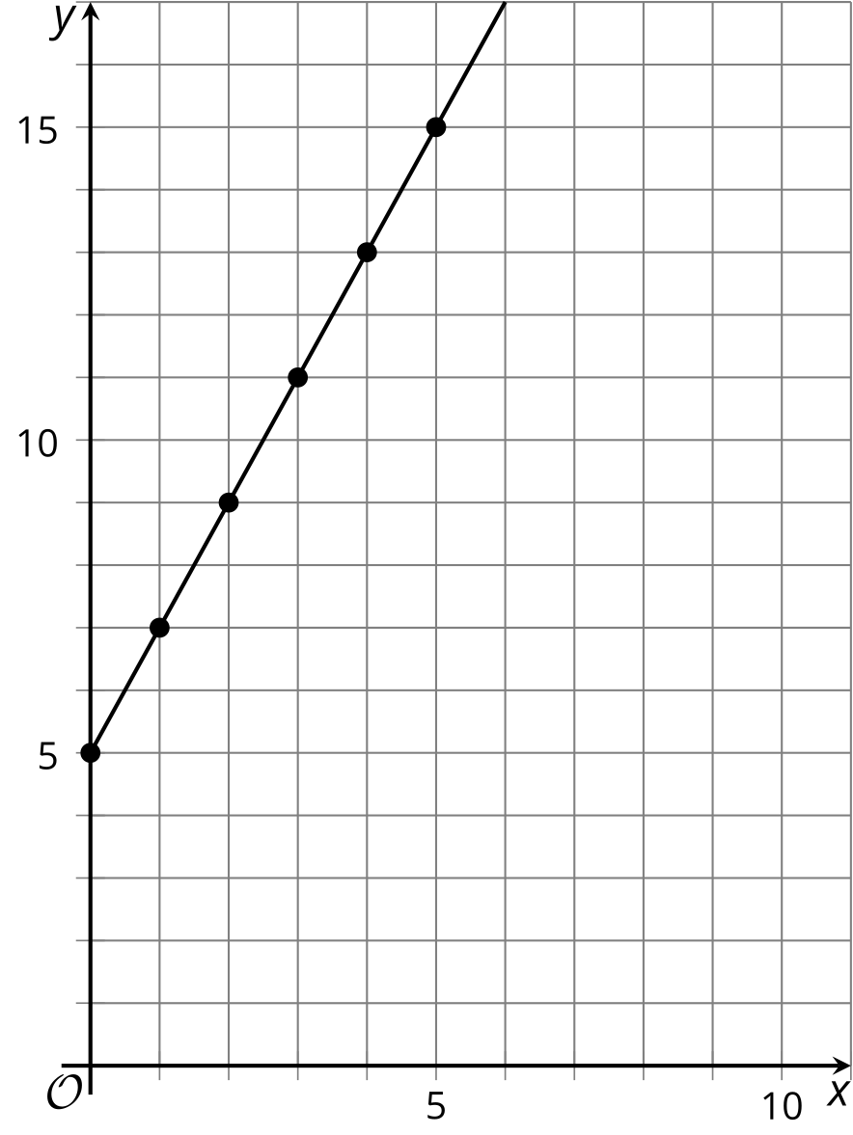

- How do the values of $f$ change whenever $x$ increases by 1, for instance, when it increases from 1 to 2, or from 19 to 20? Be prepared to explain or show how you know.
- Here is an expression we can use to find the difference in the values of $f$ when the input changes from $x$ to $x+1$.
- $[2\left(x+1\right)+5]−[2x+5]$
- Does this expression have the same value as what you found in the previous questions? Show your reasoning.

  - How do the values of $f$ change whenever $x$ increases by 4? Explain or show how you know.
  - Write an expression that shows the change in the values of $f$ when the input value changes from $x$ to $x+4$.
  - Show or explain how that expression has a value of 8.

Activity Synthesis
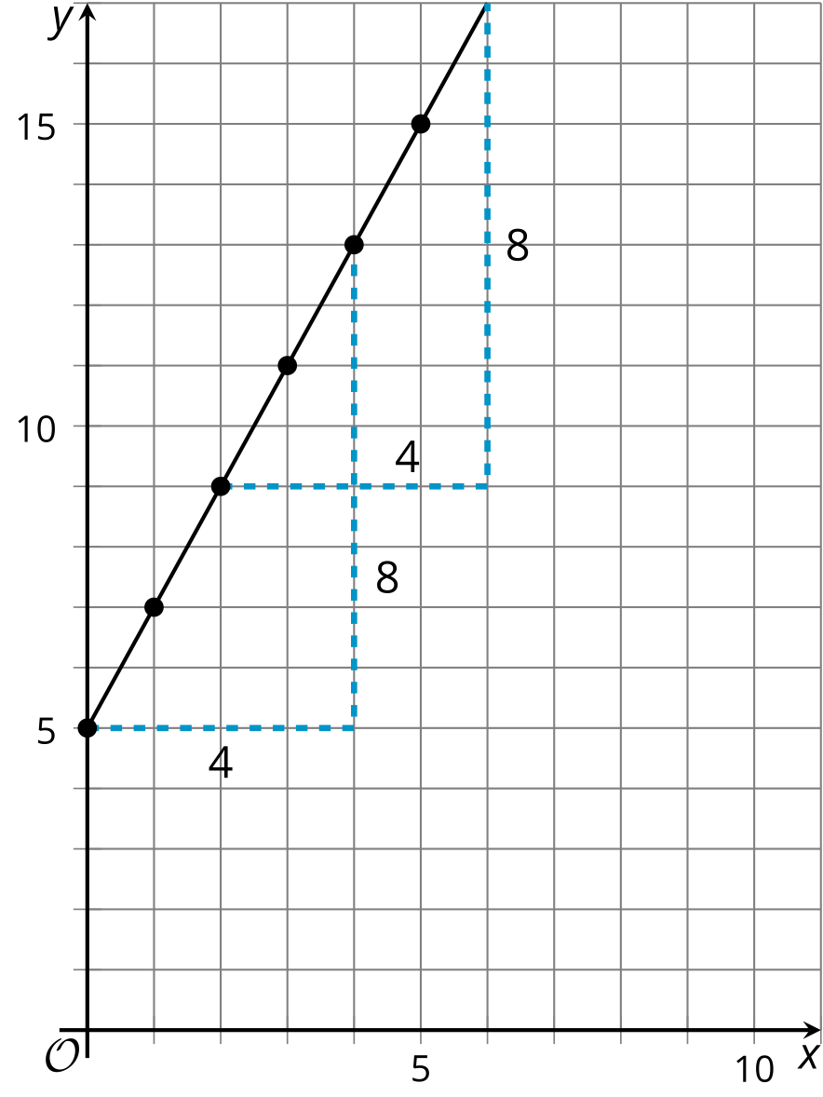
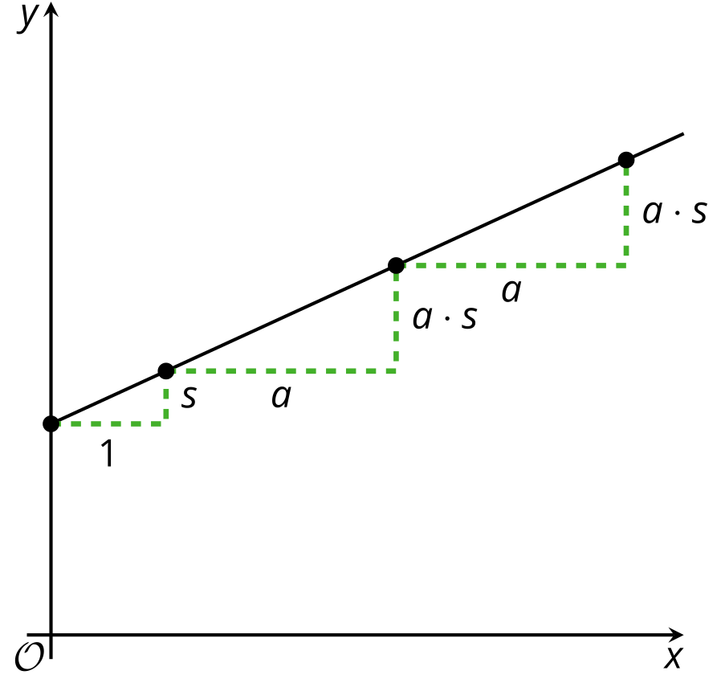

3 Outputs of An Exponential Function

Student Task Statement
Here is a table that shows some input and output values of an exponential function $g$. The equation $g\left(x\right)=3^{x}$ defines the function.
$x$ | $g\left(x\right)$
3 | 27
4 | 81
5 | 243
6 | 729
7 | 2,187
8 | 6,561
$x$
$x+1$
- How does $g\left(x\right)$ change every time $x$ increases by 1? Show or explain your reasoning.
- Choose two new input values that are consecutive whole numbers and find their output values. Record them in the table. How do the output values change for those two input values?
- Complete the table with the output when the input is $x$ and when it is $x+1$.
- Look at the change in output values as the $x$ increases by 1. Does it still agree with your findings earlier? Show your reasoning.
- Pause here for a class discussion. Then, work with your group on the next few questions.
- Choose two $x$-values where one is 3 more than the other (for example, 1 and 4). How do the output values of $g$ change as $x$ increases by 3? (Each group member should choose a different pair of numbers and study the outputs.)
- Complete this table with the output when the input is $x$ and when it is $x+3$. Look at the change in output values as $x$ increases by 3. Does it agree with your group's findings in the previous question? Show your reasoning.
- $x$ | - $g\left(x\right)$
- $x$
- $x+3$

Activity Synthesis
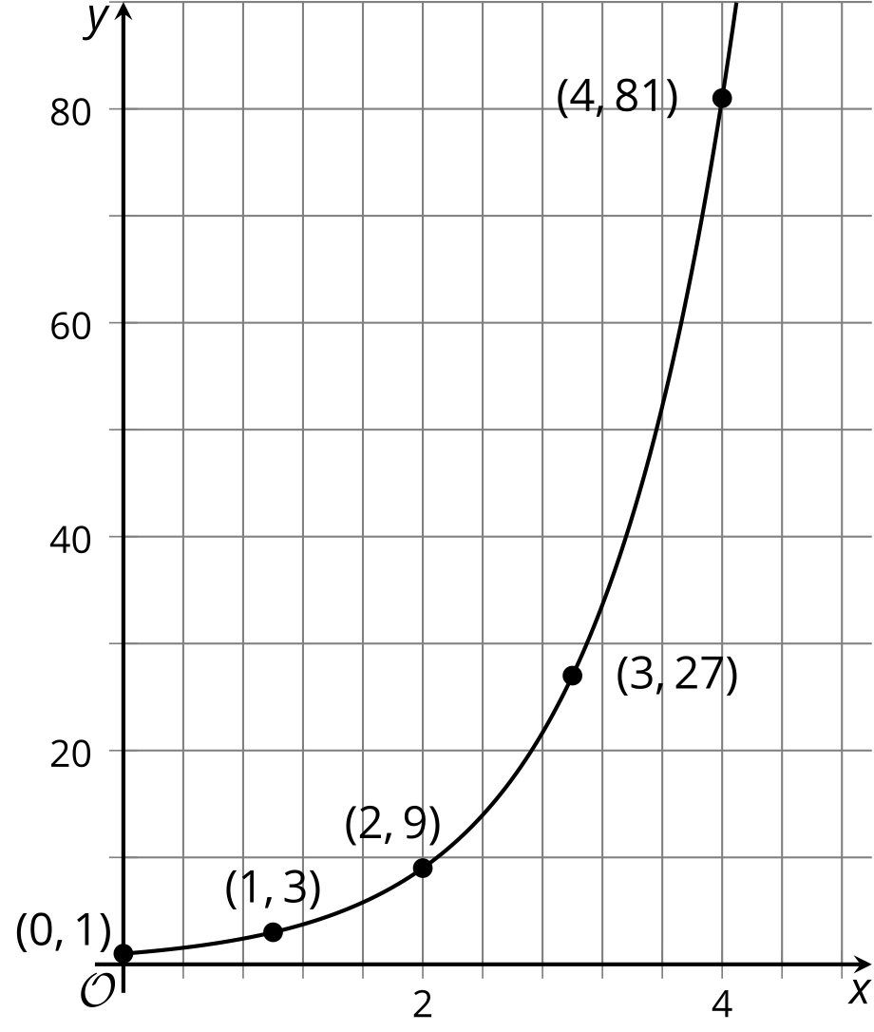
© CC BY 2019 by Illustrative Mathematics®

