Unit 5 Lesson 21: Skills for Mathematical Modeling

1 Which One Doesn’t Belong: Lists (Warm up)

Student Task Statement
Which one doesn’t belong?
A: 81, 85, 87, 90, 93, 96
B: 81, 78, 75, 72, 69, 66
C: 10, 13, 16, 19, 16, 13
D: 81, 27, 9, 3, 1, $\frac{1}{3}$

2 Holy Agave!

Student Task Statement
In the spring, an agave plant sends up a flower spike. Here are some data collected from an agave plant in a garden in Tucson, AZ, starting on April 2:
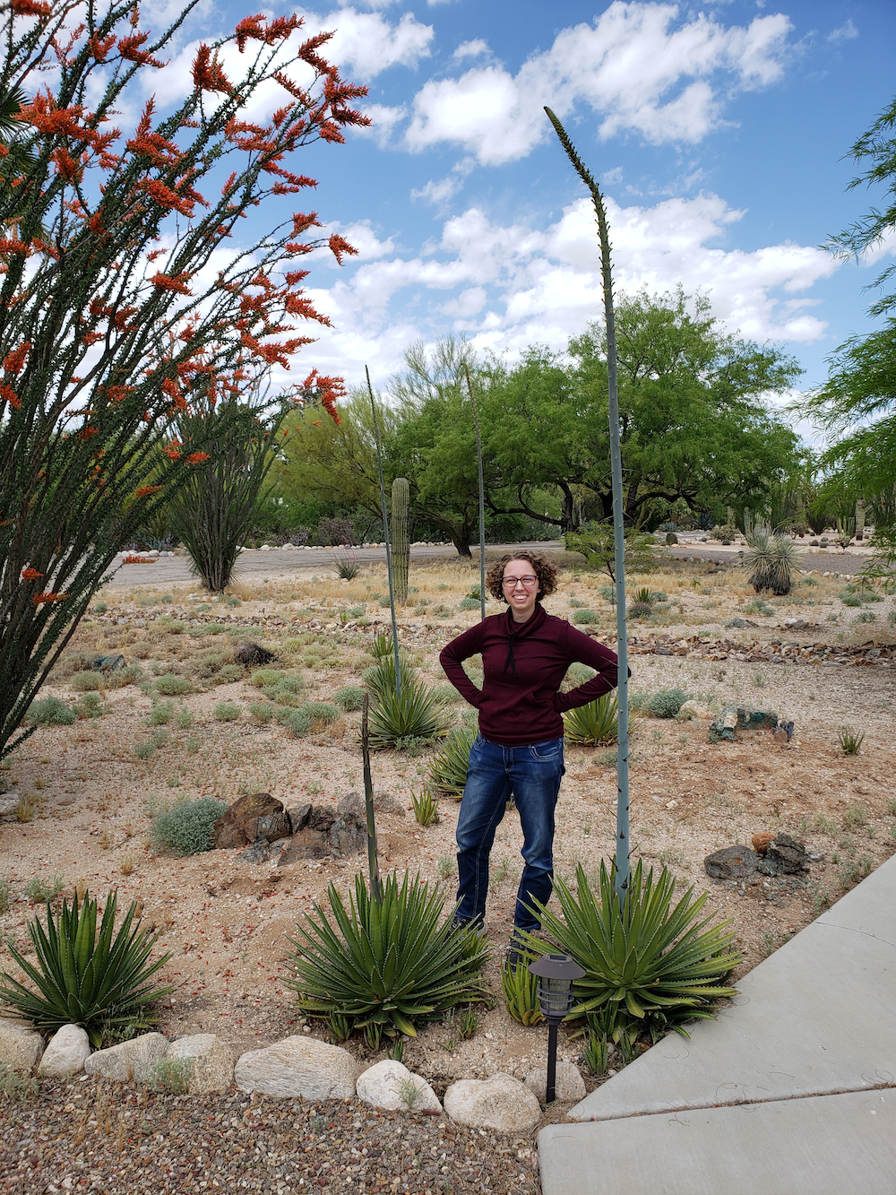
day | height in inches
0 | 17
1 | 23
2 | 29
3 | 37
4 | 45
5 | 52
6 | 62
7 | 70
8 | 80
- Use graphing technology to create a scatter plot, using days as the first coordinate and height as the second coordinate.
- Would a linear or exponential model be a better fit for this data?
- Create a function that is a good model for the data. If you chose an exponential model, start with the equation $y=a⋅b^{x}$ and select values for $a$ and $b$. If you chose a linear model, start with the equation $y=mx+c$, and select values for $m$ and $c$.
- Graph your equation on that same coordinate plane as your scatter plot. Adjust the numbers you used in the equation to improve your model.
- Explain what each number in your equation means in this situation.
- Use your model to predict the height of the flower spike on day 10.
- Describe any limitations on the domain of the function modeling the data.

3 Let’s Model Some Stuff

Student Task Statement
- Data set A: The height of some buildings, in feet, and the number of floors in each building. Would a linear or exponential model be a better fit?
- 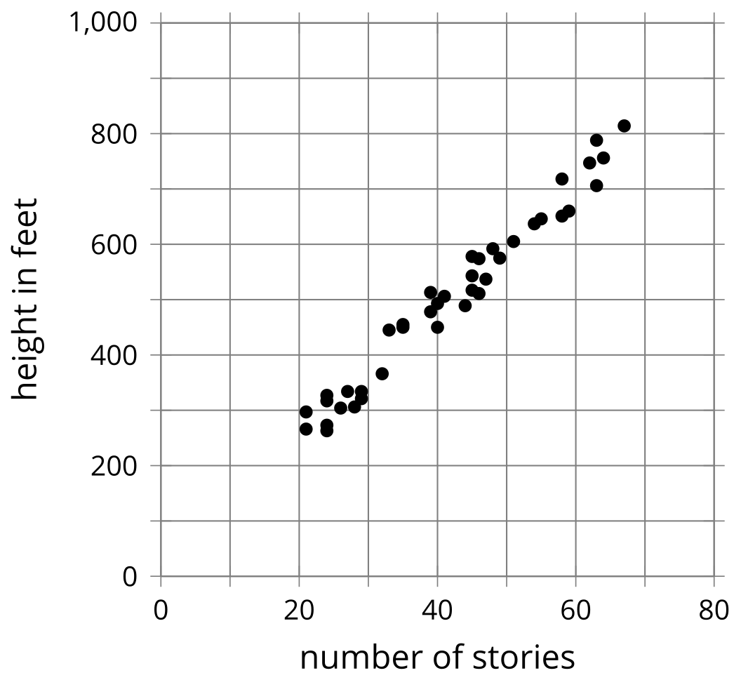
- Which equation would be the better model for the data, where $x$ represents number of stories and $y$ represents height of the building in feet?
  - $y=11.5x+21.5$
  - $y=21.5⋅{\left(11.5\right)}^{x}$
- What is the meaning of the 11.5 and the 21.5, in this situation?
- Data set B: The “enlarge by 25%” feature on a copy machine is used several times on a photo. The width of the photo in centimeters is measured after each copy is made. Would a linear or exponential model be a better fit?
- 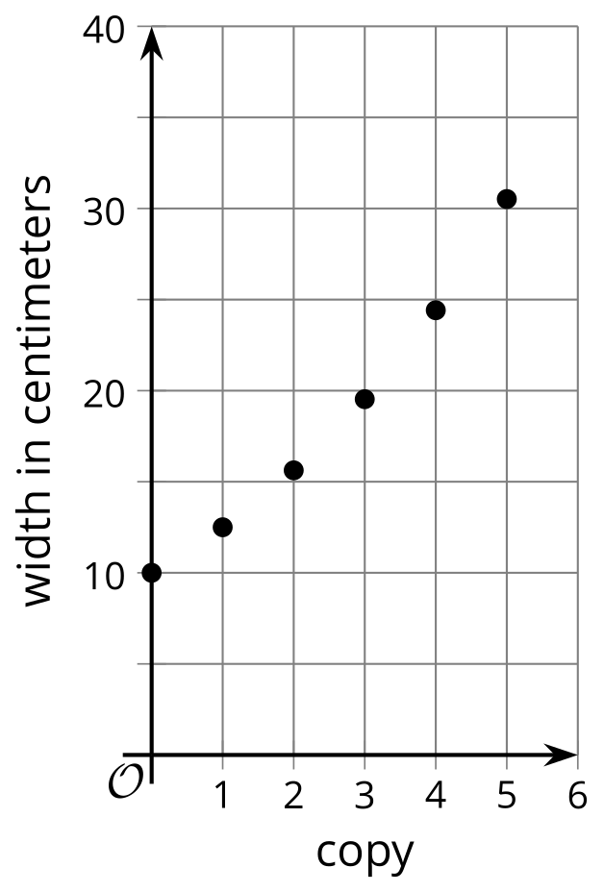
- Which equation would be the best model for the data, where $x$ represents the number of the copy and $y$ represents width of the photo in centimeters?
  - $y=25x+10$
  - $y=10⋅{\left(0.25\right)}^{x}$
  - $y=10⋅{\left(1.25\right)}^{x}$
- What is the meaning of the two numbers in the equation for the model?
- Data set C: The height of a different agave plant over time. Come up with an equation that would be a good model for this data.
- day | - 0 | - 1 | - 2 | - 3 | - 4 | - 5 | - 6 | - 7 | - 8
- height in inches | - 34 | - 44 | - 52 | - 61 | - 68 | - 74 | - 83 | - 91 | - 97
- Data set D: A person used a computer simulation to roll number cubes, and count how many rolls it took before all of the cubes came up sixes. This table shows the results. Come up with an equation that would be a good model for this data.
- number of cubes | - 1 | - 2 | - 3 | - 4 | - 5
- number of rolls | - 5 | - 29 | - 140 | - 794 | - 3,861
© CC BY 2019 by Illustrative Mathematics®

