Unit 3 Lesson 6: Connecting Similarity and Transformations

1 Dilation Miscalculation (Warm up)

Student Task Statement
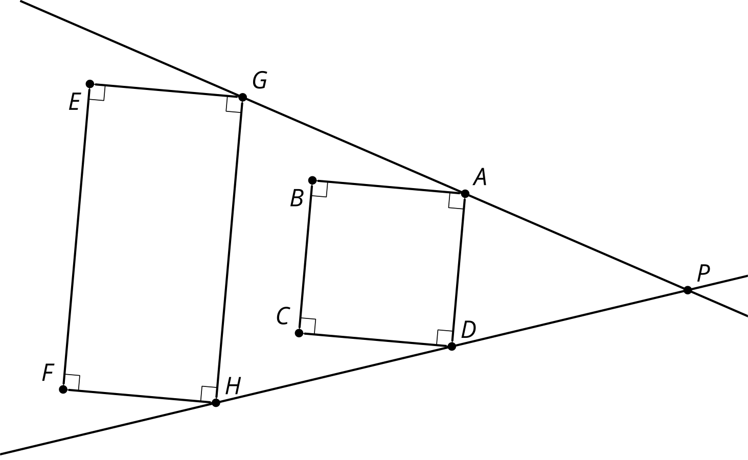
What’s wrong with this dilation? Why is $GHFE$ not a dilation of $ADCB$?

2 Card Sort: Not-So-Rigid Transformations

Student Task Statement
- Your teacher will give you a set of cards. Sort the cards into categories of your choosing. Be prepared to explain the meaning of your categories.
- Your teacher will assign you one card. Write the sequence of transformations (translation, rotation, reflection, dilation) to take one figure to the other.
- For all the cards that could include a dilation, what scale factor is used to go from Figure $F$ to Figure $G$? What scale factor is used to go from Figure $G$ to Figure $F$?

3 Alphabet Soup

Images for Launch

Translation and dilation takes $△ABC$ onto $△FDE$ so $△ABC∼△FDE$
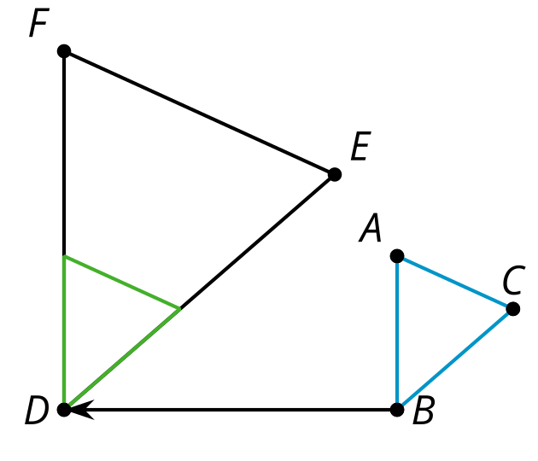

Student Task Statement
Are the triangles similar?

$\overset{¯}{AB}∥\overset{¯}{QR},\overset{¯}{AB}⊥\overset{¯}{AE},\overset{¯}{QR}⊥\overset{¯}{QT}$
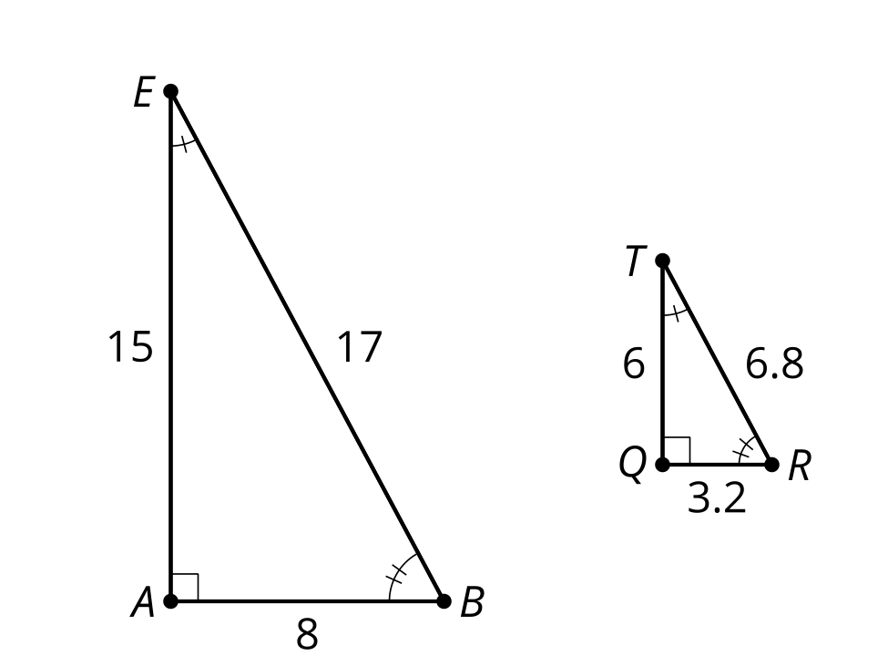
- Write a sequence of transformations (dilation, translation, rotation, reflection) to take one triangle to the other.
- Write a similarity statement about the 2 figures, and explain how you know they are similar.
- Compare your statement with your partner’s statement. Is there more than one correct way to write a similarity statement? Is there a wrong way to write a similarity statement?

Images for Activity Synthesis

$JL=2⋅PR$
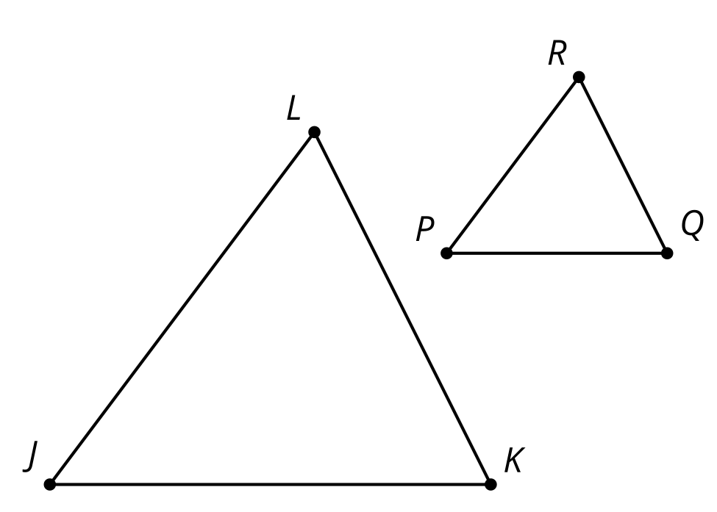
© CC BY 2019 by Illustrative Mathematics®

