Lesson 7: Grafiquemos y respondamos

Standards Alignments
Addressing | 3.MD.B.3

Teacher-facing Learning Goals
- Draw a scaled bar graph to represent a data set with several categories.
- Solve one- and two-step “how many more” and “how many less” problems using information presented in scaled bar graphs.

Student-facing Learning Goals
- Representemos nuestros datos en gráficas de barras con escala y respondamos preguntas sobre los datos.

Lesson Purpose
The purpose of this lesson is for students to draw a scaled bar graph to represent a data set with several categories.
In a previous lesson, students used a survey to collect data. In this lesson, they represent their data set with a scaled bar graph. Then, students ask and answer questions about the information presented in their scaled bar graphs.
If students need additional support with the concepts in this lesson, refer back to Unit 1, Section A in the curriculum materials.

Access for:

Students with Disabilities
- Representation (Activity 1)

English Learners
- MLR8 (Activity 2)

Instructional Routines
Notice and Wonder (Warm-up)

Materials to Gather
- Materials from a previous activity: Activity 2
- Materials from a previous lesson: Activity 1

Materials to Copy
- Draw Scaled Graphs (groups of 1): Activity 1

Lesson Timeline
Warm-up | 10 min
Activity 1 | 20 min
Activity 2 | 20 min
Lesson Synthesis | 5 min
Cool-down | 5 min

Teacher Reflection Question
As students worked in their small groups today, whose ideas were heard, valued, and accepted? How can you adjust the group structure tomorrow to ensure each student’s ideas are a part of the collective learning?

Cool-down
(to be completed at the end of the lesson) 5min
Pregunta sobre la gráfica

Standards Alignments
Addressing | 3.MD.B.3

Student-facing Task Statement
¿Cuántos estudiantes más prefieren el coliflor que los espárragos o las arvejas? Explica tu razonamiento.
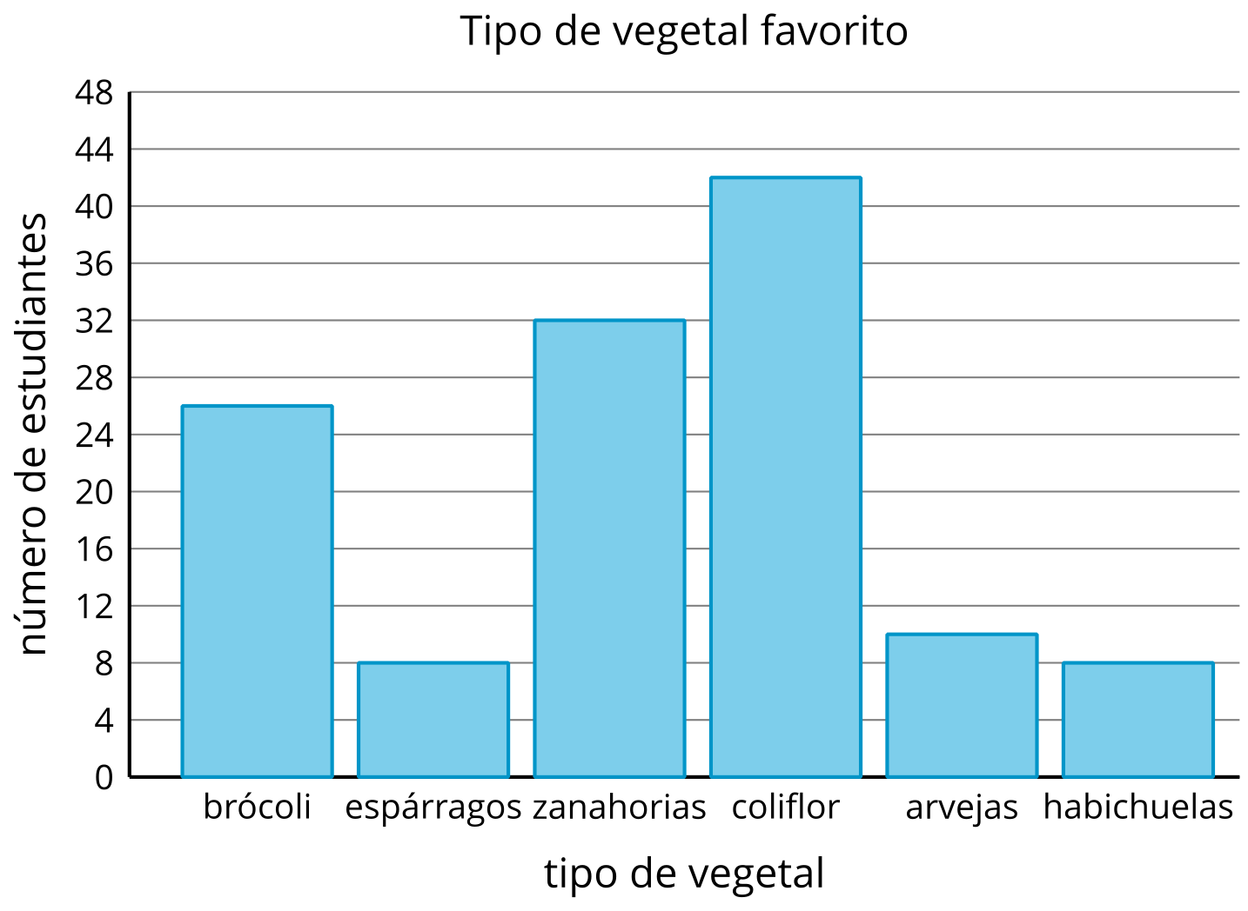

Student Responses
24 more students: Sample response: 8 students liked asparagus and 10 students liked peas. This is 18 students. 42 students liked cauliflower which is 24 more students than students who liked asparagus or peas.

