Lesson 8 Practice Problems
- Here is a hanger:
  - Write an equation to represent the hanger.
  - Solve the equation by reasoning about the equation or the hanger. Explain your reasoning.
- 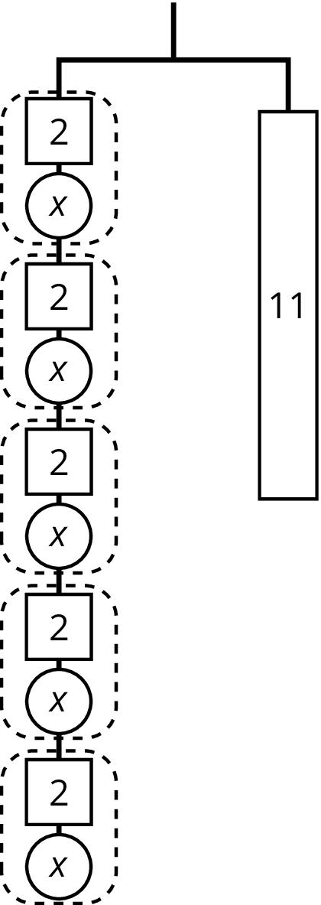
- Explain how each part of the equation $9=3\left(x+2\right)$ is represented in the hanger.
  - $x$
  - 9
  - 3
  - $x+2$
  - $3\left(x+2\right)$
  - the equal sign
- 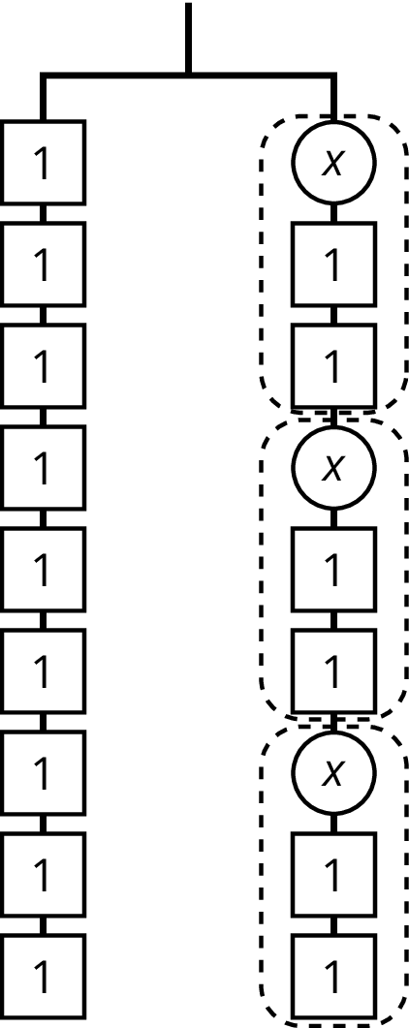
- Select the word from the following list that best describes each situation.
  - You deposit money in a savings account, and every year the amount of money in the account increases by 2.5%.
  - For every car sold, a car salesman is paid 6% of the car’s price.
  - Someone who eats at a restaurant pays an extra 20% of the food price. This extra money is kept by the person who served the food.
  - An antique furniture store pays $200 for a chair, adds 50% of that amount, and sells the chair for $300.
  - The normal price of a mattress is $600, but it is on sale for 10% off.
  - For any item you purchase in Texas, you pay an additional 6.25% of the item's price to the state government.
  - Tax
  - Commission
  - Discount
  - Markup
  - Tip or gratuity
  - Interest
- (From Unit 4, Lesson 11.)
- Clare drew this diagram to match the equation $2x+16=50$, but she got the wrong solution as a result of using this diagram.
- 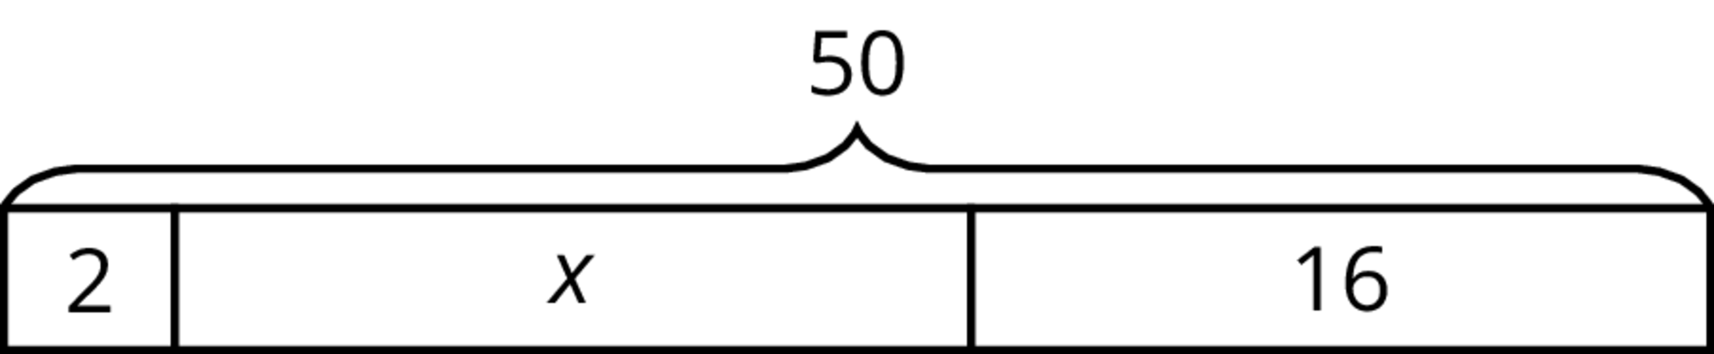

  - What value for $x$ can be found using the diagram?
  - Show how to fix Clare’s diagram to correctly match the equation.
  - Use the new diagram to find a correct value for $x$.
  - Explain the mistake Clare made when she drew her diagram.
- (From Unit 6, Lesson 3.)
© CC BY Open Up Resources. Adaptations CC BY IM.

