Unit 3 Lesson 5: Splitting Triangle Sides with Dilation, Part 1

1 Notice and Wonder: Midpoints (Warm up)

Student Task Statement
Here’s a triangle $ABC$ with midpoints $L,M$, and $N$.
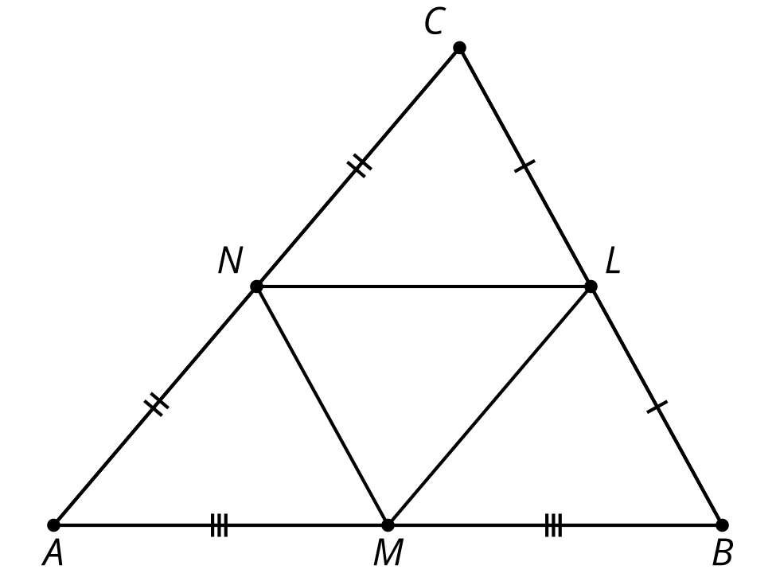
What do you notice? What do you wonder?

2 Dilation or Violation?

Student Task Statement
Here’s a triangle $ABC$. Points $M$ and $N$ are the midpoints of 2 sides.
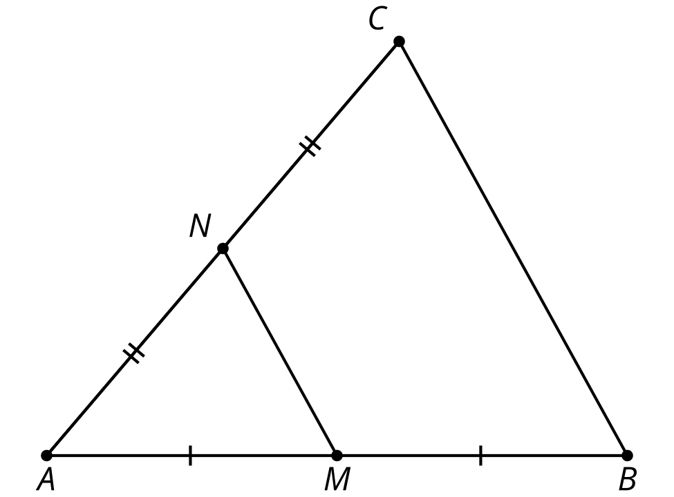
- Convince yourself triangle $ABC$ is a dilation of triangle $AMN$. What is the center of the dilation? What is the scale factor?
- Convince your partner that triangle $ABC$ is a dilation of triangle $AMN$, with the center and scale factor you found.
- With your partner, check the definition of dilation on your reference chart and make sure both of you could convince a skeptic that $ABC$ definitely fits the definition of dilation.
- Convince your partner that segment $BC$ is twice as long as segment $MN$.
- Prove that $BC=2MN$. Convince a skeptic.

3 A Little Bit Farther Now

Student Task Statement
Here’s a triangle $ABC$. $M$ is $\frac{2}{3}$ of the way from $A$ to $B$. $N$ is $\frac{2}{3}$ of the way from $A$ to $C$.
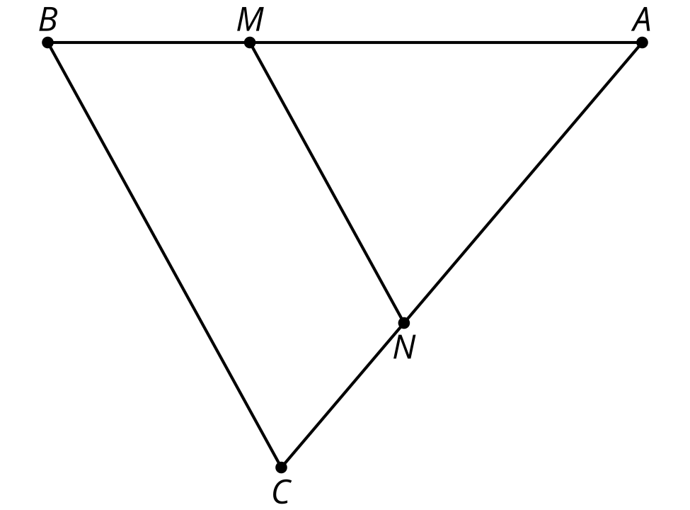
What can you say about segment $MN$, compared to segment $BC$? Provide a reason for each of your conjectures.

Activity Synthesis

$\frac{1}{2}=\frac{1.2}{2.4}$ so $\overset{¯}{AC}∥\overset{¯}{GF}$
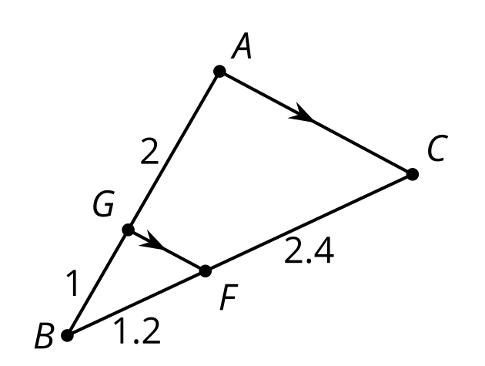
© CC BY 2019 by Illustrative Mathematics®

