Lesson 3: Using Function Notation
- Let’s use function notation to talk about points.

3.1: Which One Doesn’t Belong: Function Notation
Which one doesn’t belong?
- $f\left(0\right)=2$
- $\left(0,5\right)$
- $y=x+2$
- 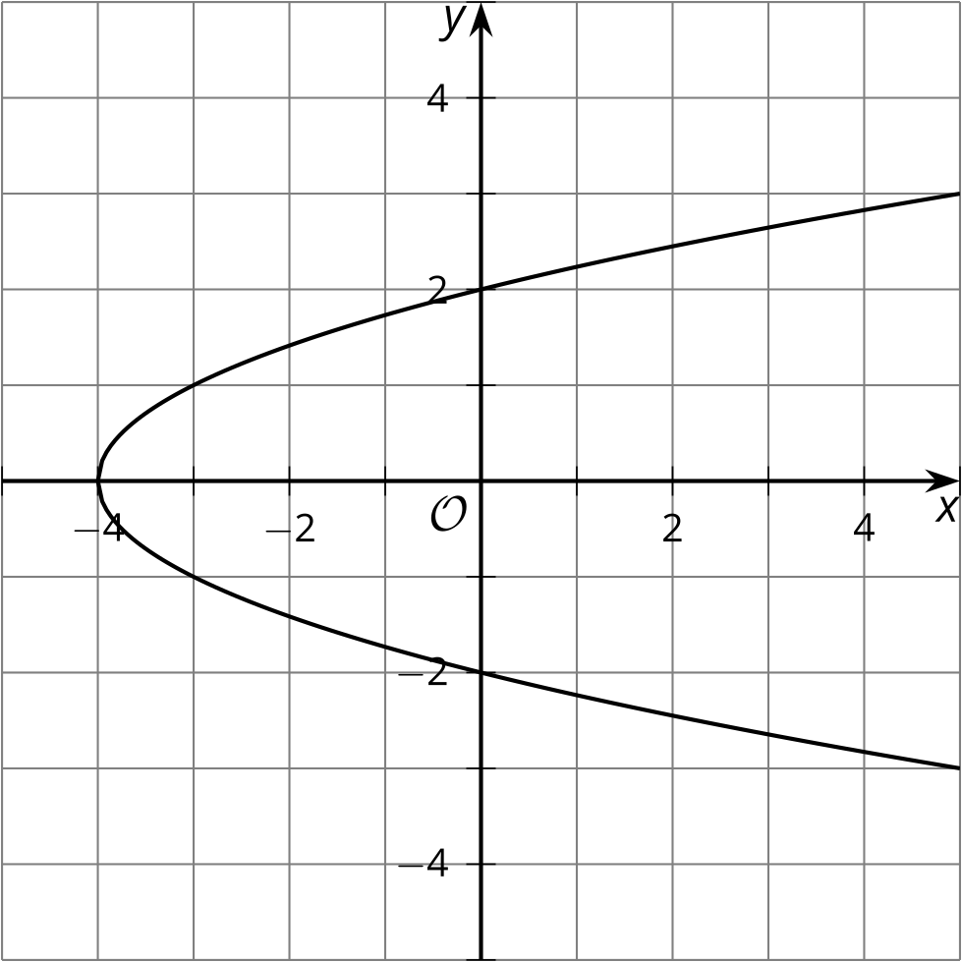

3.2: Points into Function Notation and Back
- A function is given by the equation $y=f\left(x\right)$. Write each of these coordinate pairs in function notation.
  - $\left(2,3\right)$
  - $\left(\text{-}1,4\right)$
  - $\left(0,3\right)$
  - $\left(4,0\right)$
  - $\left(\frac{2}{3},\frac{3}{4}\right)$
- A function is given by the equation $h\left(x\right)=5x−3$. Write the coordinate pair for the point associated with the given values in function notation.
  - $h\left(3\right)$
  - $h\left(\text{-}4\right)$
  - $h\left(\frac{2}{5}\right)$

3.3: A Graph with Properties
- Draw a graph of function $y=g\left(x\right)$ that has these properties:
  - $g\left(0\right)=2$
  - $g\left(1\right)=3$
  - $\left(2,3\right)$ is on the graph
  - $g\left(5\right)=\text{-}1$
- 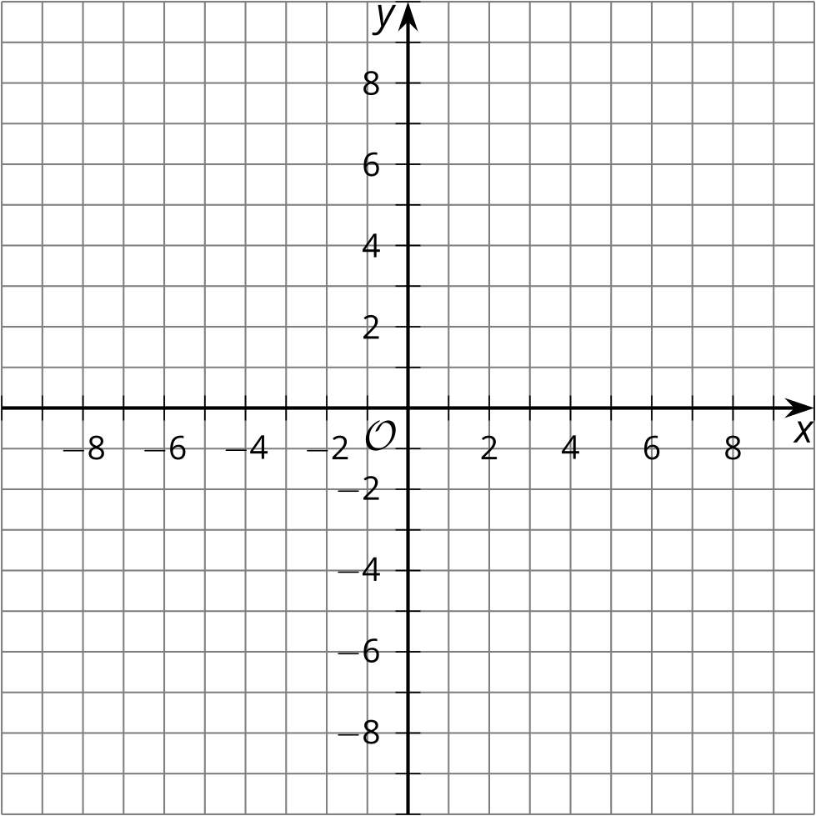
- Han draws this graph for $g\left(x\right)$. What is the error?
- 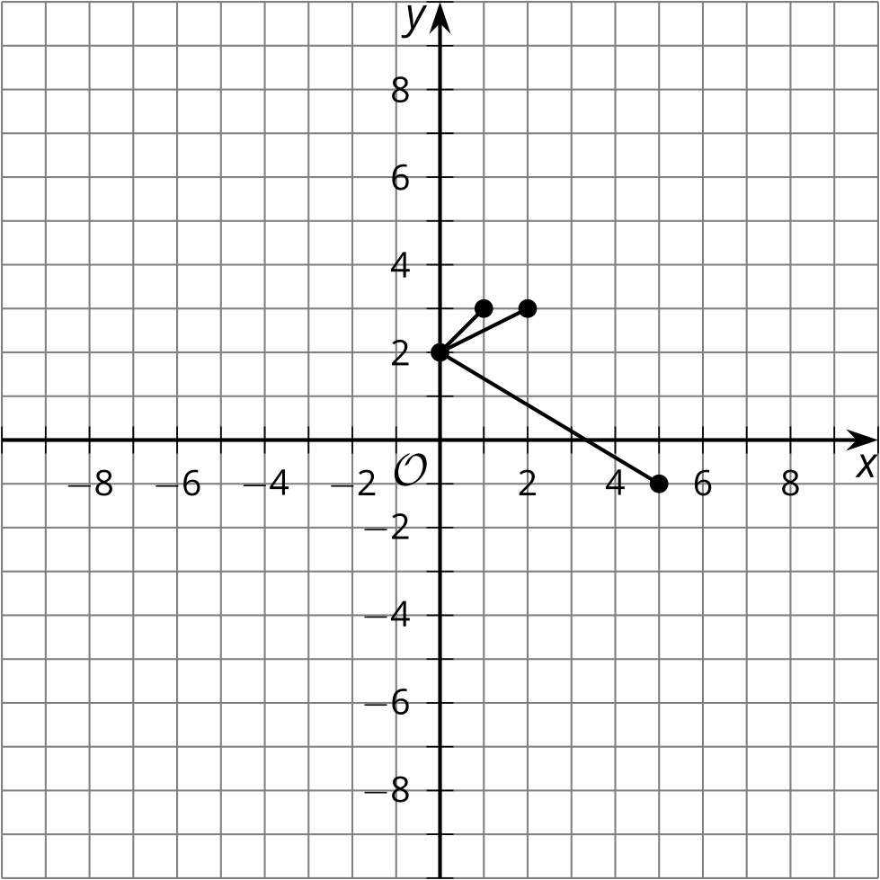
© CC BY 2019 by Illustrative Mathematics®

